This document

This is a monthly report submitted by the National Center for Atmospheric Research (NCAR) describing progress on tasks listed in the annual statement of work (SOW) for the 4DWX project, funded by the U. S. Army Test and Evaluation Command’s (ATEC’s) Developmental Test Command (DTC). Descriptions of tasks are abbreviated. For full descriptions, please refer to the SOW. The sections, subsections, and tasks in this document are numbered to match those in the SOW. Ten reports are submitted per year; none is submitted in the two months (usually April and August) during which project-review meetings (i.e., IPRs) are held.

This report is for work done in April 2011. Because of the IPR in April, no report was submitted for work done in March.

Themes and goals for the fiscal year
During FY11, NCAR will strive to preserve the current system's operational reliability and to
continue to make advances in science and engineering. NCAR will continue to customize
4DWX for each range by optimizing the configuration of the NWP core of the system (e.g.,
number of vertical levels) and by exploring ways of improving or adding to the coupled
applications driven by the NWP model’s output. Additional instances of AutoNowcaster (ANC)
will be installed, following on the great success of the first ATEC DTC-funded installation of an
ANC at WSMR.

This will be the third year of a multi-year reduction in the resources spent on graphical
applications; NCAR will increasingly rely on third-party applications, for which NCAR will
provide data translators. The 4DWX Web Portal will continue to be the ranges’ chief interface to
pre-generated, operational weather maps and plots from 4DWX. IDV will replace JViz as the
chief tool for more detailed exploration of weather data from 4DWX.

Sophisticated and more user-friendly methods of model verification will be one of the project’s
foci in FY11. Verification efforts will be applied toward tools that can aid forecasters in real
time.

FY11 will be the second in a multi-year effort to consolidate 4DWX hardware at two sites, one
primary, the other as a back-up to the primary site.

Budget summary

Please see the SOW for FY2011 (separate document).

Restrictions and security
Please see the SOW for FY2011 (separate document).

Programmatic tasks

Project reviews
- IPRs
Report: The IPR was held 12–14 April at NCAR. At the review the dates and location for the next IPR were set: 23–24 August in the Damon Room at the Mesa Lab, with the RDT&E meeting on the 25th at the Foothills Lab in room FL0-2512.

Forecaster Training
  - Forecaster Training sessions at NCAR
Report: Sessions were held on 29–31 March and 10–12 May 2011. Each training included a visit to the NWS office in Boulder. A summary of the sessions and results of exit poles will be presented at the IPR in August.

Internships
  - ATEC internships
Report: No work.

Security
- Adoption of CACs
Report: No work.
- Compliance with International Traffic in Arms Regulations (ITAR)
Report: Completed.
- Training and certification of systems administrators
Report: Completed.

Technical tasks

Support
  - Maintenance of Help Desk
Report: Standard support is ongoing.

  - Maintenance of 4DWX Knowledge Base
Report: The new liaison began reviewing the 4DWX documentation. Material is being evaluated to decide what needs to be updated and improved.

  - Teleconferences with ranges
Report: All-range teleconferences are normally scheduled each month to discuss problems and requests for individual ranges as well as topics of interest to everyone. Over the past several months, these meetings were convened, with participation from each range listed:
- February 2: ATC, CRTC, DPG, RTC
- March 2: ATC, CRTC, DPG, YPG
- April 6: ATC, CRTC, DPG, RTC

  - Support for safari missions (see Appendix B for a full list of missions)
Report: Support was provided for the safari missions listed in Appendix B. One missions was running during the month of April: a continuation of the San Nicholas Island configuration for WSMR. Normal support included the monitoring of runs and trouble-shooting of run failures.

  - Demonstrations of real-time support for tethered systems in theater
Report: No work.
  - Proposals for acquisition of dedicated or shared HPCs
Report: No work.
  - Preparation of material for DTC Range Commanders Conferences
Report: No work.
  - Hire of range liaison
Report: The new range liaison is Justin Shaw. He was formerly a forecaster, lead forecaster, then Assistant Manager for Forecast Operations at Meridian Environmental Technology in Grand Forks, ND. Justin started work on 11 April.
  - Upgrade of the operating system on the HPC at DPG
Report: Completed.

Customization of 4DWX for each range
    - Evaluation and enhancement of 4DWX for simulation of extreme cold at CRTC
Report: Work has begun on exploring the chinook (aka foehn) winds that are sometimes responsible for the most dramatic breaks in very cold weather at CRTC. The goals of the work are to a) understand better the physical processes involved and b) improve predictions of the chinooks by 4DWX. Two parallel configurations of 4DWX have been established on a research cluster at NCAR, one a control and the other a high-resolution variant of the control. Forecasters at CRTC will supply NCAR with dates of specific chinooks for study. This work will be an extension of the internship project recently finished by Caleb Witt-Schulte.
    - Improvement of forecasts of temperature at ATC, including cold air damming
Report: A set of the CAD cases that we have been studying were re-run with the new WRF v3.2. The newest simulations are significantly more accurate. In particular, there is no longer an unrealistic and unobserved warming toward the end of the CAD episode, which we had been seeing in previous simulations. We are now exploring what about the upgrade in model was responsible for the improved simulation.

    - Improvement of gravity wave forecasts at WSMR
Report: No work.

    - Miscellaneous additional testing and optimization of 4DWX configurations
Report: Initial trial simulations are now underway to focus on chinooks at CRTC, microphysics and lightning prediction at RTC, and land-use characterization at ATC.

User applications and data management
- Gridded bias correction of 4DWX output
Report: The system is undergoing what we hope is a final round of reviews before becoming fully operational. All the code appears to be functioning properly. Some book-keeping of data might still need to be improved.

- Incremental upgrades to 4DWX Web Portal
Report: Improvements to the Web Portal were deployed as part of the DAS 4.1 portion of the 4DWX 2011.v2 coordinated release for all ranges. Here are some highlights:

    - BUFKIT output now loads and displays in the BUFKIT application.
      - Previously the bufkit file output files would not load correctly in BUFKIT due to invalid header values. The key change made was supplying a value for the lifting condensation level pressure (LCLP) header. BUFKIT uses that value for a marker it places on the vertical profile (Skew-T diagram) when the user wishes to see that level (a check box in the "Convection" section).
      - There are remaining header values that are still not populated by the Portal and assistance from the ranges in the Forecasters’ Training sessions will be sought to improve the bufkit file output further.

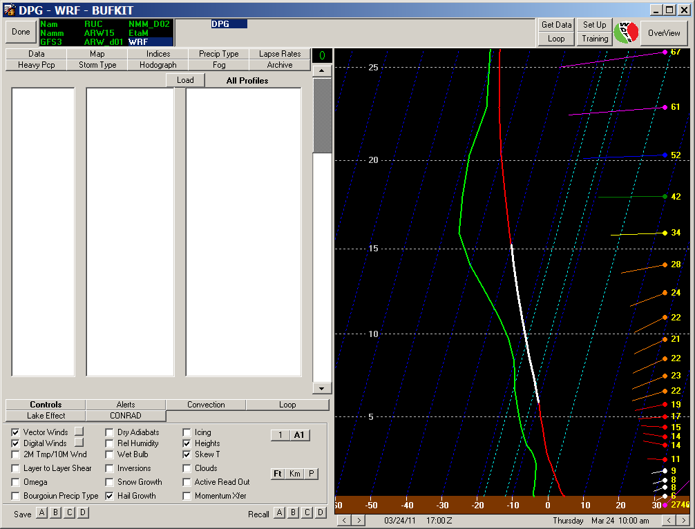

Figure 1 - BUFKIT display with DPG output

    - New cross-wind portlet
This new portlet was requested by DPG for UAV support. It provides a display of crosswind for a runway specified with a particular angle using readings for a SAMS stations selected nearby. It provides a threshold alert color for crosswinds that exceed a particular value similar to the previous threshold alert portlet.

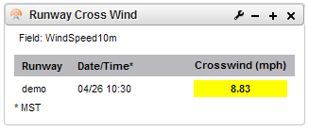
Figure 2 – Runway Cross Wind portlet at EPG with yellow warning

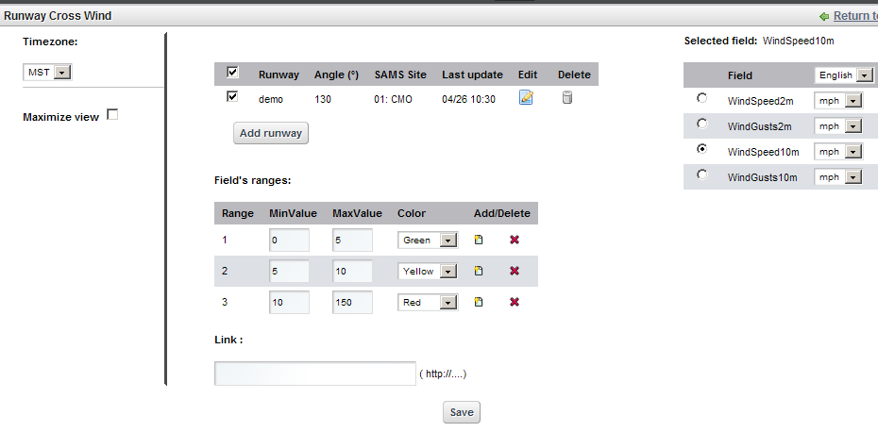
Figure 3 - Runway Cross Wind portlet configuration

    - Domain 4 was added to the model runs for WSMR

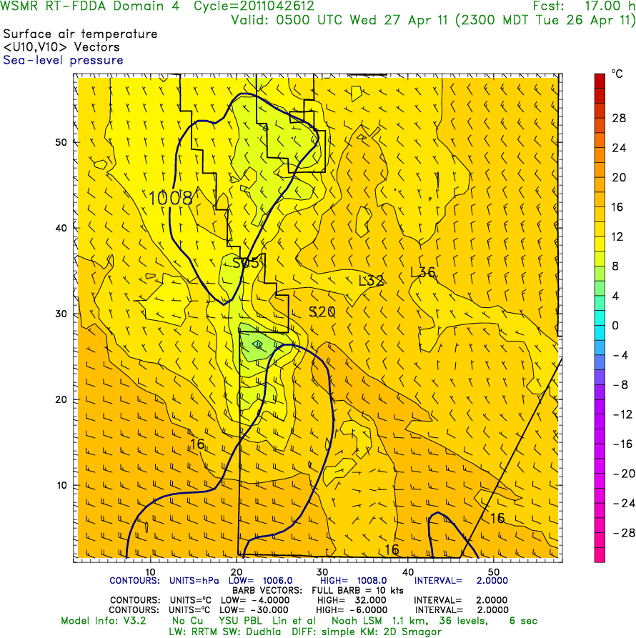
Figure 4 - WSMR Domain 4 example

    - Expanded domain 3 maps for EPG, RTC
The model maps for EPG and RTC now have a 'zoomed' D3 centered over the range (like WSMR and YPG has) in order to better view SAMS sites at the ranges.

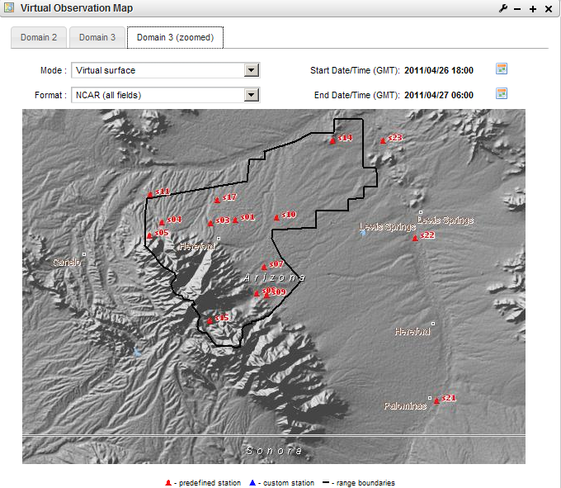
Figure 5 - Example of zoomed Domain 3 at EPG

    - The Tomcat monitoring script was improved to increase reliability of the Web Portal.

    - Fixed problem caused when a secondary applications portlet was configured on the same page with another portlet.

    - Added time series displays for observations in the Observation List portlet (example shown). This is intended as an example and we are seeking feedback during Forecasters’ Training on how this need capability could be configured and expanded.

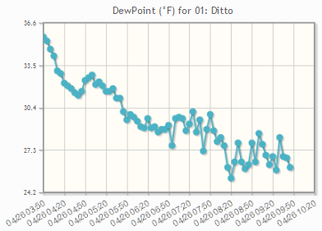
Figure 6 - Sample time series for a SAMS site at DPG

- Maintenance and enhancement of MIR database
Report: No work.

- Replacement of JViz with IDV
Report: Improvements to IDV for 4DWX were deployed as part of the DAS 4.1 portion of the 4DWX 2011.v2 coordinated release for all ranges. Here are some highlights:

    - A lightning data filter was added to improve performance with the Weather Bug data
      - Lightning strikes are considered to be the same one if the time interval is within 1 second and the location distance is within 0.1 deg
      - A count column was added to show the number of strikes that were combined. The amplitude comes from the first instance. CloudToGround and CloudToCloud are also added from each instance.

    - JViz was retired from 4DWX
      - JViz application is no longer installed on the DAS systems
      - The MDV data that was being used only by JViz is no longer converted to save processing time and disk space.

- Upgrade of data gateway systems
Report: The data gateway systems have progressed on four fronts: 1) We upgraded to a new LDM release (v 6.9.7) and now include new metrics reporting on data latencies; 2) we developed a new failover mechanism between the two gateway systems that will be completed and installed in the coming month; 3) we found a replacement for the primary data gateway, which is soon to expire its warranty; 4) we upgraded the ftp protocol for retrieving MADIS data to a secure ftp that uses the "curl" API. This transition was the result of a security requirement from NOAA data providers. Because the new secure ftp protocol also requires that the ftp password be updated every 60 days (which necessitates a modification to the automated ingest script), investigations are underway to re-code the MADIS retrieval and decoder to make use of an alternate LDM data stream. Recoding of the MADIS decoder is not an insignificant effort, but would mitigate some of the additional complexities in the code caused by the ftp mechanism.
- Evaluation of SIPS as a possible replacement for NAPS
Report: No work. Dependent on schedule of SIPS development by NSWC.
- Finalization and freeze of Lewis Model at NCAR
Report: During the second session of the Forecaster Training in May, NCAR discussed this with Blaine Thomas from WSMR. Perviously, WSMR has reported that they would like us to revert to a previous version of Lewis prior to inclusion of winds rotated away from the standard WSMR range geometry. We have started this modification. Once the revised version is tested and the results have been reviewed by WSMR and NCAR, we expect the code to be frozen, which we explained to Blaine.
- Other general upgrades to applications
Report: At the Forecaster Training, NCAR demonstrated the new color schemes that accommodate the color blind. The schemes were very warmly received by attendees at both sessions and will soon be implemented (as an option to be chosen or decline at each range).

NWP modeling
- Upgrades to WRF Model in 4DWX
Report: Improvements to RT-FDDA model forecasting were deployed in the WRF 3.2 portion of the 4DWX 2011.v2 coordinated release for all ranges. Here are some highlights:

    - WRF 3.2
      - Community WRF updates: http://www.mmm.ucar.edu/wrf/users/wrfv3.2/updates-3.2.html.
      - RAL R&D updates
        - Integration of 4DWX “Nudging Core”
        - RAL modifications to WRF physics, including: YSU, MYJ, and QNSE PBL schemes
      - Summary list of new capabilities from both Community and RAL:
        - Terrain shadows
        - New land-air coupling
        - Long wave radiation
        - Regime-based surface data assimilation (DA)
        - Adaptive time step for faster model execution
        - Radiosonde DA with terrain adjustment
        - Various bug-fixes
      - Post release: the adaptive time step feature was turned off temporarily to work around a transitory and somewhat subtle problem that has occasionally appeared on some ranges' inner domains: a low bias in near-surface temperature, along with corresponding shifts in wind. The bias seemed to appear only during daytime hours, and not every day. This problem will be fixed in a patch release to occur in this summer.

    - Plotting changes
      - Surface mixing ratio plots were replaced by dew point

    - Gridded Bias Correction update
      - Correction calculations were improved
- Refinement of nudging scheme in 4DWX
Report: Parallel real-time modeling experiments, one with 4D-REKF proxy and the other with RTFDDA have been set up with the DPG configuration (3 domains) on smac-c1 (an old research cluster at NCAR). The analysis of initial results did not show obvious advantages to the new scheme, which is not consistent with our previous case studies. This work has been paused in order to focus on the ensemble 4D-REKF tests (Item C below) on the smac-c4 (the new big cluster). We’ll resume this work by classifying proxy ensemble members according to time of day and weather regimes.

- Development of hybrid data-assimilation scheme for 4DWX (multi-year effort)
Report: We continue to test the RTFDDA-3DVAR hybrid system with radar data assimilation for ATC domains in a real-time environment. In order to better quantify the radar data impact, parallel modeling experiments have been conducted. Analysis of the model results from the two weeks of parallel execution of ATC-RTFDDA with/without radar data assimilation shows great impact of radar data assimilation up to 9-hour forecasts; results were presented at the April IPR. We are in the process of upgrading the WRF 3DVAR code to the newer community version and will test to see whether improved 3DVAR analyses can be obtained.
Development of 4D-REKF (4-Dimensional Relaxation Kalman Filter data assimilation and forecasting) continued: a) tidying, merging, and stress-testing the baseline codes has been done. The code has been upgraded to WRF Version 3.2.1; b) a prototype 4D-REKF system for real-time testing has been configured on the new smac-c4 R&D cluster with 35 nodes, and 30 ensemble members including four 4D-REKF members; c) Initial trial runs suggested a few technical challenges, including memory overshoots and issues with efficiency. We are working on algorithms to solve the issues. Plans for enhancing the baseline 4D-REKF cross-variable error covariance have been discussed.

- Demonstration of E-4DWX at ranges other than DPG
Report: No work.

- Refinement of E-4DWX perturbation schemes
Report: We designed a new WRF-only 30 member perturbation set. Research has been conducted to study the known WRF model issue – for example, underprediction of the diurnal amplitude of the surface temperatures, resulting in high biases to minimum T2 and low biases to maximum T2. Two parameters are being examined: a) soil moisture and b) thermal roughness length. Both show a great sensitivity, but no conclusion can be drawn at present. Both parameters can serve as ensemble perturbation points (i.e., they are sensitive and uncertain!).

- Extension of E-4DWX calibration to more variables and to full model grid (multi-year effort)
Report: No work.
- Operational implementation of MODIS-based SSTs and LSTs in 4DWX
Report: No work.

- Other general improvements to 4DWX
Report: Jointly with the AirDat LLC project, we have designed and are implementing a new observation quality control scheme. QC of most upper air data continues to be fine. We are debugging a bug in QC of surface data. This work is still in progress. Test runs with the “on-line” data quality control algorithm for a case study showed a great enhancement to RTFDDA analyses. More results will be reported in future.

- Exploration of LES modeling at one or more ATEC DTC ranges
Report: WRF-RTFDDA-LES modeling research continues on smac-c4, the new R&D cluster located at NCAR. Initial analysis and assessment of the WRF-RTFDDA-LES model based on six experiments shows encouraging results…and challenges too. We are disappointed to see that the new NBA subgridfilter (nonlinear backscatter and anisotropy filter) scheme did not bring in obvious benefit. These results were reported at the April IPR. A new WRF-RTFDDA-LES model run has been conducted to simulate the late- April tornado outbreak over Mississippi, Alabama, and Georgia using NCAR supercomputers and smac-c4. The result is interesting (the model simulated 40 m/s winds) and has been submitted to the June WRF users’ workshop for a presentation.

Auto-Nowcaster and convective weather forecasting
- Installation of full ANC at RTC
Report: The ANC installation at RTC was accomplished in March. Activities in April centered on monitoring the system to find any deficiencies in the system and in tuning the ANC for various synoptic regimes as they occurred. Specific accomplishments include:
- A new membership function was added to cronus to better scale the model vertical velocity field.
- The stratiform/convective algorithm was tuned for Redstone with better separation achieved and better ANC performance realized.
- Tuning of the bright-band algorithm was accomplished, but to implement it would require significant modifications to the system with the potential to increase the computation load and the I/O load on the machine. Since this seemed risky given the number of radars at Redstone, it was decided to retune the algorithm and to implement a simplified version. When the WSMR hardware is replaced in June, we may test the more complex version of this algorithm to understand the system load that this new method may incur since WSMR is only ingesting three radars with level 2 data.
- The domain for the short-term radar-based lightning potential was increased to the full radar domain (instead of only 1 radar).
- The problem where the first boundary and the first polygon entered via CIDD were vanishing has been fixed and installed at RTC.
- Sysview diagrams continue to be enhanced as changes are made such that the operational system can be monitored remotely.
- Ingestors were written for more of the new Level III radar products. The one with the biggest potential for improvement is VIL, which now allows a logarithmic scale for data values and so captures smaller variations a lot more accurately. This will be installed in the next release.
- Preliminary investigation into the dual-polarization particle identification (PID) algorithm was made.
- Tornadoes in northern Alabama on 27 April shut down the range for a period while power was restored to the area. This case will be examined closely with the ANC. Niles assisted Redstone in system recovery after the tornado.

- Implementation of probabilistic forecasts of lightning at WSMR and RTC
Report: No work.
- Maintenance and operational support of ANC and related tools at WSMR and other ranges
Report: Comparison of the Wxbug lightning data against NLDN and LMA data was completed by Wiebke Deierling and results were presented at the IPR
The COLIDE, HumanMgr, and boundary drawing tool software packages were installed at WSMR in April. In anticipation of the new ANC hardware that will be purchased and installed in June at WSMR, Dan Megenhardt has gone over the build scripts for the ANC, making improvements and modifications as needed. The NCAR Mass Storage System (MSS) was replaced with the High Performance Storage System (HPSS); necessary updates to the archival scripts for WSMR and RTC were made and installed.
Updated Sysview diagrams for the MRRD systems were made by Niles Oien. We plan to display these on the web portal when ready.
A new version of the LDM (6.9.7) was brought out by UniData. Niles readied this for installation in the next MRRD release.

Model validation and verification
- Development of more sophisticated, user-friendly methods of model verification
Report: No work.
- Operational verification of E-4DWX
Report: During the HPC’s recent troubles, when failed hard drives dictated that a smaller ensemble be run, verification metrics from the quantile-regression calibration code was used to revisit a review of which members were consistently important contributors to the regression, and how the contributions were functions of forecast lead time.
- Development of a simple graphical tool for viewing 4DWX’s verification statistics
Report: Because this work was paused for some time, a meeting was held to review the previous use cases and design criteria. Engineering has resumed.
- VV&A of the WRF-based 4DWX to satisfy army requirements
Report: No work.

Tasks funded through other sources but leveraged to benefit ATEC-4DWX project
- Use of 4DWX or E-4DWX to support forecasting at Cape Canaveral. (Currently unfunded and indefinitely on hold.)
Report: No work.

Hardware, operating systems, and security
- Expansion of data storage
Report: T he new HPC storage hardware for the ensemble runs was delivered at DPG. All the new components arrived with the exception of some cables.

Here is a summary of the new hardware components:
- Dell HPC NFS Storage Solution (NSS)
      - 24GB memory
      - 2 quad-core processors
      - NFS server for attached storage
- PowerVault MD1200 enclosure
      - 12 x 2TB drives w/ RAID6 (20 TB raw)
      - Reusable after the HPC reaches end of life
- Dell PowerEdge R510 Server
      - Used as an ensemble post-processing server
      - 2 quad-core processors
      - 48GB memory
      - 12 x 300GB storage.
After the new hardware (storage) upgrade to the DPG HPC, we reconfigured the DPG ensemble system according to the new hardware setting and fully recovered the 30-member DPG ensemble system for 6 hourly cycle and 48-h forecasts. All members and post-processing modules are running smoothly. We are planning to upgrade the WRF-models for WRF members in next 3–4 weeks with RAL-WRF V3.2.1.

- New desktop and laptop computers for project staff
Report: None.

- Consolidation of operational 4DWX hardware
Report: Completed.

- Purchase and maintenance of R&D clusters at NCAR
Report: Some model processing issues on the new R&D cluster (smac-c4) occurred and after extensive troubleshooting, the problem was due to defective hardware that was replaced under warranty.
- Purchase and maintenance of DAS hardware and miscellaneous upgrades to DAS software
Report: New 2-node DAS systems were ordered for DPG, ATC, RTC, and WSMR to replace the current 5-node DASes that are going out of warranty in May. These systems will be installed and set up during onsite range visits in June.

Here is a summary of the new hardware:
- Dell PowerEdge R610s (2 per range)
      - 24 GB memory
      - 2 quad-core processors
      - 6 x 1TB drives
Additionally a new Autonowcaster for WSMR was ordered and will be installed at the same time as the new WSMR DAS system. This system is very similar in configuration as the ANC at RTC.

Management
- NCAR’s project management
Report: No change.

Administration and miscellany
  - Articles, posters, and talks
Report:

- Articles published
  - None

- Articles accepted and in press
  - None
- Articles in revision based on reviews
  - Delle Monache, L., T. Nipen, Y. Liu, G. Roux, R. Stull, 2011: Kalman filter and analog schemes to post-process numerical weather predictions. Conditionally accepted on Monthly Weather Review.
- Articles in external review
  - None.
- Articles submitted
  - None.
- Articles in internal review
  - None.
- Articles in preparation
  - Hirschberg , P., E. Abrams, A. Bleistein, W. Bua, L. Delle Monache, T. Dulong, J. Gaynor, B. Glahn, T. Hamill, J. Hansen, D. Hilderbrand, R. Hoffman, B. Morrow, B. Philips, J. Sokich, and N. Stuart, 2011: A weather and climate enterprise strategic implementation plan for generating and communicating forecast uncertainty information. To be submitted to the Bulletin of the American Meteorological Society.
  - Hopson, T. M. and J. P. Hacker, 2011: Combined approaches for ensemble post-processing, Mon. Weath. Rev., in process idea: application of quantile-regression approach to NOAA Reforecast temperature ensembles over Utah.
    - Status: some calculations are in the process of being redone using an improved logistic regression selection technique; most figures completed, 70% of text.
  - Hopson, T. M., Assessing the ensemble forecast spread and skill relationship, Mon. Weath. Rev., in process.
    - Status: rewriting text and including material from 2 new references

  - Article on cold air damming at ATC and sensitivity of forecasts to PBL and microphysics schemes
  - Liu, Y., J. C. Knievel, T. M. Hopson, S. F. Halvorson, J. C. Pace, G. Roux, W. Wu, J. P. Hacker, S. E. Krippner, T. T. Warner, and S. P. Swerdlin, 2012: Mesoscale ensemble weather prediction at Dugway Proving Ground. Mon. Wea. Rev., in preparation
  - Liu, Y. , L. Pan, Y. Wu, A. Bourgeois, T. Warner, J. Knievel, S. Swerdlin, J. Pace, S. F. Halvorson, and F. Gallagher, 2012: The NCAR 4DREKF ensemble data assimilation and forecasting system: Part 1: System description and validation. Journal TBD, in preparation

  - Wu, Y., Y. Liu, L. Pan, A. Bourgeois, J. Knievel, T. Warner, S. Swerdlin, S. F. Halvorson, J. Pace, and F. Gallagher, 2012: The NCAR 4DREKF ensemble data assimilation and forecasting system: Part 2: Sensitivity of the critical/control parameters. Journal TBD, in preparation
  - Pan, L., Y. Liu, Y. Wu, A. Bourgeois, J. Knievel, T. Warner, S. Swerdlin, S. F. Halvorson, J. Pace, and F. Gallagher, 2012: The NCAR 4DREKF ensemble data assimilation and forecasting system: Part 3: A Proxy without running ensemble. Journal TBD, in preparation
- Presentations (no order)
  - Abstracts submitted:
    - Two abstracts were submitted to the AMS Aviation, Range and Aerospace Meteorology Conference to be held in August.
      - “Thunderstorm and Lightning Nowcasting at Redstone Test Center” by Eric Nelson, Cathy Kessinger, Wiebke Deierling, Niles Oien, Leo Lachapelle, Daniel Schmit, Eric Diaz and Richard Gazda
      - “The NCAR Short-term Lightning Alert System” by Wiebke Deierling, C. J. Kessinger, D. L. Megenhardt, and M. Steiner
    - Several abstracts were submitted to the AMS 14th Conference on Mesoscale Processes. Among them:
      - “On the impact of the assimilation of nacelle winds and yaw angles with WRF-FDDA and WRF-DART for short-term wind energy predictions” by Caroline Draxl, Luca delle Monache, Yubao Liu, Gael Descombes, Francois Vandenberghe, Will Cheng, and Jason Knievel

APPENDICES
- Acronyms
4DWX Four-Dimensional Data Assimilation and Forecast System
4DWXDB 4DWX database
AGU American Geophysical Union
AMS American Meteorological Society
AP Anomalous propagation
ATEC U.S. Army Test and Evaluation Command
ATC Aberdeen Test Center
AUSA Association of the U. S. Army
CAC Common Access Card
CAD Cold-air damming
CFDDA Climate FDDA
CIDD Configurable Interactive Data Display
CMAQ Community Multiscale Air Quality Model
COAMPS Coupled Ocean/Atmosphere Mesoscale Prediction System
COLIDE Convergent Line Detection program
CoN Certificate of Networthiness
CRTC Cold Regions Test Center
CVS Concurrent Versioning System
DART Data Assimilation Research Testbed
DAS Data Acquisition Server
DPG Dugway Proving Ground
EPG Electronics Proving Ground
ERTFDDA Ensemble-RTFDDA
GMOD Global Meteorology on Demand
GPU Game processing unit
GSL Great Salt Lake
HPC High performance computer
HPCMP HPC Modernization Program
HPSS High Performance Storage System
IPR In-process review
ITAR International Traffic in Arms Regulations
KB Knowledge Base
LMA Lightning mapping array
LHN Latent-heat nudging
LST Lake-surface temperature
MIR Meteorological Information Repository
MIPR Military Interdepartmental Procurement Request
MODIS Moderate Resolution Imaging Spectroradiometer
MODTRAN Moderate resolution atmospheric transmission
MSFC Marshall Space Flight Center
MSRC Major Shared Resource Center
MYJ scheme Mellor-Yamada-Janjic
NAPS Noise Assessment and Prediction System
NASA National Aeronautics and Space Administration
NBA Nonlinear backscatter and anisotropy
NCAR National Center for Atmospheric Research
NCEP National Centers for Environmental Prediction
NLDN National Lightning Detection Network
NRL Naval Research Laboratory
NSAP National Security Applications Program (within NCAR RAL)
NSF National Science Foundation
NVL Night Vision Laboratory
NWP Numerical weather prediction
PBL Planetary boundary layer
R&D Research and development
RAL Research Applications Laboratory
RTFDDA Real-Time Four-Dimensional Data Assimilations system
RTC Redstone Technical Test Center
SST Sea-surface temperature
STAR Inst. Science and Technology in Atmospheric Research Institute
STEP Short-Term Explicit Prediction
UAH University of Alabama at Huntsville
UF Universal format
USWRP U.S. Weather Research Program
VLAS Variational Lidar Analysis System
VDRAS Variational Doppler Radar Analysis System
WRF model Weather Research and Forecasting Model
WSMR White Sands Missile Range
YPG Yuma Proving Ground
YSU Yonsei University

- Safari missions
Report:

Requester: WSMR
Dates: Existing SNI configuration running through end of May
Location: San Nicholas Island, California
Type: WRF 3.0.1.1, 3 domains
Special needs: Support for rocket launches

