This document

This is a monthly report submitted by the National Center for Atmospheric Research (NCAR) describing progress on tasks listed in the annual statement of work (SOW) for the 4DWX project, funded by the U. S. Army Test and Evaluation Command’s (ATEC). Descriptions of tasks are abbreviated. For full descriptions, please refer to the SOW. The sections, subsections, and tasks in this document are numbered to match those in the SOW. Ten reports are submitted per year; none is submitted in the two months (usually April and August) during which project-review meetings (i.e., IPRs) are held.

This report is for work done in August 2011. Because of the IPR in August, there was no report submitted in August for work done in July.

Themes and goals for the fiscal year
During FY11, NCAR is striving to preserve the current system's operational reliability and to make advances in science and engineering. NCAR continues to customize 4DWX for each range by optimizing the configuration of the NWP core of the system (e.g., number of vertical levels) and by exploring ways of improving or adding to the coupled applications driven by the NWP model’s output. Additional instances of AutoNowcaster (ANC) are being installed, following on the great success of the first ATEC-funded installation of an ANC at WSMR.

This is the third year of a multi-year reduction in the resources spent on graphical applications; NCAR is increasingly relying on third-party applications, for which NCAR provides data translators. The 4DWX Web Portal will continue to be the ranges’ chief interface to pre generated, operational weather maps and plots from 4DWX. IDV is replacing JViz as the chief tool for more detailed exploration of weather data from 4DWX.

Sophisticated and more user-friendly methods of model verification are one of the project’s
foci in FY11. Verification efforts will be applied toward tools that can aid forecasters in real
time.

FY11 is the second in a multi-year effort to consolidate 4DWX hardware at two sites, one
primary, the other as a back-up to the primary site.

Budget summary

Please see the SOW for FY2011 (separate document).

Restrictions and security
Please see the SOW for FY2011 (separate document).

Programmatic tasks

Project reviews
- IPRs
Report: The summer IPR was held on 23–24 August in the Damon Room at NCAR’s Mesa Lab, with the RDT&E meeting on the 25 August at the Foothills Lab in room FL0-2512. The picnic was at Foothills Community Park on Wednesday evening, 24 August. The pre-IPR meeting was 3 August in FL0-2512.

Forecaster Training
  - Forecaster Training sessions at NCAR
Report: A summary of the sessions in 2011 and results of exit polls were presented at the IPR in August. Later in CY2011 NCAR shall schedule the sessions for FY2012.

Internships
  - ATEC internships
Report: No work. It is NCAR’s understanding that the Army has discontinued the internship program.

Security
- Adoption of CACs
Report: No work, and none is anticipated unless the Army mandates use of CACs.
- Compliance with International Traffic in Arms Regulations (ITAR)
Report: Completed.
- Training and certification of systems administrators
Report: Completed.

Technical tasks

Support
  - Maintenance of Help Desk
Report: Standard support is ongoing.

  - Maintenance of 4DWX Knowledge Base
Report: The new liaison continued reviewing the 4DWX documentation. Material is being evaluated to decide what needs to be updated and improved.

  - Teleconferences with ranges
Report: All-range teleconferences are normally scheduled each month to discuss problems and requests for individual ranges as well as topics of interest to everyone. Over the past several months, these meetings were convened, with participation from each range listed:
- June 8: ATC, CRTC, DPG, RTC, WSMR, YPG
- July 6: ATC, CRTC, DPG, RTC, YPG
- August 10: ATC, CRTC, DPG, RTC, WSMR, YPG

  - Support for safari missions (see Appendix B for a full list of missions)
Report: Support was provided for the safari missions listed in Appendix B. In July, the San Nicholas Island configuration for WSMR and in August, the PMRF configuration for WSMR were both updated to WRF 3.2. Both missions ran through August. Normal support included
monitoring of runs and trouble-shooting.

  - Demonstrations of real-time support for tethered systems in theater
Report: No longer a task assigned to this FY.
  - Proposals for acquisition of dedicated or shared HPCs
Report: NCAR purchased a new HPC-II for Dugway using funds provided by the Meteorology Division of the WDTC. Components have been arriving at Dugway and the system is scheduled to be racked and stacked in October.
  - Preparation of material for Range Commanders Conferences
Report: No work.
  - Hire of range liaison
Report: Completed.
  - Upgrade of the operating system on the HPC at DPG
Report: Completed.

Customization of 4DWX for each range
    - Evaluation and enhancement of 4DWX for simulation of extreme cold at CRTC
Report: No work.
    - Improvement of forecasts of temperature at ATC, including cold air damming
Report: Tests have begun on use of the new National Land Cover Database (NLCD) 2006 for defining the land cover in 4DWX for all ranges’ configurations, including ATC’s. NLCD data were downloaded and converted to WRF-ready binary, then urban data were remapped. Initial simulations of a cold-air-damming case showed differences but no significant improvement. More simulations are scheduled.

    - Improvement of gravity wave forecasts at WSMR
Report: No work.

    - Miscellaneous additional testing and optimization of 4DWX configurations
Report: No work.

User applications and data management
- Gridded bias correction of 4DWX output
Report: Completed. The last step was “battle hardening” of the GBC code. Here is a summary of the tuning parameter settings that resulted from this process.

- Empirically defined the “N” day window used for estimating bias
  - Balanced two competing objectives
    - Make N large enough to get statistically robust estimate; but
    - Make N small enough to retain as many stations as possible within grid 3 area
  - Implementation: N currently set to a minimum of 4 days, and maximum of 7 days

- Empirically defined optimal QC thresholds for input observations
  - Balanced two competing objectives
    - Make QC high enough to retain only “good” observations
    - Make QC low enough to retain as many observations as possible within grid 3 area
  - Implementation: QC = 3 (Best = 10)

- Empirically defined radii of influence for input observations
  - Temperature: R = 125 km
  - Specific humidity: R = 100 km
  - Zonal and meridional wind: R = 50 km
- Mitigated Kalman filter divergence, which yields false minima/maxima
  - Tends to occur in regions far removed from observation stations (control points) and along lateral boundaries
  - Implementation: Run a Cressman-type 9-point smoother over any grid point whose bias exceeds 2.5 standard deviations (lower- and upper-most 1%) from grid-averaged mean
  - If extrema still exist, repeat, but widen radius of influence to 25 surrounding points

- Incremental upgrades to 4DWX Web Portal
Report: Improvements to the Web Portal were deployed as part of the DAS 4.2 release for all ranges. Here are some highlights:

- Model Map
  - New functionality was added to allow the user to select units and intervals. The user can now choose the units for plots and displays in the portal.

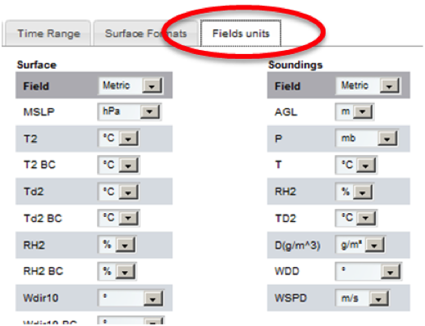

  - The user can specify the interval of the sounding data within the Virtual Observations portlet when accessing the Virtual Soundings mode.

- Animation Portlet

The default image controls have been moved to use less screen space. These can also be repositioned on the page for convenience by clicking/dragging and placing the controls where desired.

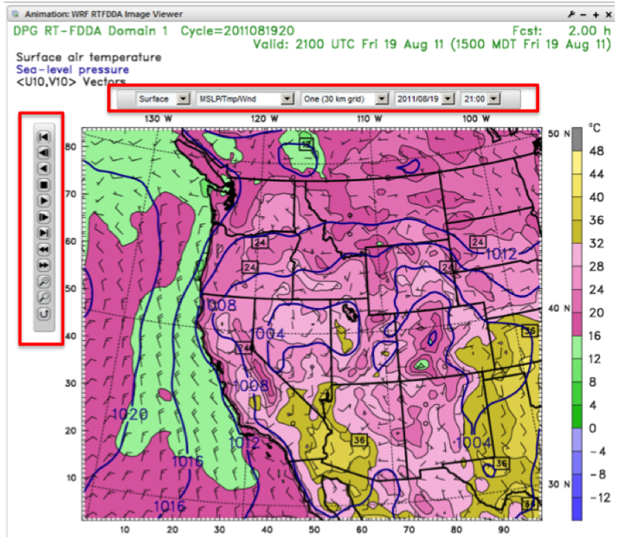

- Sortable Tables

The data contained within the observations, min/max, and the threshold alert and lightning alert tables can now be sorted by clicking on the arrows to the right of the menu label.

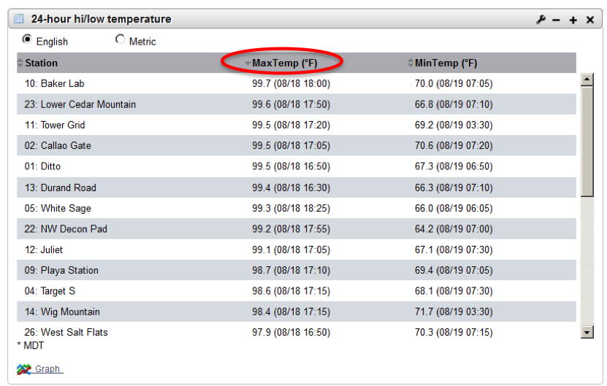

- New Graphs for the Observations and 24-Hour High/Low Portlets

These bar graphs display the data for all stations within the Observations and 24-hour high/low table portlets. The graphs can be accessed by clicking on the ‘graph’ icon at the bottom of each table.

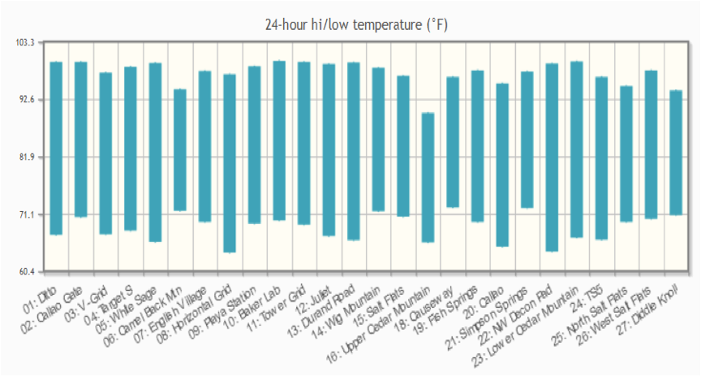

- Range Maps

These maps are now selectable in the Image Viewer portlet. The new maps include Land Use, Land Use Legend, and Grid Configuration.

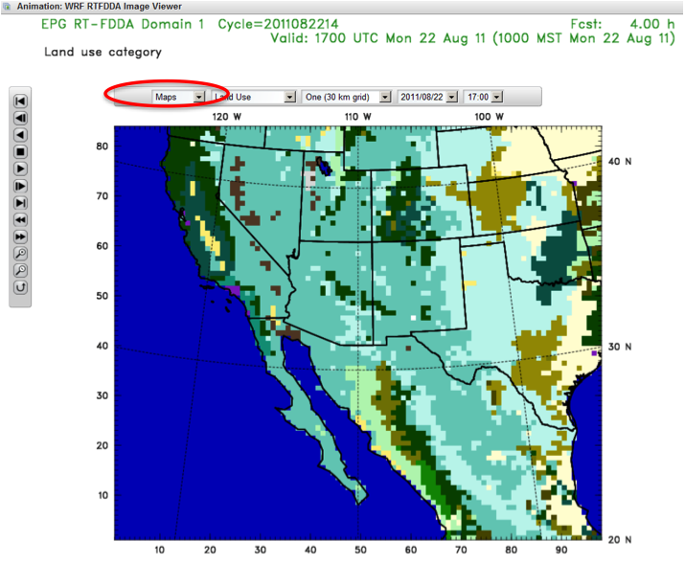

- Banners and Notices
  - The banner has been moved to the bottom of the portal to save screen space.
  - A notice has been added to the DPG portal when logging in for Information Assurance compliance. Additionally, each portal page at DPG displays “UNCLASSIFIED - FOUO” text.

- Other improvements
  - Runway crosswind portlet: this portlet now uses the absolute value of wind speed for the alert threshold.
  - Weather Warning Tool: customized criteria have been added to the email subject line.
  - Met Format: in the Virtual Sounding tool, a conversion that was incorrectly displaying output in MSLP has been corrected to AGL.

- Maintenance and enhancement of MIR database
Report: Improvements to the MIR database were deployed as part of the DAS 4.2 release for all ranges. Highlights included:
- Password encryption for DPG Information Assurance
- Query speed optimization

- Replacement of JViz with IDV
Report: Completed.

- Upgrade of data gateway systems
Report: No work.
- Evaluation of SIPS as a possible replacement for NAPS
Report: No work. Dependent on schedule of SIPS development by NSWC.
- Finalization and freeze of Lewis Model at NCAR
Report: No work.
- Other general upgrades to applications
Report: NCAR made a few final updates to the RIP namelist-creation code and to the namelists themselves. The namelist creation suite now includes the capability of creating new "special" cross-section plot types, and it’s now possible to create duplicate sounding plots without the parcel information box, which occasionally obscured sounding data.

NWP modeling
- Upgrades to WRF Model in 4DWX
Report: The new version of 4DWX modeling software will be deployed in autumn 2011.
- Refinement of nudging scheme in 4DWX
Report: No work.

- Development of hybrid data-assimilation scheme for 4DWX (multi-year effort)
Report: We continued to test the RTFDDA-3DVAR hybrid system with radar data assimilation for ATC in a real-time environment, in addition to testing with case studies. A hardware issue that caused gaps in radar data was recently resolved. Plans have been made for making the real-time forecast products available to ATC range users next spring. We will also be working on documentation and consolidation of the code and modules in the next a few months. We have started to construct an outline for wrapping up the radar data assimilation for a journal paper.
Development of the 4D-REKF (4-Dimensional Relaxation Kalman Filter data assimilation) also continues with improved memory based on reconstructing the 4D-REKF Kalman gain processing algorithms. A new R&D version, 4D-REKF/RTFDDA v3.2.1R2 has been formulated with several bug fixes. We are continuing the real-time tests of 4D-REKF with the new 4D-REKF/RTFDDA v3.2.1R2 to evaluate 4D-REKF and compare with standard RTFDDA. We presented the result of these tests at the recent European Meteorological Society 2011 Annual Meeting, whose theme was on probabilistic forecast and data assimilation. We’ll start to integrate the new community WRF V3.3.1 (to be released in September 2011) into 4DWX RTFDDA and 4D-REKF technologies in the middle of October to formulate RTFDDA V3.3.1R0, which will be upgraded for the 4DWX operations later this autumn.

- Demonstration of E-4DWX at ranges other than DPG
Report: No work.

- Refinement of E-4DWX perturbation schemes
Report: No work.

- Extension of E-4DWX calibration to more variables and to full model grid (multi-year effort)
Report: No work.
- Operational implementation of MODIS-based SSTs and LSTs in 4DWX
Report: A few unexpected problems still have to be resolved with the Python scripts that have been rewritten to accommodate changes in the latest Python libraries. The problems should be solved by end of summer.

- Other general improvements to 4DWX
Report: We have designed an enhanced and streamlined calibration of E-4DWX. The new design integrates a joint Analog Kalman Filter (ANKF) bias correction and Quantile Regression (QR) calibration scheme that we developed for Xcel wind energy forecasts. Development of the new design has been started on an NCAR cluster. Discussion to purchase and install MATLAB and IDL on a DPG workstation to support this work is on-going.
We have continued to implement and test the new on-line observation quality-control scheme. This work is still in progress. We have redesigned the algorithms in the data preprocessing and in the WRF code that convert and interpolate for missing data needed for data assimilation. This part was done in the old off-line data QC module. We have begun to conduct real-time tests of the new QC algorithm using an off/on-line interim solution. We are working to solve some technical issues in order to input the diverse raw data.

- Exploration of LES modeling at one or more ATEC ranges
Report: We are evaluating, cleaning, and organizing the ultra-high resolution land-cover (30 m) and terrain (~90 m) database to prepare for the implementation of WRF-RTFDDA-LES systems at the ATEC ranges. Analysis and evaluation of WRF-RTFDDA-LES model behavior and performance with 90–270 m grid intervals is on-going. Four cases of WRF-RTFDDA-LES runs were summarized and reported at the European Meteorological Society 2011 Annual meeting. We appear to be the first ones to research and experiment with LES-scale NWP predictions of this kind. Plans have been made to start real-time WRF-RTFDDA-LES experimental modeling and assessment for the ATC and DPG test regions for 2 weeks to 1 month when the new HPC-II is set up at DPG.

Auto-Nowcaster and convective weather forecasting
- Installation of full ANC at RTC
Report: The ANC installation at RTC was accomplished in March.
RTC's NOAAport seems to be fixed. We are continuing to push satellite and surface data (from projects at NCAR) to the RTC ANC for awhile yet, but will shut it down as soon as the system is stable.
Staff traveled to RTC from 6–8 July, as discussed in the last monthly report, and made changes to the display, fixed several software problems and is still working to resolve the problem with the lifted index field. Additional training was completed with staff. We continue to tune the ANC and are selecting case studies for analysis.
The tornado case from 27 April was presented at the IPR along with initial validation results.

- Implementation of probabilistic forecasts of lightning at WSMR and RTC
Report: The WSMR radar-based short-term time lightning-potential forecast was validated and results were presented at the IPR.
The short-term and longer term model-based RTC lightning-potential forecast evaluation is underway. The 4DWX-RTC sensitivity tests to the microphysics scheme (i.e., Thompson vs. Lin et al.) are underway.
We continue to work with Chris Schultz, UAH, who will be visiting until early September. He is working on the LMA lightning jump algorithm. Chris presented a seminar of his results. We hope to continue this collaboration after he returns to UAH.
- Maintenance and operational support of ANC and related tools at WSMR and other ranges
Report: The installation of new hardware for the ANC was completed in late June and the implementation and set-up of the ANC system was completed in late July. Staff traveled to WSMR on 25–28 July to check out the new system and to turn off the old one. While there, the new system received a thorough test. In addition, a number of upgrades to the system were made, display improvements were made, and staff were trained. A full reporting of what was done was made at the IPR.

Model validation and verification
- Development of more sophisticated, user-friendly methods of model verification
Report: No work.
- Operational verification of E-4DWX
Report: No work.
- Development of a simple graphical tool for viewing 4DWX’s verification statistics
Report: Because this work was paused for some time, a meeting was held to review the previous use cases and design criteria. Engineering has resumed.
- VV&A of the WRF-based 4DWX to satisfy army requirements
Report: No work.

Tasks funded through other sources but leveraged to benefit ATEC-4DWX project
- Use of 4DWX or E-4DWX to support forecasting at Cape Canaveral. (Currently unfunded and indefinitely on hold.)
Report: No work.

Hardware, operating systems, and security
- Expansion of data storage
Report: Latest expansion is completed.

- New desktop and laptop computers for project staff
Report: None.

- Consolidation of operational 4DWX hardware
Report: Completed.

- Purchase and maintenance of R&D clusters at NCAR
Report: A new webserver for 4dwx.org and a new data gateway server were purchased to replace aging systems that were out of warranty.
- Purchase and maintenance of DAS hardware and miscellaneous upgrades to DAS software
Report: Completed for DPG, ATC, RTC, and WSMR. New DAS hardware for NVL is planned for purchase in September.

Management
- NCAR’s project management
Report: No change.

Administration and miscellany
  - Articles, posters, and talks
Report:

- Articles published
  - None

- Articles accepted and in press
  - Delle Monache, L., T. Nipen, Y. Liu, G. Roux, R. Stull, 2011: Kalman filter and analog schemes to post-process numerical weather predictions. Conditionally accepted on Monthly Weather Review.
- Articles in revision based on reviews
  - Hirschberg , P., Abrams, E., Bleistein, A., Bua, W., Delle Monache, L., Dulong, T., Gaynor, J., Glahn, B., Hamill, T., Hansen, J., Hilderbrand, D., Hoffman, R., Morrow, B., Philips, B., Sokich, J., Stuart, N., 2011: A weather and climate enterprise strategic implementation plan for generating and communicating forecast uncertainty information. Bulletin of the American Meteorological Society, conditionally accepted.
- Articles in external review
  - None.
- Articles submitted
  - None.
- Articles in internal review
  - None.
- Articles in preparation
  - Hirschberg , P., E. Abrams, A. Bleistein, W. Bua, L. Delle Monache, T. Dulong, J. Gaynor, B. Glahn, T. Hamill, J. Hansen, D. Hilderbrand, R. Hoffman, B. Morrow, B. Philips, J. Sokich, and N. Stuart, 2011: A weather and climate enterprise strategic implementation plan for generating and communicating forecast uncertainty information. To be submitted to the Bulletin of the American Meteorological Society.
  - Hopson, T. M. and J. P. Hacker, 2011: Combined approaches for ensemble post-processing, Mon. Weath. Rev., in process idea: application of quantile-regression approach to NOAA Reforecast temperature ensembles over Utah.
    - Status: some calculations are in the process of being redone using an improved logistic regression selection technique; most figures completed, 70% of text.
  - Hopson, T. M., Assessing the ensemble forecast spread and skill relationship, Mon. Weath. Rev., in process.
    - Status: rewriting text and including material from 2 new references

  - Article on cold air damming at ATC and sensitivity of forecasts to PBL and microphysics schemes
  - Liu, Y., J. C. Knievel, T. M. Hopson, S. F. Halvorson, J. C. Pace, G. Roux, W. Wu, J. P. Hacker, S. E. Krippner, T. T. Warner, and S. P. Swerdlin, 2012: Mesoscale ensemble weather prediction at Dugway Proving Ground. Mon. Wea. Rev., in preparation
  - Liu, Y. , L. Pan, Y. Wu, A. Bourgeois, T. Warner, J. Knievel, S. Swerdlin, J. Pace, S. F. Halvorson, and F. Gallagher, 2012: The NCAR 4DREKF ensemble data assimilation and forecasting system: Part 1: System description and validation. Journal TBD, in preparation

  - Wu, Y., Y. Liu, L. Pan, A. Bourgeois, J. Knievel, T. Warner, S. Swerdlin, S. F. Halvorson, J. Pace, and F. Gallagher, 2012: The NCAR 4DREKF ensemble data assimilation and forecasting system: Part 2: Sensitivity of the critical/control parameters. Journal TBD, in preparation
  - Pan, L., Y. Liu, Y. Wu, A. Bourgeois, J. Knievel, T. Warner, S. Swerdlin, S. F. Halvorson, J. Pace, and F. Gallagher, 2012: The NCAR 4DREKF ensemble data assimilation and forecasting system: Part 3: A Proxy without running ensemble. Journal TBD, in preparation
- Presentations (no order)
  - Presented in August:
      - Deierling, W., C. J. Kessinger, D. L. Megenhardt, and M. Steiner: The NCAR Short-term Lightning Alert System. AMS 15th Conference on Aviation, Range, and Aerospace Meteorology, Los Angeles, CA, 1-4 August 2011.

APPENDICES
- Acronyms
4DWX Four-Dimensional Data Assimilation and Forecast System
4DWXDB 4DWX database
AGU American Geophysical Union
AMS American Meteorological Society
AP Anomalous propagation
ATEC U.S. Army Test and Evaluation Command
ATC Aberdeen Test Center
AUSA Association of the U. S. Army
CAC Common Access Card
CAD Cold-air damming
CFDDA Climate FDDA
CIDD Configurable Interactive Data Display
CMAQ Community Multiscale Air Quality Model
COAMPS Coupled Ocean/Atmosphere Mesoscale Prediction System
COLIDE Convergent Line Detection program
CoN Certificate of Networthiness
CRTC Cold Regions Test Center
CVS Concurrent Versioning System
DART Data Assimilation Research Testbed
DAS Data Acquisition Server
DPG Dugway Proving Ground
EPG Electronics Proving Ground
ERTFDDA Ensemble-RTFDDA
GMOD Global Meteorology on Demand
GPU Game processing unit
GSL Great Salt Lake
HPC High performance computer
HPCMP HPC Modernization Program
HPSS High Performance Storage System
IPR In-process review
ITAR International Traffic in Arms Regulations
KB Knowledge Base
LMA Lightning mapping array
LHN Latent-heat nudging
LST Lake-surface temperature
MIR Meteorological Information Repository
MIPR Military Interdepartmental Procurement Request
MODIS Moderate Resolution Imaging Spectroradiometer
MODTRAN Moderate resolution atmospheric transmission
MSFC Marshall Space Flight Center
MSRC Major Shared Resource Center
MYJ scheme Mellor-Yamada-Janjic
NAPS Noise Assessment and Prediction System
NASA National Aeronautics and Space Administration
NBA Nonlinear backscatter and anisotropy
NCAR National Center for Atmospheric Research
NCEP National Centers for Environmental Prediction
NLDN National Lightning Detection Network
NRL Naval Research Laboratory
NSAP National Security Applications Program (within NCAR RAL)
NSF National Science Foundation
NVL Night Vision Laboratory
NWP Numerical weather prediction
PBL Planetary boundary layer
R&D Research and development
RAL Research Applications Laboratory
RTFDDA Real-Time Four-Dimensional Data Assimilations system
RTC Redstone Technical Test Center
SST Sea-surface temperature
STAR Inst. Science and Technology in Atmospheric Research Institute
STEP Short-Term Explicit Prediction
UAH University of Alabama at Huntsville
UF Universal format
USWRP U.S. Weather Research Program
VLAS Variational Lidar Analysis System
VDRAS Variational Doppler Radar Analysis System
WRF model Weather Research and Forecasting Model
WSMR White Sands Missile Range
YPG Yuma Proving Ground
YSU Yonsei University

- Safari missions
Report:

Requester: WSMR
Dates: Existing SNI configuration updated to WRF 3.2
Location: San Nicholas Island, California
Type: WRF 3.2, 3 domains
Special needs: Support for rocket launches

Requester: WSMR
Dates: Existing PMRF configuration updated to WRF 3.2
Location: Kauai, Hawaii
Type: WRF 3.2, 4 domains
Special needs: Support for rocket launches

