This document

This is a monthly report submitted by the National Center for Atmospheric Research (NCAR) describing progress on tasks listed in the annual statement of work (SOW) for the 4DWX project, funded by the U. S. Army Test and Evaluation Command’s (ATEC). Descriptions of tasks are abbreviated. For full descriptions, please refer to the SOW. The sections, subsections, and tasks in this document are numbered to match those in the SOW. Ten reports are submitted per year; none is submitted in the two months (usually April and August) during which project-review meetings (i.e., IPRs) are held.

This report is for work done in September 2011. It is the last report of the fiscal year.

Themes and goals for the fiscal year
During FY11, NCAR is striving to preserve the current system's operational reliability and to make advances in science and engineering. NCAR continues to customize 4DWX for each range by optimizing the configuration of the NWP core of the system (e.g., number of vertical levels) and by exploring ways of improving or adding to the coupled applications driven by the NWP model’s output. Additional instances of AutoNowcaster (ANC) are being installed, following on the great success of the first ATEC-funded installation of an ANC at WSMR.

This is the third year of a multi-year reduction in the resources spent on graphical applications; NCAR is increasingly relying on third-party applications, for which NCAR provides data translators. The 4DWX Web Portal will continue to be the ranges’ chief interface to pre generated, operational weather maps and plots from 4DWX. IDV is replacing JViz as the chief tool for more detailed exploration of weather data from 4DWX.

Sophisticated and more user-friendly methods of model verification are one of the project’s
foci in FY11. Verification efforts will be applied toward tools that can aid forecasters in real
time.

FY11 is the second in a multi-year effort to consolidate 4DWX hardware at two sites, one
primary, the other as a back-up to the primary site.

Budget summary

Please see the SOW for FY2011 (separate document).

Restrictions and security
Please see the SOW for FY2011 (separate document).

Programmatic tasks

Project reviews
- IPRs
Report: No work.

Forecaster Training
  - Forecaster Training sessions at NCAR
Report: No work.

Internships
  - ATEC internships
Report: No work. It is NCAR’s understanding that the Army has discontinued the internship program.

Security
- Adoption of CACs
Report: No work, and none is anticipated unless the Army mandates use of CACs.
- Compliance with International Traffic in Arms Regulations (ITAR)
Report: Completed.
- Training and certification of systems administrators
Report: Completed.

Technical tasks

Support
  - Maintenance of Help Desk
Report: Standard support is ongoing.

  - Maintenance of 4DWX Knowledge Base
Report: The new liaison continued reviewing the 4DWX documentation. Material is being evaluated to decide what needs to be updated and improved.

  - Teleconferences with ranges
Report: All-range teleconferences are normally scheduled each month to discuss problems and requests for individual ranges as well as topics of interest to everyone. Over the past several months, these meetings were convened, with participation from each range listed:
- July 6: ATC, CRTC, DPG, RTC, YPG
- August 10: ATC, CRTC, DPG, RTC, WSMR, YPG
- September 7: CRTC, DPG, RTC, WSMR, YPG

  - Support for safari missions (see Appendix B for a full list of missions)
Report: The Hawaii MLP configuration for WSMR was updated for a new ship location, and an additional run centered at Pearl Harbor was added, with several iterations to solidify locations for cross-section locations, soundings, and labels. The existing SNI and PMRF runs were turned off to make room for the new runs, which ran through the month of September. Normal support included the monitoring of runs and trouble-shooting of run failures..

  - Demonstrations of real-time support for tethered systems in theater
Report: No longer a task assigned to this FY.
  - Proposals for acquisition of dedicated or shared HPCs
Report: All components for the new HPC-II have arrived at Dugway. The previously scheduled system set up has been delayed until November to allow time for power drops to be installed in the Kuddes Building.
  - Preparation of material for Range Commanders Conferences
Report: No work.
  - Hire of range liaison
Report: Completed.
  - Upgrade of the operating system on the HPC at DPG
Report: Completed.

Customization of 4DWX for each range
    - Evaluation and enhancement of 4DWX for simulation of extreme cold at CRTC
Report: Simulations are underway for a case in February 2010. Among these is one with 150 vertical levels, designed to explore the role of vertical resolution in simulating chinooks and their ability to erode shallow, cold air.
    - Improvement of forecasts of temperature at ATC, including cold air damming
Report: No work.

    - Improvement of gravity wave forecasts at WSMR
Report: No work.

    - Miscellaneous additional testing and optimization of 4DWX configurations
Report: No work.

User applications and data management
- Gridded bias correction of 4DWX output
Report: Completed.

- Incremental upgrades to 4DWX Web Portal
Report: Development on new improvements to the Web Portal commenced using feedback obtained from the August IPR.

- Maintenance and enhancement of MIR database
Report: No work.

- Replacement of JViz with IDV
Report: Completed.

- Upgrade of data gateway systems
Report: Replacement hardware for the primary data gateway system, which had expired its 5-year warranty, has been purchased and is in the process of being installed and configured to take over operations. The first area of focus underway on the new hardware is a consolidated LDM, configured to support the role of three disparate LDMs. In consolidating the operations of three LDMs onto the new system, we will be able to streamline the LDM data distribution, reduce some redundant network traffic, and decrease the long-term maintenance.
In addition to progress on the new hardware, work on the prototype system continues, with recent focus on improvements to the MADIS datastream. In particular, the MADIS retrieval is transitioning from ftp to LDM mechanism. The LDM arrival of MADIS data will eliminate the need to change the MADIS user password every 60 days, a manual process that requires source code modifications each time.
- Evaluation of SIPS as a possible replacement for NAPS
Report: No work. Dependent on schedule of SIPS development by NSWC.
- Finalization and freeze of Lewis Model at NCAR
Report: Work to back out rotated wind calculations from the Lewis code was initiated.
- Other general upgrades to applications
Report: NCAR made a few more minor updates to the RIP namelist-creation code and to the namelists themselves, based on a few more comments from the range forecasters.

NWP modeling
- Upgrades to WRF Model in 4DWX
Report: We have mapped the path to updating 4DWX with WRF v3.3.1, the latest community version of the WRF Model. Updating the code will begin in November.
- Refinement of nudging scheme in 4DWX
Report: Progress continues on development of on-line data quality-control (QC) for all observations ingested into 4DWX. The on-line QC, in contrast to the current off-line QC, is not applied during pre-processing but rather during each assimilation cycle. It is designed to produce more accurate, cleaner, and faster QC. When the new QC scheme is fully functional, 4DWX will be able to skip the costly and slow data QC preprocessing. This work is partly sponsored by AirDat LLC for real-time quality control of their TAMDAR data, but the scheme itself is more general for all kind observations. We are able to start an interim scheme that combines off-line and on-line combined QC, and test it in real-time. The figure below shows a scatter plot of the QC flags (range of 1-10, lowest to highest) colored for an hour of TAMDAR temperature observations. Work to refine the QC scaling and sever the off-line QC component is on-going.

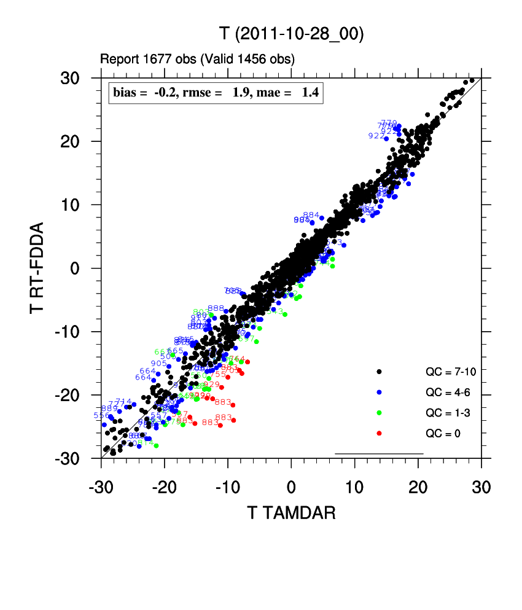

- Development of hybrid data-assimilation scheme for 4DWX (multi-year effort)
Report: The RTFDDA-3DVAR hybrid system with radar data assimilation for ATC is now being continuously evaluated in a real-time environment. Upgrades of the radar assimilation module into the more general RTFDDA framework have been done and are currently being tested. Discussions between the research team and the operation engineering team have been conducted to lay out a path for operational implementation. We are discussing whether and how to release a preview product to forecasters in the next several months.
For the next-generation 4D-REKF (4-Dimensional Relaxation Kalman Filter data assimilation) development, we are testing and tracking down bugs in the new code for the Kalman gain. We are still planning how to incorporate 4D-REKF into WRF V3.3.1.

- Demonstration of E-4DWX at ranges other than DPG
Report: No work.

- Refinement of E-4DWX perturbation schemes
Report: No work.

- Extension of E-4DWX calibration to more variables and to full model grid (multi-year effort)
Report: No work.
- Operational implementation of MODIS-based SSTs and LSTs in 4DWX
Report: Problems with the Python scripts have been solved and composites of LST for the Great Salt Lake are now being generated. The WRF Model is now being modified to accept updates to the LST and SST fields during execution. For the current implementation of LSTs and SSTs, fields are fixed at the start of a simulation.

- Other general improvements to 4DWX
Report: No work.

- Exploration of LES modeling at one or more ATEC ranges
Report: We have started to collect and reformat the high-resolution terrain and land-cover data for CRTC. Those data are separate from those for the conterminous U.S. We will start real-time WRF-RTFDDA-LES experimental modeling and assessment with the new data for the ATC and DPG test regions for 2 weeks to 1 month when the new HPC-II is set up at DPG.

Auto-Nowcaster and convective weather forecasting
- Installation of full ANC at RTC
Report: The ANC installation at RTC was accomplished in March. We are continuing to push satellite and surface data (from projects at NCAR) to the RTC ANC since the NOAAport still seems to have data outages, and we continue to tune the ANC based on selected cases.

- Implementation of probabilistic forecasts of lightning at WSMR and RTC
Report: Wiebke is continuing to evaluate the short-term and longer term model-based RTC lightning-potential forecast. The 4DWX-RTC sensitivity tests to the microphysics scheme (i.e., Thompson vs. Lin et al.) are underway. Chris Schultz, visitor from University of Alabama-Huntsville, left in early September but we plan to continue our collaboration on the LMA lightning jump algorithm (as an indicator for sever weather).
- Maintenance and operational support of ANC and related tools at WSMR and other ranges
Report: Niles Oien left NCAR on September 15. Dan Megenhardt has assumed lead software engineering duties. Sue Dettling has joined our team as a backup software engineer and has begun to familiarize herself with ATEC. Dan has been familiarizing himself with the other ranges, learning their systems. He has made changes to the RTC data push and data archival to remove Niles’ accounts and put them into his own. He has corrected a data backup problem, made updates to Sysview diagrams at WSMR and RTC, is working to document image generation processing and data distribution at the ranges, and has modified the script that transfers WSMR Sysview diagrams to NCAR to be at 5 minutes intervals instead of 10 minutes.

Model validation and verification
- Development of more sophisticated, user-friendly methods of model verification
Report: No work.
- Operational verification of E-4DWX
Report: No work.
- Development of a simple graphical tool for viewing 4DWX’s verification statistics
Report: The liaison is now engaged with the engineering and scientific staff to firm up the design requirements for the tool.
- VV&A of the WRF-based 4DWX to satisfy army requirements
Report: No work.

Tasks funded through other sources but leveraged to benefit ATEC-4DWX project
- Use of 4DWX or E-4DWX to support forecasting at Cape Canaveral. (Currently unfunded and indefinitely on hold.)
Report: No work.

Hardware, operating systems, and security
- Expansion of data storage
Report: Latest expansion is completed.

- New desktop and laptop computers for project staff
Report: None.

- Consolidation of operational 4DWX hardware
Report: Completed.

- Purchase and maintenance of R&D clusters at NCAR
Report: A new server was purchased for DAS development and testing to replace several aging systems that were out of warranty. The new system is identical to the recently replaced DAS machines and will enable quicker DAS development and testing on a platform that is fully compatible with the operational systems.
- Purchase and maintenance of DAS hardware and miscellaneous upgrades to DAS software
Report: New DAS hardware was purchased and delivered to NVL. Installation and configuration of the new systems is on hold pending resolution of requirements to meet ATO rules at NVL.

Management
- NCAR’s project management
Report: No change.

Administration and miscellany
  - Articles, posters, and talks
Report:

- Articles published
  - None

- Articles accepted and in press
  - Delle Monache, L., T. Nipen, Y. Liu, G. Roux, R. Stull, 2011: Kalman filter and analog schemes to post-process numerical weather predictions. Conditionally accepted on Monthly Weather Review.
- Articles in revision based on reviews
  - Hirschberg , P., Abrams, E., Bleistein, A., Bua, W., Delle Monache, L., Dulong, T., Gaynor, J., Glahn, B., Hamill, T., Hansen, J., Hilderbrand, D., Hoffman, R., Morrow, B., Philips, B., Sokich, J., Stuart, N., 2011: A weather and climate enterprise strategic implementation plan for generating and communicating forecast uncertainty information. Bulletin of the American Meteorological Society, conditionally accepted.
- Articles in external review
  - None.
- Articles submitted
  - None.
- Articles in internal review
  - None.
- Articles in preparation
  - Hirschberg , P., E. Abrams, A. Bleistein, W. Bua, L. Delle Monache, T. Dulong, J. Gaynor, B. Glahn, T. Hamill, J. Hansen, D. Hilderbrand, R. Hoffman, B. Morrow, B. Philips, J. Sokich, and N. Stuart, 2011: A weather and climate enterprise strategic implementation plan for generating and communicating forecast uncertainty information. To be submitted to the Bulletin of the American Meteorological Society.
  - Hopson, T. M. and J. P. Hacker, 2011: Combined approaches for ensemble post-processing, Mon. Weath. Rev., in process idea: application of quantile-regression approach to NOAA Reforecast temperature ensembles over Utah.
    - Status: Recalculations nearly complete.
  - Hopson, T. M., Assessing the ensemble forecast spread and skill relationship, Mon. Weath. Rev., in process.
    - Status: rewriting text and including material from 2 new references

  - Article on cold air damming at ATC and sensitivity of forecasts to PBL and microphysics schemes
  - Liu, Y., J. C. Knievel, T. M. Hopson, S. F. Halvorson, J. C. Pace, G. Roux, W. Wu, J. P. Hacker, S. E. Krippner, T. T. Warner, and S. P. Swerdlin, 2012: Mesoscale ensemble weather prediction at Dugway Proving Ground. Mon. Wea. Rev., in preparation
  - Liu, Y. , L. Pan, Y. Wu, A. Bourgeois, T. Warner, J. Knievel, S. Swerdlin, J. Pace, S. F. Halvorson, and F. Gallagher, 2012: The NCAR 4DREKF ensemble data assimilation and forecasting system: Part 1: System description and validation. Journal TBD, in preparation

  - Wu, Y., Y. Liu, L. Pan, A. Bourgeois, J. Knievel, T. Warner, S. Swerdlin, S. F. Halvorson, J. Pace, and F. Gallagher, 2012: The NCAR 4DREKF ensemble data assimilation and forecasting system: Part 2: Sensitivity of the critical/control parameters. Journal TBD, in preparation
  - Pan, L., Y. Liu, Y. Wu, A. Bourgeois, J. Knievel, T. Warner, S. Swerdlin, S. F. Halvorson, J. Pace, and F. Gallagher, 2012: The NCAR 4DREKF ensemble data assimilation and forecasting system: Part 3: A Proxy without running ensemble. Journal TBD, in preparation
- Presentations (no order)
  - None

APPENDICES
- Acronyms
4DWX Four-Dimensional Data Assimilation and Forecast System
4DWXDB 4DWX database
AGU American Geophysical Union
AMS American Meteorological Society
AP Anomalous propagation
ATEC U.S. Army Test and Evaluation Command
ATC Aberdeen Test Center
AUSA Association of the U. S. Army
CAC Common Access Card
CAD Cold-air damming
CFDDA Climate FDDA
CIDD Configurable Interactive Data Display
CMAQ Community Multiscale Air Quality Model
COAMPS Coupled Ocean/Atmosphere Mesoscale Prediction System
COLIDE Convergent Line Detection program
CoN Certificate of Networthiness
CRTC Cold Regions Test Center
CVS Concurrent Versioning System
DART Data Assimilation Research Testbed
DAS Data Acquisition Server
DPG Dugway Proving Ground
EPG Electronics Proving Ground
ERTFDDA Ensemble-RTFDDA
GMOD Global Meteorology on Demand
GPU Game processing unit
GSL Great Salt Lake
HPC High performance computer
HPCMP HPC Modernization Program
HPSS High Performance Storage System
IPR In-process review
ITAR International Traffic in Arms Regulations
KB Knowledge Base
LMA Lightning mapping array
LHN Latent-heat nudging
LST Lake-surface temperature
MIR Meteorological Information Repository
MIPR Military Interdepartmental Procurement Request
MODIS Moderate Resolution Imaging Spectroradiometer
MODTRAN Moderate resolution atmospheric transmission
MSFC Marshall Space Flight Center
MSRC Major Shared Resource Center
MYJ scheme Mellor-Yamada-Janjic
NAPS Noise Assessment and Prediction System
NASA National Aeronautics and Space Administration
NBA Nonlinear backscatter and anisotropy
NCAR National Center for Atmospheric Research
NCEP National Centers for Environmental Prediction
NLDN National Lightning Detection Network
NRL Naval Research Laboratory
NSAP National Security Applications Program (within NCAR RAL)
NSF National Science Foundation
NVL Night Vision Laboratory
NWP Numerical weather prediction
PBL Planetary boundary layer
R&D Research and development
RAL Research Applications Laboratory
RTFDDA Real-Time Four-Dimensional Data Assimilations system
RTC Redstone Technical Test Center
SST Sea-surface temperature
STAR Inst. Science and Technology in Atmospheric Research Institute
STEP Short-Term Explicit Prediction
UAH University of Alabama at Huntsville
UF Universal format
USWRP U.S. Weather Research Program
VLAS Variational Lidar Analysis System
VDRAS Variational Doppler Radar Analysis System
WRF model Weather Research and Forecasting Model
WSMR White Sands Missile Range
YPG Yuma Proving Ground
YSU Yonsei University

- Safari missions
Report:

Requester: WSMR
Dates: Existing SNI configuration turned off early September
Location: San Nicholas Island, California
Type: WRF 3.2, 3 domains
Special needs: Support for rocket launches.

Requester: WSMR
Dates: Existing PMRF configuration turned off early September
Location: Kauai, Hawaii
Type: WRF 3.2, 4 domains
Special needs: Support for rocket launches.

Requester: WSMR
Dates: Existing MLPH configuration adjusted for new ship locations and upgraded to WRF 3.2, running through September
Location: West of Kauai - Hawaii
Type: WRF 3.2, 3 domains
Special needs: Support for rocket launches.

Requester: WSMR
Dates: New configuration to support beginning/end of MLP run, running through September
Location: Pearl Harbor - Hawaii
Type: WRF 3.2, 4 domains
Special needs: None.

