OTREC EOL In-Field Data Sharing
NCAR/EOL provides storage options for instrument data collected during field projects. The storage is made available throughout the duration of the field-phase so there is a backup of data in the field and on an NCAR server. You can access the storage locations on the Network Attached Storage (NAS) by connecting to the Ops Center Network in the field.

There are two options for this storage:
- Field storage only on the Network Attached Storage (NAS).
- Field storage on the NAS and in a project FTP location which allows access to anyone with an internet connection and credentials. The project FTP location will be available for a period of time after the project ends, but is not meant for long-term data storage / archive. Please complete the Field Data Requirement survey for each dataset that you expect to generate, so that we can anticipate dataset size, your preference for syncing from the NAS to the project FTP location, and your preference for archiving datasets after the project ends. If you prefer to have your dataset archived, we request that you provide appropriate metadata for each dataset after the project ends. If you have any questions regarding this, please email:

The directory structure on the NAS looks like this:
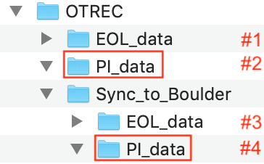

If you wish to store your instrument data only on the NAS, please place your datasets in: /OTREC/PI_data (#2)

If you wish to back up your instrument data on the NAS and have the files sync to the FTP location for the project, please place your datasets in /OTREC/Sync_to_Boulder/PI_data (#4). Once your data is in this location on the NAS, it will automatically sync to the FTP location where it will be accessible using the following credentials.

ftp.eol.ucar.edu
/PI_data

Username: otrec
Password: tr0pics!

Note: There are no restrictions placed on whether you want to create a sub-folder by instrument, format, or other criteria in /Sync_to_Boulder/PI_data. All folders and files under /Sync_to_Boulder/PI_data will sync to the FTP location. RAF creates the /Sync_to_Boulder/PI_data folder, but does not create further folders. The /RAF_data folders contains the aircraft data, for your reference during the project.

