How to Make and Save Revisions

to the

CARMA GitHub Repositories
A Work in Progress

Basic Information

There are two CARMA repositories in GitHub:

- CARMA_base https://github.com/ESCOMP/CARMA_base
This is the repository, or repo, for the CARMA model core source code, used in CESM, specifically in CAM. Changes to the main code are pushed to this repo which presently has a main (default) branch (and possibly other experimental branches.)

- CARMA “stand-alone” https://github.com/ESCOMP/CARMA/
This is the repository for the stand-alone regression tests of the CARMA model core source code, and the self-generated HTML documentation. It has a single default branch, main, and points to the CARMA_base repo for the source code in the source/base directory.
For more information on the CARMA stand-alone regression tests see:

- The README on the CARMA stand-alone page

- How to run stand-alone CARMA regressions test on the CARMA wiki

Get Help on Git

The Linux man page for help on Git, invoked by typing either

man git
or
git help git

Either will present detailed information about Git.

You can also access help on Git by typing:

git help

To get help on any Git command or to see what options to the command are available, add the command name:

git <command> --help

git help <command>
or
man git <command>

Any of these will give you Linux man page-type help. You do not have to be in your local Git repository to use these commands.

Some Online Git References

Some online references on the basics of using Git are:

- The ESCOMP/CAM wiki Git and Github page
Provides links to Git tutorials and references, and information about setting up your Git environment.

- Git Reference (https://git.github.io/git-reference/ )
“[M]eant to be a quick reference for learning and remembering the most important and commonly used Git commands”

- Git Cheat Sheet (https://education.github.com/git-cheat-sheet-education.pdf)
“[F]eatures the most important and commonly used Git commands for easy reference.”

- Basic Git Commands (https://www.hostinger.com/tutorials/basic-git-commands)
Lists basic Git commands with basic information on each and examples on their use.

Some Basic Git Commands

Some basic Git commands with and a few options in no particular order:

- git status - show the status of your working tree
    - -v: be verbose

- git branch - list , create, or delete branches in your clone
    - -a: list both local and remote tracking branches
    - -d: delete branch named
    - -v: list all (local) branches

- git remote - manage the set of remote repositories that you track
    - -v: be verbose, show URL of remote after name

- git checkout - switch to another branch or restore working tree files

- git add - add (stage) a file or files to your next commit; new files must be staged in order for Git to know about and track them.
    - -v: be verbose

- git commit - commit your staged (added) content to your local repository
    - -a: stage all tracked files that have been modified or deleted
    - -m “<msg>”: use the given <msg> as the commit message

- git push - send commits in your local branch to the remote repository

- git fetch - download (fetch) branches and tags from the Git remote repository
    - -v: be verbose

- git merge - merge the fetched branch(es) into your current branch

- git reset - reset the index and the working directory to the last git commit’s state

- git restore - restore modified but not yet committed files in your working tree to last commit; changes are discarded (Note: new, experimental command)

- git diff - show changes between commits, commit and working tree, etc.

- git rm - remove files from the index and working directory
    - -r: allow recursive removal when a leading directory name is given

Make a Fork

If you plan to submit new code to the CARMA or CARMA_base repositories you will need to make a fork of the repo of interest if you do not already have one. You can have only a single fork of any one remote repository at a time.

  - Go to the online (mote) repository you wish to fork on GitHub and click the Fork “button” in the upper right corner of the page:

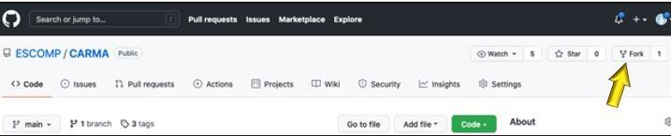

  - You will be asked where to make the fork; select your GitHub account if more than one choice is offered. Your new fork will include all the branches that are part of the parent repository.

Create a Clone

You will need to clone your fork to create a local copy of the repository on your Linux account; it is this local clone (local repo) where you will make your changes.

    - Create a clone of your fork in your account on cheyenne; this is where you will do your development work. Here we’re cloning a fork of the CARMA GitHub repository we made:

​​git clone --recursive https://github.com/<userid>/CARMA.git <clone>

where <userid> is your GitHub user ID and <clone> is the name you wish to give your clone as well as the name of the directory into which your fork is cloned. Note: <clone> is optional, but if you do not provide a name your clone and directory will be named CARMA.

    - Connect your local repository, the clone you just created, to the remote CARMA repo:

cd <clone>

git remote add ESCOMP https://github.com/ESCOMP/CARMA.git

    - Download the existing remote GitHub repository to your local repo:

git fetch ESCOMP

Create a Branch in Your Clone

- Create a branch in your clone and set it to track the remote branch main from the remote ESCOMP repository:

git branch <branch> ESCOMP/main

Where <branch> is the name you give your new branch. The second argument, ESCOMP/main is where on the repository “tree” your branch begins.

- Switch to your new branch:

git checkout <branch>

You’re now ready to make modifications in your branch on your local repository.

MakeYour Modifications

Make modifications and/or additions to the code as you see fit, save the files and test your changes. Repeat this process until you’re satisfied with the changes you’ve made. You’re now ready to save the changes to your repository.

Save Your Changes to Your Local Repository

Saving your changes to your local repo involves three steps:

- Check to see what untracked changes you may have made

git status

An example of output from a git status command:

On branch kappa_dev
Your branch is up to date with 'myCARMAfork/kappa_dev'.

Changes not staged for commit:
(use "git add <file>..." to update what will be committed)
(use "git restore <file>..." to discard changes in working directory)
modified: source/base (new commits)

Untracked files:
(use "git add <file>..." to include in what will be committed)
build/
doc/f90doc/
run/
tests/bench/carma_kappawetrtest.txt

no changes added to commit (use "git add" and/or "git commit -a")

In this example you can see that the new file carma_kappawetrtest.txt in directory tests/bench/ is not yet tracked.

- Stage your new changes to be committed:

git add <new_file(s)>

Using the information in the “git status” example above you would type

git add tests/bench/carma_kappawetrtest.txt

to stage the new file. If you have more than one file to add you can type the file names sequentially on the same line; e.g.,

git add <new_file1> <new_file2> <new_file3> ...

Or you can add each one individually:

git add <new_file1>
git add <new_file2>
git add <new_file3>
etc, ...

If you want to stage everything you can do the following:

git add *

But be careful with this command: be sure that you want all of the files you’re about to add to be pushed to the remote repository. In the example above you would find that you’ve added all of the files in the directories build/, doc/f90doc/ and run/, files which don’t belong in the remote CARMA repository.

- Commit your changes:

git commit -m “<description of changes/reason for commit>”

where <description of changes/reason for commit> is a short commit message describing all the changes in this commit. To enter a longer message, omit the m and the “<description of changes/reason for commit>”:

git commit

Depending on how you’ve set up your Git environment, an editor window should open that allows you to enter a longer, more detailed message than is possible using the first version, above.

Another option that allows you to write a longer message, as well as to edit you message, is to create a text file <filename> in which you put your commit comments, then use the -F option:

git commit -F <filename>

Your changes have now been committed to your local repository, but not to your fork. Before your changes can be added to the CARMA repository you will first need to push them back up to your fork.

Before pushing your changes back to your personal CARMA fork you will need to bring your branch in your local repository up-to-date with the remote upstream repository. You may also need to update your fork on GitHub.

Bringing Your Local Branch Up-to-date

First, an optional step to create a “shortcut”:

- Tell Git to get all the contents of the upstream repository:

git fetch https://github.com/ESCOMP/CARMA

If you will be updating your local branch frequently or working in this or other branches from your fork in the future you should consider adding a remote for the CARMA repository. Here, we’ve added remote we called upstream:

git remote add upstream https://github.com/ESCOMP/CARMA

Now the git fetch command can be shorter with less likelihood for typing mistakes:

git fetch upstream

- Next, make sure you’re on the correct branch in your local repository:

git checkout <your branch>

- And, finally, tell Git to look in the contents of your local copy and merge it with the contents of CARMA_base:

git merge ESCOMP/CARMA_base

Your working branch in your local repository is now up-to-date with the upstream remote repository.

Push Your Changes to Your Fork

- To push your changes to your fork; type:

git push <origin> <branch>

where <branch> is the name you gave your branch and <origin> is the name of the source repository; here, your personal fork. The default name is ‘origin’, so, if you have not renamed origin, you can type

git push origin <branch>

You will be asked for your GitHub userid and password.

- If you don’t remember the name you gave your branch, before you issue the push command, type

git branch

You should see output similar to this:

* new_feature
master

The branch you are working in is denoted by the asterisk. In this example, the branch in use is new_feature.

- If you want to push your entire (new) branch from your local repository up to your fork to create a new branch in your fork which mirrors the one in your local repo, add the -u option to your push command:

git push -u <origin> <branch>

For example,

git push -u <origin> new_feature

This will create a new branch in your fork named new_feature identical to the branch of the same name in your local repo. The -u option will “add upstream (tracking) reference…” (from git push –help.)
Note: You will be asked for your GitHub user ID when you issue the git push command.

You must get approval of the changes you’ve pushed to your fork before they can be merged into the CARMA code. To do this, you will need to open a pull request or PR.

Open a Pull Request (PR)

- In your fork on GitHub, check that your changes have been uploaded to your CARMA fork. If you are on a branch of your fork, back out so that you see a list of your branches:

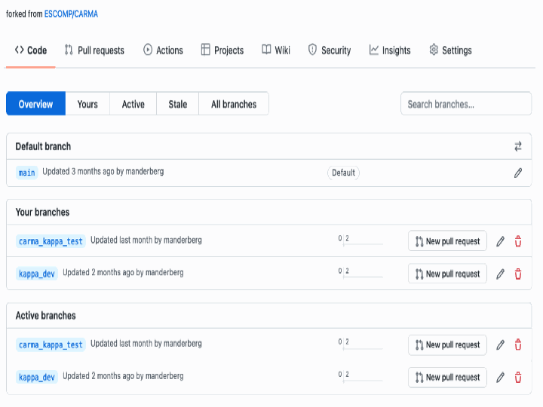

- Select the the branch for which you you want to initiate a new Pull Request (PR), and click the “New pull request” button to the right of it:

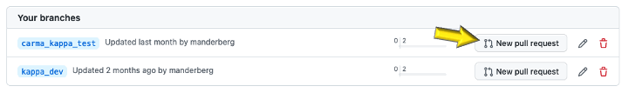

You will get a page similar to this:

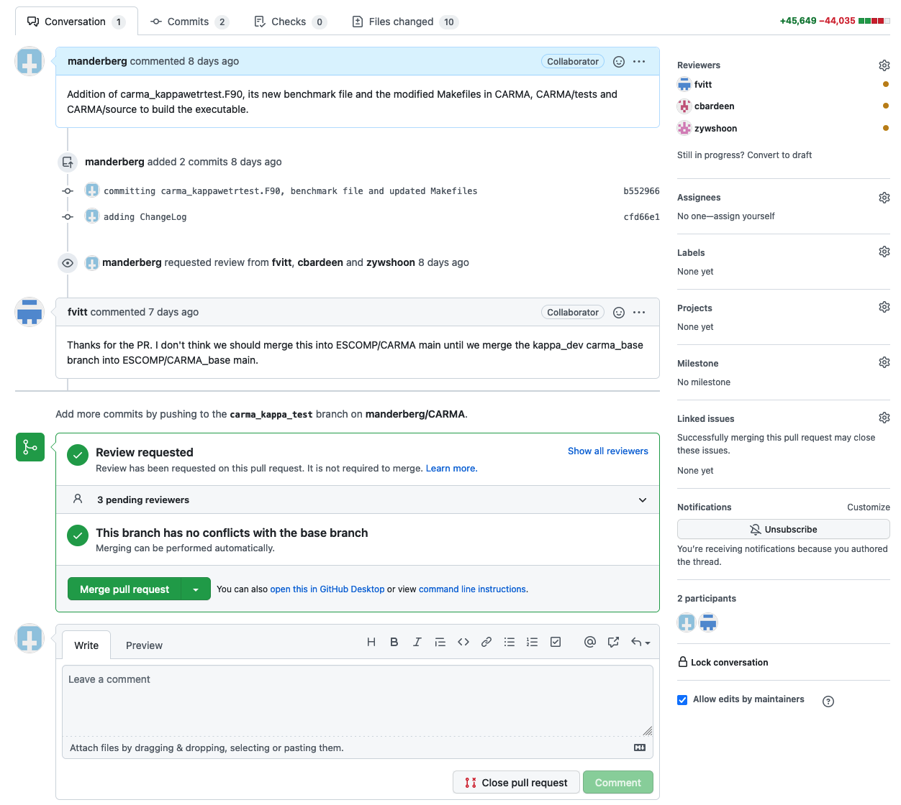

- Click on the “gear” in the upper right hand corner to select reviewers for your PR:

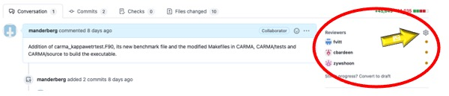

- At the bottom of the PR page is a space to leave a comment about your pull request.

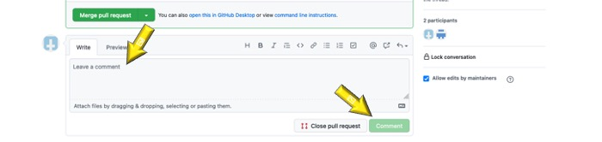

- Near the bottom of your pull request page is a panel similar to this one summarizing how many changes have been requested by your reviewers before the PR can be approved.

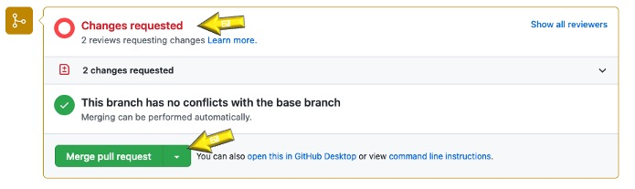

This icon in the upper left hand corner of the panel will turn green when all
requested changes have been made and your pull request approved.

Once your pull request has been approved you can click the Merge pull request button.

