Image Processing Technique Incorporated Into the CoMP-S Solar Coronagraph
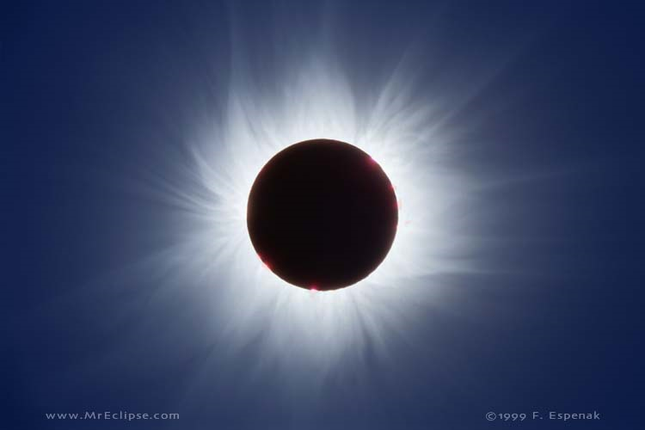
Abstract
Coronal mass ejections pose a potentially crippling threat to communications infrastructure, yet little is known about the solar corona. A myriad of inquiries surround it ranging from the origins of these mass ejections to the mechanisms involved in coronal heating. Ground-based coronagraphs compete with their satellite-based counterparts for cost-efficiency and image quality. Unfortunately, Earth’s atmosphere and optical defects lower the standards of many ground-based instrumentation. New technologies will allow us to remove these defects and analyze our parent star from the comforts of home. We have utilized LabVIEW to create image calibration and analysis algorithms to be used in conjunction with a new type of coronagraph. Our algorithms were able to remove defects associated with our atmosphere as well as the optics themselves. The superiority of satellite-based instrumentation will be no more compared to equally capable and cheaper ground-based arrays.

Keywords
Corona, coronagraph, data reduction, image processing, LabVIEW, polarimeter

1.0 Introduction

Understanding the sun is tantamount to our understanding of its influences on Earth in terms of space weather. The outer region of the sun, known as the corona, is of particular concern since it is the solar component that most affects us. The sun always emits energy, hence the presence of life on Earth; however, it periodically releases extreme quantities of energy. Coronal mass ejections emit billions of megatons of energy into space, and if this energy should strike our satellites, communication networks may be destroyed. Current observational techniques include both orbiting satellite as well as ground-based coronagraphs. A coronagraph is an instrument that produces a false eclipse allowing for analysis of the sun’s corona. My project is to develop a set of image calibration and analysis algorithms for a newly available Scientific Complementary Metal Oxide Semiconductor (sCMOS) based array detector that will be interfaced with a ground-based coronagraph.
Satellite-based instrumentation requires significant financial investment due to positioning; however, both satellite and ground-based methods succumb to defective imagery. One limitation of a ground-based instrument compared to its satellite counterpart is the depth of the atmosphere. Scattering of radiation due to the atmospheric composition and the presence of aerosols renders satellite-borne instruments imperative to properly study the coronal structure and properties (MacQueen et al. 1974). Another limitation of our project is to overcome image defects due to instrumental polarization and thermal agitation of electrons (dark current). Our goal is to utilize the calibration and analysis algorithms to mitigate the influences of these defects and atmospheric aerosols on coronagraph imagery as obtained from the surface. The presence of aerosols is simulated in previously acquired sample images and the knowledge we expect to attain will revolutionize Earth-based observation of the solar corona by resolving the fundamental setbacks associated with such technology. The ability to overcome the obstacles presented by our atmosphere will certainly prove cost-effective in future research.
The sCMOS detector is an integral part of a birefringent filter instrument being developed by NCAR’s High Altitude Observatory (HAO). This instrument will be deployed to the Lomnicky Peak Observatory in Slovakia at the end of March 2011 where it will be interfaced to an existing 20cm coronagraph built by the Zeiss Corporation from Germany. In addition, the detector will make high resolution (5.5 megapixel images at the diffraction limit of the coronagraph), and high cadence (30 frames per second) observations of the entire solar corona between ~1.1 and 2 solar radii at wavelengths between 540nm and 1083nm.
Once the array detector is interfaced with the existing coronagraph, this instrument, the Coronal Multichannel Polarimeter – Slovakia (CoMP-S), will allow investigators to directly address two of the most important problems of the solar corona: (i) how is the solar corona heated and (ii) how and where do coronal mass ejections occur? Both of these scientific questions require 2-D maps of coronal magnetic fields at high spatial resolution. Furthermore, these magnetic fields are dynamic and high cadence measurements are required to resolve their changing structure.
Until recently, camera technology could provide either high resolution or high frame rates but not both in the same package and usually not with the low levels of noise required for scientific grade images of the corona. sCMOS technology, with its megapixel array size, 50 frames per second readout rates with a global shutter and 2-3 electrons of read noise, will provide a quantum leap in solar observation science if the technology produces on its promises.
The calibration algorithms created will promote optimum efficiency and allow complete analysis of these images. The premise behind developing proper image processing technique is to facilitate constructing and operating the solar coronagraph, CoMP-S. CoMP-S will be a stand-alone coronagraph operated by Slovakia modeled on the current Coronal Multichannel Polarimeter (CoMP) (Tomczyk et al. 2008). The functional capabilities of both devices seek to improve understanding of solar coronal heating (Tomczyk et al. 2007).
The solar temperature profile cannot be explained in the same fashion as Earth’s profile due to deviations in their respective compositions and the influence of the vacuum of space. Inversions, regions where temperature increases with altitude, on the Earth’s profile can be explained by chemical reactions occurring in the atmosphere such as the photodissociation of ozone which releases heat. However, such reactions do not occur in the solar corona and cannot explain the massive inversion between the solar photosphere, or surface, and the corona. In addition to understanding solar coronal heating, the CoMP-S device will be able to further our understanding on ejections of coronal mass from the sun that ultimately interfere with our satellite communications (MacQueen et al. 1980) after the obtained images have been processed by the calibration and analysis algorithms.
2.0 Literature Synthesis
Images obtained from such highly sensitive electronics often become subject to noise interference. Noise is any unwanted electrical signal that interferes with the image being read and transferred by the imager. Keller (2000) details the noise that images experience due to instrumentation errors. These errors are particularly prevalent in highly sensitive solar observations such as our CoMP-S coronagraph. Keller presents a wide array of potential culprits; however, instrumental polarization is of most interest to our project for the reason that it is the most challenging defect to correct. Instrumental polarization may be caused by the optics of the instrument, temperature dependence, and polarized scattered light. The motivation behind our selection of sCMOS Camera was partially influenced by the manufacturer’s claim that it would overcome the polarization issues of other camera types. This claim has been thoroughly tested by Scott Sewell and Steve Tomczyk via light transfer curves and Quantum Efficiency tests. The claim was found accurate enough to select the camera for incorporation into the instrument. However, to ensure minimal interference as a result of polarization, the instrumentation will be cooled to low temperatures to mitigate the temperature dependence factor (Keller 2000).
Despite careful considerations regarding the instrumentation, the images obtained from an optical device contain defects that must be calibrated to ensure quality during final data extraction. Howell (2000) provides a detailed examination of the various image defects that occur. One such defect comes from Dark Current that originates due to the thermal noise that all objects contain unless they are at absolute zero. As long as molecular motion can still occur, albeit slowly, the material will contain minimal thermal energy. If the thermal agitation is strong enough, electrons become excited and gain kinetic energy resulting in their incorporation into the image signal. The term Dark Current refers to the principle that electric current consists of moving electrons.
Image bias is another defect that may trace its origins to variations among pixel gain, or Quantum Efficiency (Howell 2000). Individual pixels that comprise an entire image may be more or less efficient at converting photons into electrons relative to an adjacent pixel. An additional source of pixel gain error may result from the lack of uniform light exposure. Individual pixels may be exposed to more or less light than another which would also result in an image containing bias.
Berry and Burnell (2000) provide a method for performing data reduction that we intend to follow; however, we will be forced to make adjustments specific to coronal photography since their work applied to nighttime astronomy. The suggested method uses dark frame subtraction so that subsequent flat field corrections may be formed with greater ease. Dark frames are composed of two components; a thermal signal accumulated at a temperature dependent rate containing the dark current, and a zero-point bias which is essentially a dark frame taken with zero exposure time to prevent the accumulation of dark current. Flat fields are images obtained that consist of uniform illumination of every pixel by a light source of identical spectral response to that of your object frames (Howell 2000). Due to variations in pixel gain, or Quantum Efficiency, flats allow for corrections by measuring pixel efficiency in response to a flat, or uniform, field of light. Flat fields require an image of a uniform low-level light source that fills half of the camera’s dynamic range (Berry and Burnell 2000). Flat-fields are challenging because their signal is often subtle and difficult to isolate, which explains our intention to follow Berry and Burnell’s example to apply that correction in the final stages of image processing.
After we obtain the necessary reference frames to calibrate our images, the remainder of the work will be completed via the program LabVIEW. Utilizing this virtual instrumentation program, I will be responsible for performing the necessary data reduction corrections. Subtracting dark frames from the actual image will negate the influence of dark current from the final product. Averaging flat fields with the image will ensure a near uniform Quantum Efficiency range for the entire image. It will minimize the presence of overly bright spots, or “hot” pixels and cool spots, or “dead” pixels. It is our hope that following Berry and Burnell’s example will promote the most effective methods.
3.0 Data & Methods

LabVIEW
- Dark Frame Subtraction

- Algorithm Steps
- Load a TIF Image File from computer
  - One should be the initial image while the other should be the dark frame
- Display individual pixels of images
- Perform Statistical Analysis on image pixels
- Subtract dark image from initial image (heart) on pixel-by-pixel basis
- Perform Statistical Analysis on the resulting image pixels
- Reload image from pixels
- Images
- Q Drive\CoMP-S\Tests\pco.edge Camera Tests June 2010\pco.edge Camera tests 01-june-2010
- Use 10 ms bullseye 01-june-2010
- 10 ms lens cover on –room lights off.tif

10 ms bullseye (Bullseye & Histogram)

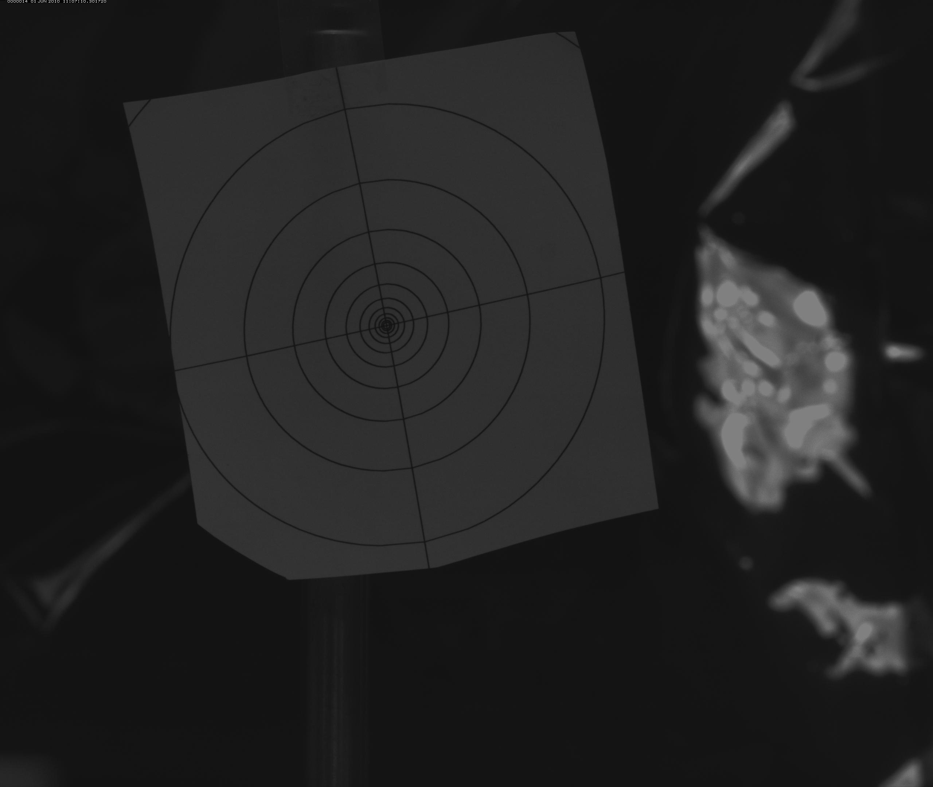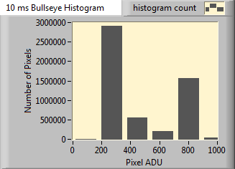

10 ms lens cover on – room lights off (Dark & Histogram)

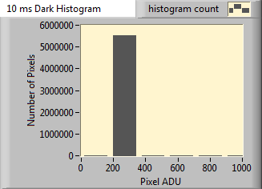

(Bullseye – Dark & Histogram)

- Flat Field

- Algorithm Steps
- Load a TIF Image File from computer
  - One should be the initial image while the other should be the flat taken under uniform illumination
- Display individual pixels of images
- Perform statistical analysis of image pixels
- Divide initial image by its flat image to obtain flat field image
- Perform statistical analysis of image pixels
- Reload image from pixels

- Aerosol?
- Polarization?

Two different cameras were utilized to obtain images and compare data reduction (image processing, transformation of raw data into a more useful form) techniques. The first camera was the sCMOS PCO.Edge that will be used with the actual coronagraph. Its resolution is 2560 x 2160 pixels; the maximum frame rate is 100 frames per second (fps); the readout noise is less than 3 electrons at 100 fps (less than 2 electrons at 30 fps); the dynamic range is 14-bit and the pixel size is 6.5 x 6.5 μm² (square microns). [Obtained from manufacturer’s website] This device is currently on the leading edge of available technology. The second camera utilized was the more modest CMOS Photon Focus (Model Number MV-D1024E-160-CL-12). Its resolution is 1024 x 1024 pixels, with a maximum frame rate of 150 fps; dynamic range is 12-bit and the pixel size is 10.6 x 10.6 μm². [Obtained from manufacturer’s website].
The cameras were used to obtain their own unique image data sets (compilation of different types of images) for later manipulation. Each data set consisted of a number of target frames (images of the desired object), dark frames (images with the shutter closed to prevent all light from entering), and flat frames (images of uniform illumination). The target frames of the sCMOS PCO.Edge detector captured a fake print-out of a solar eclipse thus allowing the surrounding corona to be seen. The presence of aerosols was simulated in these target frames by sprinkling oatmeal and salt in front of the image while the detector was acquiring the images inside of the High Altitude Observatory Instrumental Group Optics Lab (HAOIG). The exposure of the 423 images obtained over 60 seconds (s) was set at 33 milliseconds (ms) which is equivalent to 30 Hertz (Hz). The target frames of the CMOS Photon Focus camera were actual aerosols of cottonweed as illuminated by the sun obtained outside during a clear afternoon in Boulder, CO. In the sample data set, 1000 images were obtained at an exposure of 33 ms as well. [See Figure 1].
The bias frames (dark frames and flat frames) were acquired specifically for each image data set. The only bias frames obtained for the sCMOS detector were the dark frames due to time restraints. The lens cap was placed on the camera, and the room was made pitch black for the dark frames. The door was shut, the lights turned off, and the computer monitor shut off to eliminate all sources of light pollution. The dark frames obtained must be the same exposure as the target images they will be subtracted from (Berry and Burnell 2000). In our case, this would require an exposure time of 33 ms. [See Figure 2].
The bias frames obtained from the Photon Focus device consisted of both dark frames and flat frames. Since there were 1000 target images, 10 dark frames would suffice to subtract the bias presented by dark current. Based on this multiplicative factor of 10, the number of flat frames to be obtained was also set at 10. In order to obtain a flat frame, the lens of the detector must receive a uniform light output (Berry and Burnell 2000). Every pixel in the detector must receive the same amount of light as any other. The uniform dispersion of light was achieved via an Opal Diffuser. This piece of glass is coated with opal to cause a large amount of scattering loss. The result is a uniform distribution of photons reaching a detector, such as the CMOS camera. The diffuser is placed at the end of the lens and the images obtained are the flat frames to be used for later calibration.
To perform the image calibrations and correct for bias, LabVIEW 2009 was utilized to create algorithms capable of performing data reduction procedures. Performing any type of math or analysis on an image requires first converting the image into an array of its pixels. An array is a 2-dimensional grid of an image’s pixel values based on its resolution. The easiest method to perform this conversion was to save the acquired images first as binary files. Then using LabVIEW, these Binary files can first be converted into 1-D arrays and subsequently into the required 2-D arrays. A LabVIEW programming structure known as a For Loop allowed all the files specified by the user in a particular directory to undergo the same processing to allow for time efficiency, a necessity when converting over 1000 images.
Once the arrays were obtained, the first step in the data reduction process of dark frame subtraction commenced. First, an average dark frame array was created from all the dark frame arrays. This was necessary to obtain a Master Dark Frame Array (MDFA), an image array that will be subtracted from the initial target image arrays. After the positioning of another For Loop, the MDFA was subtracted from all of the initial target image arrays. The resultant arrays were then saved for later usage in the second procedure and converted back into images for observational analysis. LabVIEW was highly efficient at facilitating all conversion needs.
The second procedure of flat field division involved a similar approach. The acquired flat frame arrays were averaged together to create a Master Flat Frame Array (MFFA). The resultant image arrays from the first procedure were then divided by the MFFA. In an identical fashion, a For Loop ensures that all of the images are processed via the same methods. These new resultant arrays are then saved for later usage and converted back into images for observational analysis.
The last stage in the data reduction procedure specific to the coronagraph was the removal of aerosol pollution in the images. Dark frame subtractions omit thermal noise from the detectors. Flat field divisions ensured a uniform light distribution. However, neither method was sufficient enough to combat the natural constituents of our atmosphere. A new, three-pronged method was applied to the post-processed image arrays.
This new method converted our pre-processed arrays into three new arrays that were later analyzed. Each of the new arrays was derived using LabVIEW from the same initial, post-processed array. The first new array, known as the Minimum Array (MINA) took the minimum value of all the previous arrays and subjected those arrays to this threshold. Only the Pixel ADU values that were in agreement with this minimum array value would be displayed thus lowering the array’s dynamic range. The MINA was then converted into an image for later comparison. The second array, known as the Median Array (MEDA) operated in a similar fashion. The median of all the post-processed arrays was taken and then used as a threshold for the resultant, MEDA. The MEDA was also converted into an image for later visual analysis. The final new array created was the Average Array (AVGA). Average was substituted for mean to prevent acronym confusion. The AVGA was obtained after the post-processed arrays were averaged together and another threshold was utilized based on the mean array value. The AVGA was also converted into an image for later analysis.
All of the arrays obtained throughout the data reduction procedures were subjected to additional analysis. LabVIEW was utilized to produce histograms displaying the relationship between the Number of Pixels in an array in regards to the Pixel ADU. In addition, time series were constructed in which Pixel ADU was plotted against the Frame Number in order to observe any irregularities that appeared. Lastly, all arrays created were evaluated for their mean and standard deviation. This analysis produced quite an impressive display that will revolutionize the image processing community.

4.0 Results

Discussion (Alternate and Contrast)
- CCD vs. CMOS and why we used CMOS

Conclusion

Acknowledgements

Appendices

References (aka BIBLIO)

Tables & Figures

Bibliography
Berry, Richard, and James Burnell. The Handbook of Astronomical Image Processing. Richmond, Virigina: Willmann-Bell, Inc., 2000.
Elmore, David F., Joan T. Burkepile, J. Anthony Darnell, Lecinski Alice R., and Andrew L. Stange. "Calibration of a Ground-based Solar Coronal Polarimeter." Proceedings. Tuscon: The Society of Photo-Optical Instrumentation Engineers, 2003. 66-75.
Howell, Steve B. Handbook of CCD Astronomy. Cambridge: Cambridge University Press, 2000.
Keller, Christoph U. "Instrumentation for Astrophysical Spectropolarimetry." National Optical Astronomy Observatory 889 (November 2000): 1-52.
MacQueen, R.M., et al. "The High Altitude Observatory Coronagraph/Polarimeter On The Solar Maximum Mission." Solar Physics 65 (1980): 91-107.
MacQueen, R.M., J.T. Gosling, E. Hildner, R.H. Munro, A.I. Poland, and C.L. Ross. "The High Altitude Observatory White Light Coronagraph." Proceedings. Tuscon: The Society of Photo-Optical Instrumentation Engineers, 1974. 201-212.
Malherbe, J.M., J.C. Noens, and TH. Roudier. "Numerical Image Processing Applied To The Solar Corona." Solar Physics 103 (1986): 393-398.
Tomczyk, S., et al. "Alfven Waves in the Solar Corona." Science 317 (August 2007): 1192-1196.
Tomczyk, S., et al. "An Instrument to Measure Coronal Emission Line Polarization." Solar Physics 247 (2008): 411-428.

Stuff From Timeline Files
Image Processing – Data Extraction Timeline

- Image
  - Image is obtained from photography instrument (CCD)
  - Image details……
    - Inherent noise exists from the device itself
    - QE refers to ability to turn photons into electrons, 100% is ideal

  - Defects in images will occur such as hot pixels, variable QE that leads to deviations in pixel gain
  - Transition to Data Reduction → necessary to achieve high polarimetric sensitivity since raw data (image before calibrations have been applied) contain errors on the order of a few percent in fractional polarization and the expected signal is one or two orders of magnitude smaller than desired

- Data Reduction
  - Image is “cleaned” up in order to enhance the signal to noise ratio
    - NOISE
Noise - The same as static in a phone line or "snow" in a television
picture, noise is any unwanted electrical signal that interferes with the
image being read and transferred by the imager. There are two main types
of noise associated with CMOS Sensors:

Read Noise (also called temporal noise) - This type of noise occurs
randomly and is generated by the basic noise characteristics of
electronic components. This type of noise looks like the "snow" on a
bad TV reception.

Fixed Pattern Noise (also FPN) - This noise is a result of each
pixel in an imager having its own amplifier. Even though the design
of each amplifier is the same, when manufactured, these amplifiers
may have slightly different offset and gain characteristics. This
means for any picture given, if certain pixels are boosting the
signal for every picture taken, they will create the same pattern
again and again, hence the name.

Blooming - The situation where too many photons are being produced to be
received by a pixel. The pixel overflows and causes the photons to go to
adjacent pixels. Blooming is similar to overexposure in film photography,
except that in digital imaging, the result is a number of vertical and/or
horizontal streaks appearing from the light source in the picture.

  - Subtraction of dark current and bias
    - Dark Current refers to the movement of electrons due to thermal agitation of atoms (Berry and Burnell 2000). An alternative explanation is that due to heat energy, electrons become excited and gain kinetic energy, resulting in a current.
    - Bias by definition refers to a particular tendency or inclination (reference.com). A bias, or zero, image allows one to measure the zero noise level of a CCD (Howell 2000). The bias is our desire to achieve an image devoid of noise.
  - Division by flat fields
    - Flat fields are images obtained that consist of uniform illumination of every pixel by a light source of identical spectral response to that of your object frames (Howell 2000). Due to variations in pixel gain, or Quantum Efficiency, flats allow for corrections by measuring pixel efficiency in response to a flat, or uniform, field of light (Berry and Burnell 2000).
  - Calculation of fractional polarization Q/I, U/I, and V/I
    - Stokes Vectors, or parameters, are a set of values that describe the polarization state of electromagnetic radiation such as that we receive from the sun (????? Get source). The Stokes parameters I, Q, U, and V, provide an alternative description of the polarization state which is experimentally convenient because each parameter corresponds to a sum or difference of measurable intensities The Stokes vector spans the space of unpolarized, partially polarized, and fully polarized light. (Wikipedia).
  - Subtraction of polarization bias
  - Removal of polarized fringes
  - Calibration with polarization efficiency (polarization flat field)
  - If required, multiplication with calibrated intensity I to obtain, V, Q, and U
  - In order to formulate the best data reduction strategy, it is imperative to understand the instrumental impacts on the raw data so that they may be removed during image processing;
  - In order to determine necessary calibrations, it is imperative to base data reduction steps on physical model of data collection process; a theory of the observing process and a model of the instrument in which the theory may be solved for the parameters that should be determined as a function of the measured quantities

- Data Extraction
  - The image may now be analyzed for data; however, any observations must be supported by the raw data.

Info Obtained from the two CCD handbooks, the Keller Paper,
Flat Fields – My Own Words

The images obtained from most photographic devices contain an array of imperfections. These defects must be calibrated out to ensure the highest quality of analysis. One such error, non-uniform illumination, can result from two distinct sources. The first pertains to the actual environment in which the image was obtained. For example, a mostly cloudy day with partial peaks of sun may result in an image containing variable amounts of illumination. Reflection off of particular surfaces such as the metal on an automobile may also cause variations in illumination within a frame. The other source of variable lighting error is the pixels themselves. Each pixel has its own efficiency at which it can convert photons into electrons. This is known as Quantum Efficiency. Two pixels next to each other could possibly have differing Quantum Efficiencies which would result in an image with variable illumination. In order to correct this imperfection, a technique called flat-fielding, is often performed during the image processing, or data reduction, stage. A flat is an image obtained in which the optical instrument (camera) was exposed to a uniformly lit environment. As previously mentioned, this may be very difficult to obtain. A special device, known as an Opal, is effective at converting random rays of light into a uniform scattering of light. The camera lens would be positioned so that it looks only at the opal and subsequent light shining through. The obtained image, called the flat, now contains a near-uniform light distribution. The flat image may now be used to calibrate the actual image to account for the variable Quantum Efficiency of the pixels, as well as the variable environmental illumination. The actual calibration technique involves a pixel-by-pixel division of each initial image by its respective flat. This ensures an averaging technique that makes the bright areas due to dark current darker, and the dim areas due to lower Quantum Efficiencies brighter. This is only one of the many stages of data reduction that ensure high quality images for later analysis.

Dark Current – My Own Words

The images obtained from most photographic devices contain an array of imperfections. These defects must be calibrated out to ensure the highest quality of analysis. One such error, dark current, results from the thermal (heat) agitation of the electrons in the optical device. The primary heat source of dark current comes from the instrumentation itself. It is no secret that electronics must often be kept cool due to the heat generated by electricity. For example, computers have fan mechanisms that turn on at a certain temperature in order to protect the sensitive electronics. Optical instruments do have mechanisms that keep them cool; however, unless the molecules were kept at absolute zero, there will still be some thermal energy leaked. As this thermal energy comes into contact with the electrons of the image, they become excited and gain kinetic energy. Current is created whenever there are moving electrons, hence the term dark current. This current that occurs due to thermal agitation of electrons results in bright spots within an image. These bright spots are referred to as “hot” pixels. The technique to cure this image defect is known as dark frame subtraction. An image is taken with the lens cap on so that only the thermal noise component from the device (dark current) is captured. This image is then subtracted from the initial images, omitting the noise.
GLOSSARY

- Dark Current
- Dark Frame
- Hot Pixel
- Dead Pixel
- Pixel
- Flat
- Flat-field
- CCD
- CMOS
- CoMP
- CoMP-S
- Polarization
- Stoke’s Vectors
- Corona
- ?

Joan Email Timeline From K-Coronagraph
Detector calibration
Quantum Efficiency and spectral response
Bias/Dark
Gain: Non-linearity; response changes over time
Charge transfer efficiency (signal out/signal in)
Photon Transfer Curve to get electrons per ND; system noise and full well
Hot and dark pixels
Fixed patter noise (flat field)
Absolute photometry
Filter transmission curves
Transmission of lenses in optical train
Correct for chromatic aberrations
Calibration of opal diffuser
Daily calibration images: opal with and without polarization plates +
dark image
Removal of scattered light (sky + instrumental)
Scattered light test results (NVTF)
Sky polarization components: sin0, sin20
Sky polarization tangent to solar limb: HOW DO WE DETECT AND REMOVE THIS?
Vignetting Function
Determine Plate scale:
Measure focal length
Use height mask and hairlines?
Remove geometric distortion
Accurate knowledge of exposure time
Sky Transmission Telescope

