Image Processing Algorithms for Aerosol Removal in Solar Coronal Images
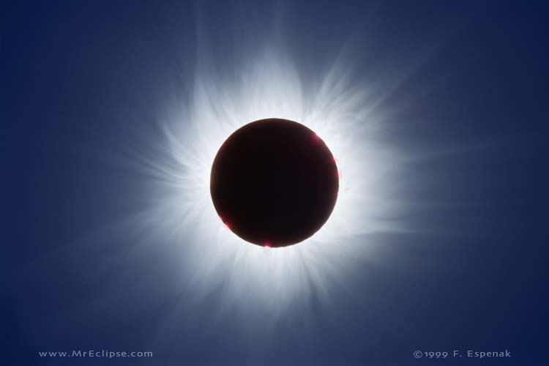
Abstract
Coronal mass ejections, which are explosions of solar material and energy into space, pose a potentially crippling threat to communications infrastructure, yet little is known about the solar corona. A myriad of inquiries exist, relating to the origins of these mass ejections as well as the mechanisms involved in coronal heating. The corona and coronal mass ejections are measured by satellite and ground-based coronagraphs, instruments that produce a false eclipse of the Sun, with cost-efficiency and image quality being crucial issues. Unfortunately, Earth’s atmosphere, optical defects, and the presence of aerosols limit the usefulness of images obtained from ground-based coronagraphs. New technologies will allow us to remove these defects and obtain higher quality images of the Sun’s corona from Earth-based platforms. We have utilized LabVIEW to create image calibration and analysis algorithms to be used in conjunction with a new type of coronagraph. First we calibrated two unique images from our data set; a mean and a median image. Then, we used these images individually to perform two thresholding applications on each; one spatially, the other temporally, in which we successfully removed the aerosols from our images. These techniques, performed in real time, will increase the effectiveness of ground-based coronagraphs in providing warning of incoming coronal mass ejections and understanding of the corona.
Keywords
Aerosols, corona, coronagraph, data reduction, image processing, polarimeter
Table of Contents
1.0 Introduction 3
2.0 Background 6
3.0 Data & Methods 9
3.1 Instrumentation 9
3.2 Aerosol Image Acquisition 10
3.3 Aerosol Image Dataset Overview 12
3.4 Aerosol Identification 19
3.5 Aerosol Removal Techniques 23
3.5a Mean (Average) Threshold Image 23
3.5b Median Threshold Image 28
3.5c Proximity (Spatial) Average Algorithm 31
3.5d Proximity (Spatial) Median Algorithm 32
3.5e Time (Temporal) Average Algorithm 33
3.5f Time (Temporal) Median Algorithm 33
4.0 Results 34
4.1 Time (Temporal) Average Algorithm Results 34
4.2 Time (Temporal) Median Algorithm Results 39
4.3 Proximity (Spatial) Average Algorithm Results 44
4.4 Proximity (Spatial) Median Algorithm Results 49
5.0 Discussion 54
6.0 Conclusion 57
Bibliography 58

1.0 Introduction
Understanding the sun is tantamount to our understanding of its influences on Earth in terms of space weather. The outer region of the sun, known as the corona, is of particular concern since it is the solar component that most affects us. The sun always emits energy, hence the presence of life on Earth; however, it periodically releases extreme quantities of energy. Coronal mass ejections emit billions of megatons of energy into space, and if this energy should strike our satellites, communication networks may be destroyed. Despite the presented danger, little is known about the Sun’s corona. Current observational techniques include both orbiting satellite as well as ground-based coronagraphs. A coronagraph is an instrument that produces a false eclipse allowing for analysis of the Sun’s corona. My project is to develop a set of image calibration and analysis algorithms to remove aerosols for a newly available Scientific Complementary Metal Oxide Semiconductor (sCMOS) based array detector that will be interfaced with a ground-based coronagraph.
Satellite-based instrumentation requires significant financial investment due to positioning; however, both satellite and ground-based methods succumb to defective imagery. Correcting for defective imagery requires efficient image processing techniques, although less is usually required for satellite-based instruments. One limitation of a ground-based instrument compared to its satellite counterpart is the depth of the atmosphere. Scattering of radiation due to the atmospheric composition and the presence of aerosols renders satellite-borne instruments imperative to properly study the coronal structure and properties (MacQueen et al. 1974). Our goal is to utilize the calibration and analysis algorithms to mitigate the influences of atmospheric aerosols on coronagraph imagery obtained from the surface. The presence of aerosols is captured in acquired sample images and the knowledge we expect to attain will revolutionize Earth-based observation of the solar corona by resolving the fundamental setbacks associated with such technology. The ability to overcome the obstacles presented by our atmosphere will certainly prove cost-effective in future research.
The sCMOS detector is an integral part of a birefringent filter instrument being developed by NCAR’s High Altitude Observatory (HAO). This instrument will be deployed to the Lomnicky Peak Observatory in Slovakia at the end of March 2011 where it will be interfaced to an existing 20cm coronagraph built by the Zeiss Corporation from Germany. In addition, the detector will make high resolution (5.5 megapixel images at the diffraction limit of the coronagraph), and high cadence (30 frames per second) observations of the entire solar corona between ~1.1 and 2 solar radii at wavelengths between 540nm and 1083nm.
Once the array detector is interfaced with the existing coronagraph, this instrument, the Coronal Multichannel Polarimeter – Slovakia (CoMP-S), will allow investigators to directly address two of the most important problems of the solar corona: (i) how is the solar corona heated and (ii) how and where do coronal mass ejections occur? Both of these scientific questions require 2-D maps of coronal magnetic fields at high spatial resolution. Furthermore, these magnetic fields are dynamic and high cadence measurements are required to resolve their changing structure (Tomczyk et al. 2008).
The solar temperature profile cannot be explained in the same fashion as Earth’s profile due to deviations in their respective compositions and the influence of the vacuum of space. Inversions, regions where temperature increases with altitude, on the Earth’s profile can be explained by chemical reactions occurring in the atmosphere such as the photodissociation of ozone which releases heat. However, such reactions do not occur in the solar corona and cannot explain the massive inversion between the solar photosphere, or surface, and the corona. In addition to enhancing our understanding of solar coronal heating, the CoMP-S device will be able to further our understanding on ejections of coronal mass from the sun that ultimately interfere with our satellite communications (MacQueen et al. 1980) after the obtained images have been processed by the calibration and analysis algorithms.
Until recently, camera technology could provide either high resolution or high frame rates but not both in the same package and usually not with the low levels of noise required for scientific grade images of the corona. sCMOS technology, with its megapixel array size, 50 frames per second readout rates with a global shutter and 2-3 electrons of read noise, will provide a quantum leap in solar observation science if the technology produces on its promises.

2.0 Background
Images obtained from such highly sensitive electronics often become subject to noise interference. Noise is any unwanted electrical signal that interferes with the image being read and transferred by the imager. Keller (2000) details the noise that images experience due to instrumentation errors. These errors are particularly prevalent in highly sensitive solar observations such as our CoMP-S coronagraph. Keller presents a wide array of potential culprits including dark current, flat field bias, and instrumental polarization; however, the primary focus of our investigation is the removal of aerosols. Therefore, we will only briefly touch on a few of these other defects and note that corrections were performed on our data set to account for the most prevalent defects.
The images obtained from most photographic devices contain an array of imperfections. These defects must be calibrated out to ensure the highest quality of analysis. Howell (2000) provides a detailed examination of the various image defects that occur. One such error, dark current, results from the thermal (heat) agitation of the electrons in the optical device. The primary heat source of dark current comes from the instrumentation itself. Electronic devices must often be kept cool due to the heat generated by electricity. For example, computers have fan mechanisms that turn on at a certain temperature in order to protect the sensitive electronics. Optical instruments do have mechanisms that keep them cool; however, unless the molecules were kept at absolute zero (0 K), there will still be excess thermal energy. As this thermal energy comes into contact with the electrons of the image, they become excited and gain kinetic energy. Current is created whenever there are moving electrons, hence the term dark current. This current occurs due to thermal agitation of electrons and results in bright spots within an image. These bright spots are referred to as “hot” pixels.
Image bias is another defect that may trace its origins to variations among pixel gain, or Quantum Efficiency (Howell 2000). Individual pixels that comprise an entire image may be more or less efficient at converting photons into electrons relative to an adjacent pixel. An additional source of pixel gain error may result from the lack of uniform light exposure. Individual pixels may be exposed to more or less light than another which would also result in an image containing bias.
Berry and Burnell (2000) provide a method for performing data reduction applications to remove the aforementioned defects. The suggested method removes dark current via dark frame subtraction first so that subsequent flat field corrections for image bias may be performed with greater ease. In dark frame subtraction, an image is taken with the lens cap on so that only the thermal noise component from the device (dark current) is captured. This image is then subtracted from the initial images, resulting in the omission of the noise.
Flat fields are images obtained that consist of uniform illumination of every pixel by a light source of identical spectral response to that of your object frames (Howell 2000). Due to variations in pixel gain, or Quantum Efficiency, flats allow for corrections by measuring pixel efficiency in response to a flat, or uniform, field of light. Flat fields require an image of a uniform low-level light source that fills half of the camera’s dynamic range (Berry and Burnell 2000). Flat-fields are challenging because their signal is often subtle and difficult to isolate. This correction was not performed because the impact was insignificant to the image signal for the purposes of aerosol removal.
We utilized the virtual instrumentation program, LabVIEW, to acquire our initial images as well as dark frames for calibration. I will be responsible for performing the necessary data reduction corrections as well as creating the algorithms capable of removing aerosols from the images. Dark frame subtractions from the initial images will negate the influence of dark current from the final product. It will minimize the presence of overly bright spots, or “hot” pixels, and allow for identification of the aerosols themselves. The created algorithms removed aerosols on spatial (space) as well as temporal (time) scales utilizing statistical elements to complete. Our results indicate that some statistical parameters were more efficient than others in aerosol removal. In addition, there were notable variations in success between space and time as well.

3.0 Data & Methods

3.1 Instrumentation
The camera utilized was the CMOS Photon Focus (Model Number MV-D1024E-160-CL-12). On its Web site, Photon Focus states that the resolution is 1024 x 1024 pixels, with a maximum frame rate of 150 frames per second (fps); a dynamic range of 12-bit and the pixel size is 10.6 x 10.6 μm² (square microns). Figure 1 shows the optical device measuring 55 x 55 x 46 mm³ (W x H x D).
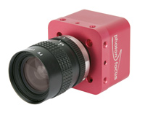
Figure 1 - The Photon Focus CMOS Camera Model Number MV-D1024E-160-CL-12 as seen on the Photon Focus Web site.

3.2 Aerosol Image Acquisition
In order to investigate and optimize techniques to remove aerosols, images were acquired containing the presence of aerosols outside of our lab, the High Altitude Observatory (HAO) in Boulder, CO on June 16, 2010. Figure 2 displays the necessary setup to acquire the data set. The CMOS camera was mounted on a table and wired to a computer [insert computer specs here] for storing the images obtained. The lens was pointed up so that images of the sky and aerosols would be captured. Proper positioning of the camera with regards to the building edge was essential because the powerful light from the Sun could damage sensitive optics; however, the Sun’s light was also necessary to illuminate the aerosols enough to incorporate them in the image signal. The Sun lay just obstructed behind the building during our image acquisition. 10 seconds (s) worth of data operating the camera at its maximum frame rate of 150 fps was obtained.
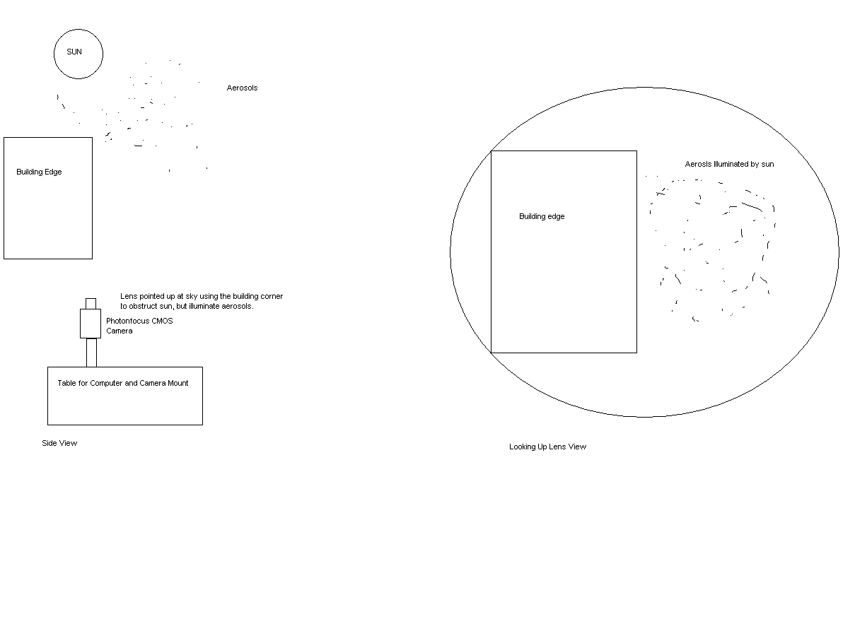
Figure 2 - Diagram obtained from MS Paint demonstrating aerosol image acquisition setup. Note the diagram at left shows a side view whereas the diagram at right shows the view from the lens looking up.

3.3 Aerosol Image Dataset Overview
A data set of 120 images was extracted from the acquired images in order to perform our analysis. LabVIEW 2009 was used to process the images according to the created algorithms and display various image analysis graphs. Figure 3 shows one image obtained from this data set with Cartesian coordinate axes included for reference positions. The diagonal structure on the top right was the building edge and the Sun was just obscured behind the façade. The faint white dots abundant near the building edge were aerosols. The primary constituent on this day was cottonweed pollen; however, while this represents a fairly large aerosol it does suffice in terms of removal techniques. Figure 4 provides a more quantitative description of the image in terms of an intensity histogram. The horizontal axis corresponds to pixel brightness value, or Analog-to-Digital Units (ADU), and the vertical axis denotes the number of pixels that correlate to a certain brightness value. The bimodal features show the primary components of the image. The larger of the two peaks was due to the blue background of the sky, whereas the smaller local maximum was due to the darker structure of the building’s edge. However, focus will be on the faint signals towards 4000 ADU that represent aerosol outliers and are causing the histogram to be right, or positively, skewed.
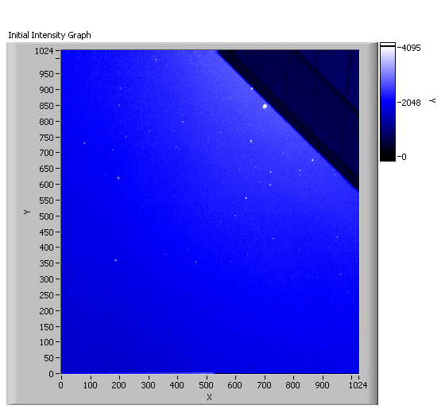
Figure 3 - Single image from data set showing aerosols (little white dots). Note coordinate axes have been included for reference positions.
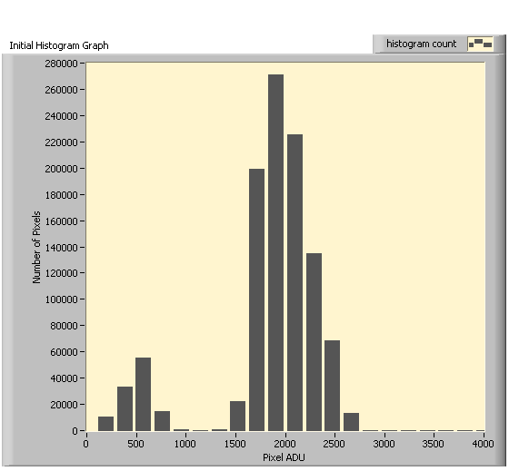
Figure 4 - Histogram of pixel intensity (brightness) values for Figure 3 Image. Note the bimodal appearance corresponds to the two main image components; the building edge and blue sky, respectively. The faint signal trace at 4000 ADU causes the histogram to be right (positively) skewed and corresponds to aerosol presence.
Figure 5 shows a zoomed in image of an aerosol at the coordinates: (700, 850). This aerosol will be our primary aerosol (PA) for evaluating techniques throughout the investigation. The histogram in Figure 6; however, is the critical path for the removal of aerosols. The first step in aerosol removal was to identify whether or not aerosols are present. While it may be possible to qualitatively state the presence of aerosols by visual inspection, the data must support this claim as well. Note the spike in the number of pixels registering around 4000 ADU. These are known as saturated, or hot, pixels. A saturated pixel is one that records a maximum reading in the dynamic range spectrum and corresponds to the color white. For our purposes, these pixels are bad. Recall from the specifications, that the dynamic range of the CMOS camera was 12-bit. This means that the range of ADU values is from 0 to 2¹² or 0 to 4096. Our claim was that all of the pixels registering this maximum ADU value are aerosols. The only method to confirm this claim was via dark frame subtraction. The subtraction of a dark frame from the initial image in question removed other sources of pixel saturation such as dark current.
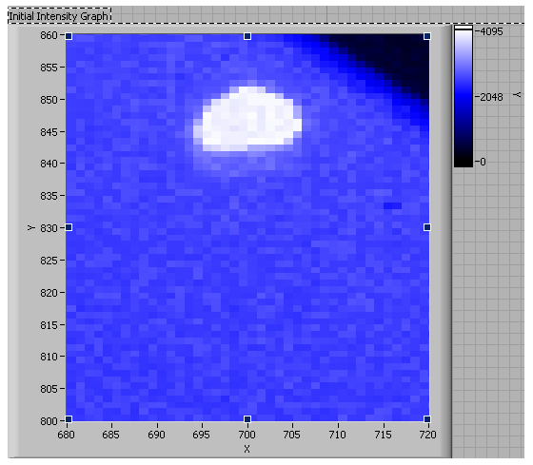
Figure 5 - Zoomed in image of Figure 3 showing aerosol located at approximately (700,850). This will be primary aerosol to evaluate performance of algorithms.
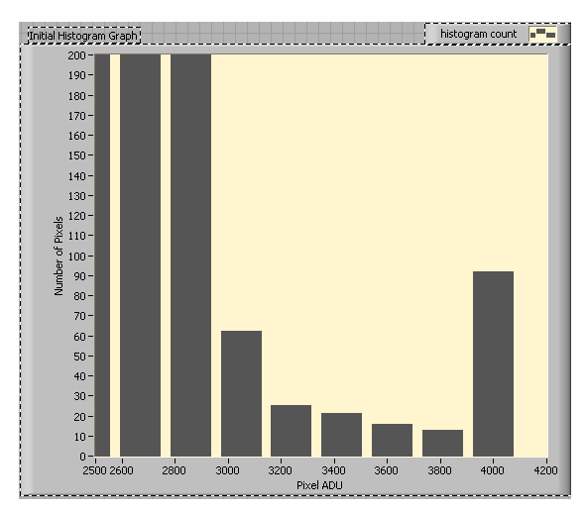
Figure 6 - Adjusted histogram from Figure 4 focused on outliers resulting in slightly right-skewed histogram. Note the peak at 4000 ADU.
Figure 7 shows a dark frame image. As previously stated, it was obtained by taking an image when the camera’s lens was on. This captured the dark current, or noise, associated with the thermal energy emitted by any electronic device. Note in Figure 8, the dark frame histogram, that while most pixel values correspond to 0 ADU, or black, there were some anomalies. These non-zero ADU values corresponded to the image’s dark current. There appeared to be little-to-no signal in the dark frame beyond ±40 ADU. Our claim was that the aerosols were located at 4000 ADU. After subtracting this dark frame from all of the 120 images in our data set, that spike was still present at 4000 ADU. It is with a fair amount of certainty that we may claim those “hot” pixels at 4000 ADU are representative of the aerosol contributions to the image signal.
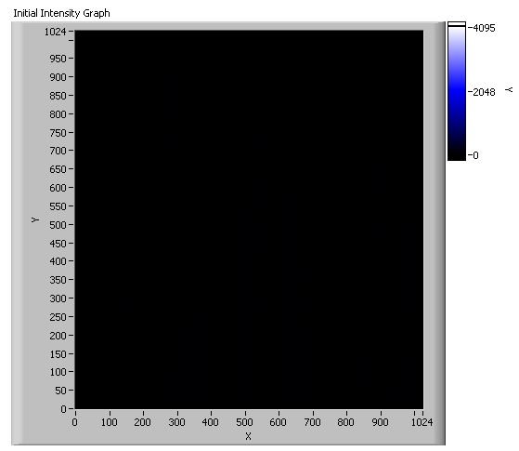
Figure 7 - Dark frame image that was subtracted from all 120 images in the data set to remove optical defects.
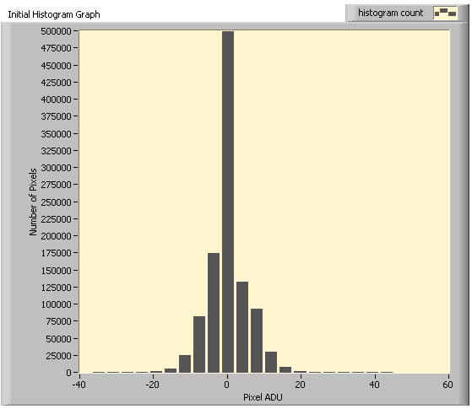
Figure 8 - Histogram of dark frame image. Note that most pixels correspond to 0 ADU (black); however, there are trace amounts of additional signal.

3.4 Aerosol Identification
Now that the presence of aerosols could be confirmed both qualitatively and quantitatively, the new task was identification. In order to remove them, the aerosols must be located visually and mathematically. Figure 9 shows the aerosol trajectories over the 120 image data set. This corresponded to approximately one second worth of data, and was obtained by taking the standard deviation of all 120 images on a pixel-by-pixel basis. The resultant image showed the change in pixel location over time. Aerosol motion presented the challenge that must be overcome in real-time.
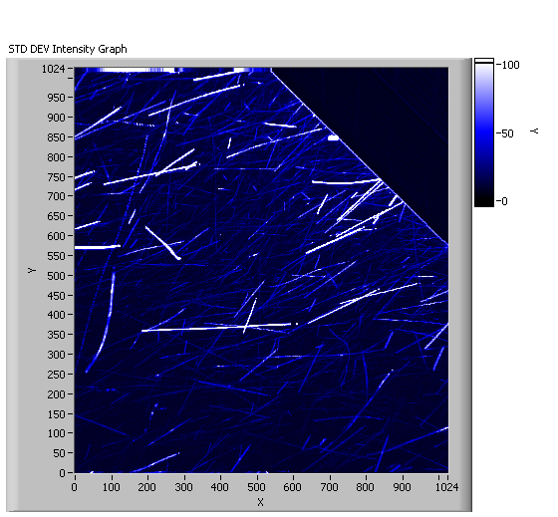
Figure 9 - Aerosol trajectories over 120 image data set or approximately 1 second.
The easiest method to identify aerosols was on a pixel-by-pixel basis. Figure 10 shows a black-and-white bad pixel image representing the primary aerosol in question once again. This image was obtained by assigning each pixel a value of 0 or 1. If the pixel’s ADU was not greater than two times the standard deviation (2-sigma), it received a value of 0, or black. However, if the pixel in question exceeded this threshold, it received a value of 1, or white. Based on the dynamic range, this threshold would only filter out the pixels registering 4000 ADU and representing an aerosol. The remainder of the image would not be affected; however, 2-sigma was a fairly wide threshold that almost certainly identified non-aerosol bad pixels as well. The 2-sigma threshold meant that 2.5% of the image was manipulated and the resulting image was 97.5% unchanged. This was deemed satisfactory for the purposes of identification and aerosol removal. Note that the aerosol, in white, encompasses several pixels and not just one. Also, the aerosol does not cause a solid or spherical area of pixels to be saturated, but rather an irregular swath of pixels. The aerosol identification process resulted in yet another barrier to overcome; the non-uniform nature of the aerosols when viewed on a pixel by pixel basis.
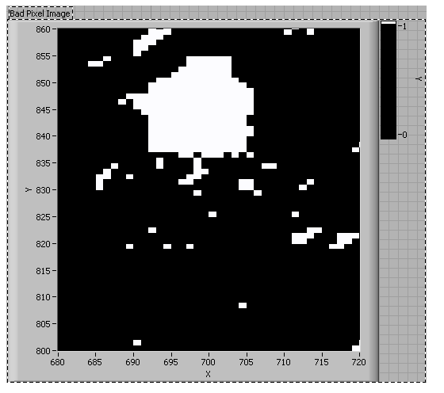
Figure 10 - Aerosol located at (700,850) as viewed on a pixel-by-pixel basis. Note the challenging logistics issue of the aerosol not being a single pixel but a variable blob over several pixels.
Figure 11 shows the same aerosol after the image was converted from the black and white bad pixel image into the regular color image from before. However, this time, if the pixel was assigned a value of 1 previously, it was now assigned a value of 0 which represents black on the original scale for the 12-bit dynamic range. This image was termed a zero image based on this conversion. The white pixels in Figure 10 correlate to the black pixels in Figure 11 perfectly. An initial technique will be to remove these bad pixels by replacing them with the average of the surrounding pixels, a spatial average algorithm. As previously stated, though, this presents a challenge when even the surrounding pixels are bad as well. Our threshold algorithm must have specified dimensions around each bad pixel to extrapolate the surrounding ones and average their ADU values. Subsequent techniques attempted a temporal solution as well by observing changes in pixels over time.
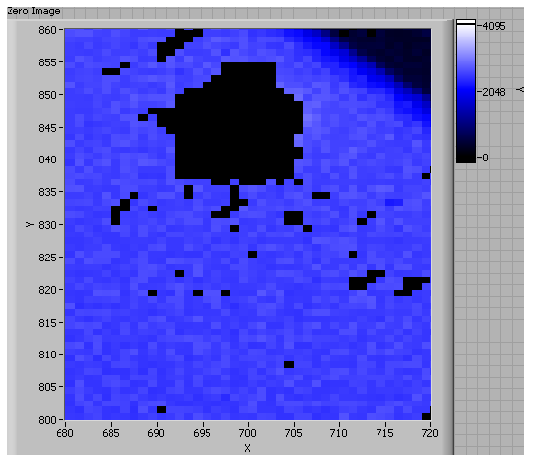
Figure 11 - A zero-image of the pixel at (700,850). Pixel values greater than two standard deviations above the mean were converted to 0 or black.

3.5 Aerosol Removal Techniques

3.5a Mean (Average) Threshold Image
In order to proceed with the spatial averaging threshold algorithm, a base image was not required; however, a mean image was obtained for later usage in a temporal averaging threshold algorithm. Figure 12 shows the mean image that was obtained by calculating the mean of all 120 images in our data set on a pixel-by-pixel ADU basis. The most noteworthy feature in this image was the absence of aerosols. To confirm this absence quantitatively, Figure 13 shows the intensity histogram associated with the mean image. It shared a similar bimodal structure as previously witnessed in Figure 4. However, the primary difference is the lack of signal beyond 3000 ADU. Upon closer inspection of the mean image in Figure 14, the PA is completely gone. Figure 15 shows that there is no signal reported at 4000 ADU. It can be concluded that this mean image indeed omitted all of the aerosols and would be a suitable image to perform our subsequent thresholding algorithms. For comparison and a potential alternative technique, a median image was also calculated.
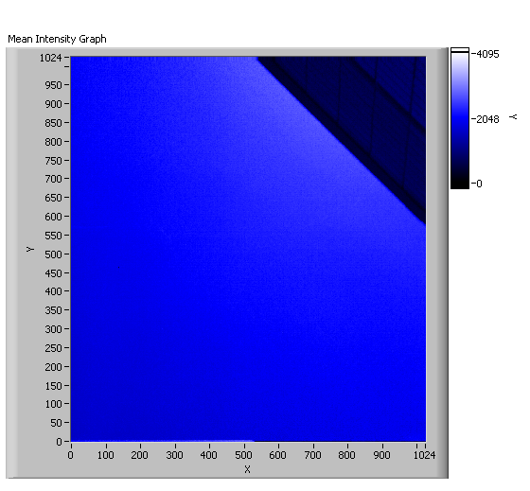
Figure 12 - Mean image calculated from 120 image data set on a pixel-by-pixel basis. This will serve as one of the images to compare pixels by and determine if they need to be averaged by the surrounding pixels. Note the absence of aerosols.

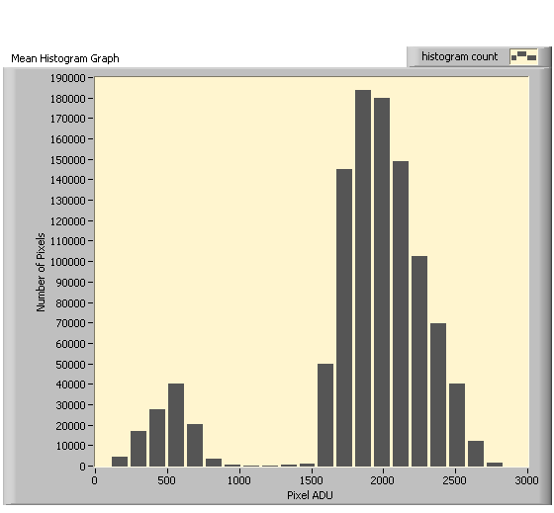
Figure 13 - Histogram representative of mean image. Note the similar bimodal appearance; however, there is no signal beyond 3000 ADU signifying an absence of aerosols.
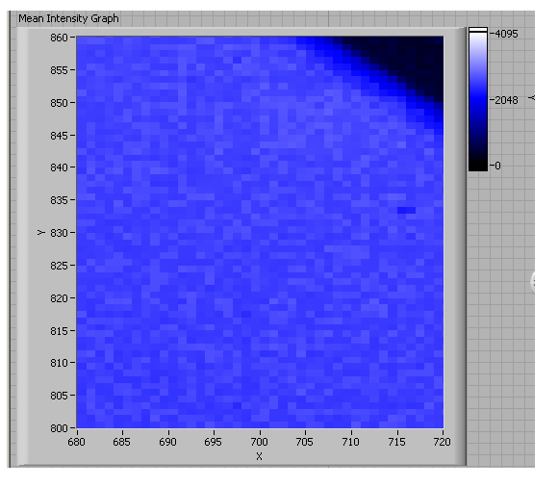
Figure 14 - Mean image zoomed in to location of our primary aerosol located previously at (700,850). Note its absence in the mean image.
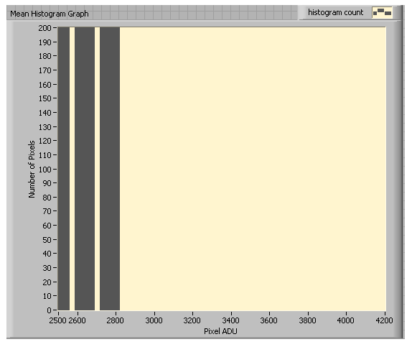
Figure 15 - Histogram of mean image manipulated to determine if there are any hot pixels around 4000 ADU. Note that there are none.

3.5b Median Threshold Image
The median image was obtained similarly to its mean counterpart. The median of all 120 images in the data set was calculated on a pixel-by-pixel ADU basis. Figure 16 shows the median image and once again the absence of aerosols is the most notable feature. Closer inspection via the image histogram in Figure 17 confirms the lack of signal out beyond 3000 ADU. Based on the similarities, it was safe to conclude that both the mean and median images efficiently removed the aerosols and would both be suitable thresholds to test later algorithms on. The first set of algorithms would remove aerosols based on spatial scales, whereas the second set would remove aerosols based on temporal scales. Both sets utilized a mean and median threshold application for a total of four algorithms to compare.
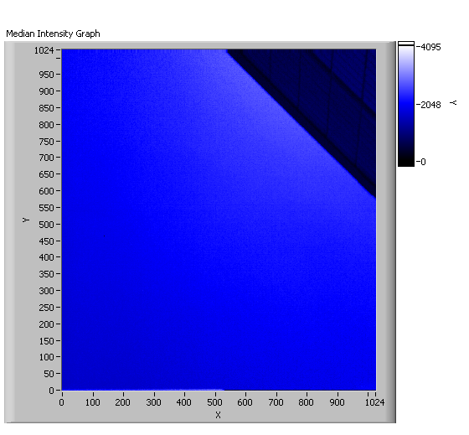
Figure 16 - Median image calculated on a pixel-by-pixel basis from 120 images in the data set. Note similarities to the mean image as well as absence of aerosols.
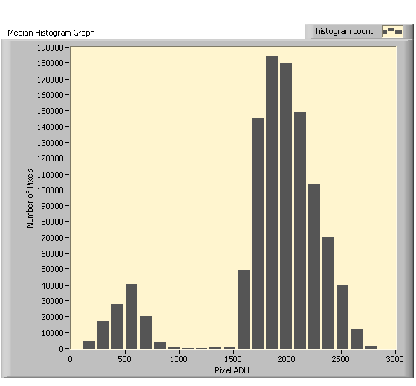
Figure 17 - Histogram of median image. Note the similar appearance to the mean image histogram.

3.5c Proximity (Spatial) Average Algorithm
This was the first algorithm to remove aerosols by combining the elements obtained thus far. The overall premise is shown in Figure 18. Once a bad pixel containing an aerosol had been identified and confirmed, the goal was to replace that pixel with the average ADU of the pixels around it. However, the figure fails to note the true dimensions of the entire image. This 3 x 3 matrix of pixels is only demonstrative of the real dimensions of 1024 x 1024 pixels. The first step of the algorithm after obtaining an image was to create a 1-D Array of its pixels. Based on the camera resolution (1024 x 1024 pixels) a string of pixels equaling the product of the resolution dimensions had to be created. That number comes to 1,048,576 pixels, and this was the number of elements in our 1-D Array. The reason for this conversion was because LabVIEW processes 1-D arrays easier than 2-D and all of our mathematical operations must be performed on arrays, not images. The next step in the procedure was to add the mean array with 2-sigma. This resultant array was our threshold for all subsequent images. The ultimate question was whether or not a pixel in question was greater than the mean ADU plus two standard deviations. This threshold ensured that only the aerosols would be targeted and not a bright object such as the Sun’s corona. In addition, this maintained that approximately 2.5% of the image signal was manipulated, and the remaining 97.5% was untouched to promote high quality imagery. The pixels greater than this threshold were then replaced by the average brightness value of the surrounding pixels. In most instances, this involved an 8-pixel average. However, for pixels located along the corners or edges of an image, the average was calculated from the maximum number of adjoining pixels. For the issue of multiple bad pixels in close proximity, the average was taken from the outside pixels and worked inward to avoid replacing bad pixels with the mean of other bad pixels. The last step in this process was to recompile an image with the bad pixels replaced. [See LabVIEW Algorithm – LabVIEW Mean Spatial]
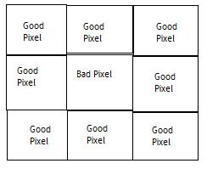
Figure 18 - This diagram, created in MS Paint, shows the orientation of pixels association with the Proximity Average Algorithm. Note that the actual pixel dimensions are 1024 x 1024, so this 3 x 3 matrix is only representative. The bad pixel will be replaced by the average of the surrounding good pixels in the algorithm.

3.5d Proximity (Spatial) Median Algorithm
This algorithm was conducted identical to the previous; however, the only deviation was that instead of replacing the bad pixels with the average ADU value of the adjoining pixels, the bad pixel was now replaced with the median brightness value of the adjoining pixels. All other procedures were identical to the above method. [See LabVIEW Algorithm – LabVIEW Median Spatial]

3.5e Time (Temporal) Average Algorithm
After removing aerosols on spatial scales, it was determined to compare removal algorithms on temporal scales as well. This algorithm required the usage of the mean threshold image that was previously calculated as shown in Figure 12. The mean image already represented the temporal variable required. It was an image in which all of the pixels’ mean ADU value was shown. Each pixel (1,048,576) was evaluated 120 times (120 images) and a mean value was calculated. These mean ADU values were then reassembled into an image. This algorithm analyzed our initial; aerosol contaminated images, and utilized the same 2-sigma threshold to determine if a pixel element (i-th) contained an aerosol. If an element exceeded the threshold (contained an aerosol) it was replaced with that same element extracted from the mean image. Once again, this algorithm was performed on 1-D arrays of pixels that were later recompiled into 2-D arrays and subsequent images for visual interpretation. [See LabVIEW Algorithm –LabVIEW Mean Temporal]

3.5f Time (Temporal) Median Algorithm
This final algorithm was identical to the previous; however, instead of replacing a bad pixel with the same pixel from the mean image, the median image pixel elements were used for replacement when applicable. These algorithms produced four unique resulting data sets; mean and median, each evaluated on spatial and temporal scales. [See LabVIEW Algorithm – LabVIEW Median Temporal]

4.0 Results
The thresholding algorithms performed to remove aerosols from a time series of images yielded varying degrees of success depending on the statistical parameter (mean or median) used. Furthermore, the results varied markedly between the usages of a parameter derived in time versus one derived in space. Success in removing aerosols was noted by visual observation from the time series of 120 images. The temporal thresholding algorithms recorded the most efficiency at aerosol removal.

4.1 Time (Temporal) Average Algorithm Results
The first algorithm performed replaced pixels identified as containing aerosols, as per the 2-sigma threshold, with the same pixel value extracted from the previously obtained mean image, which represented our temporal variable. In [Figure 19?] aerosols were non-existent when compared to the image presented in Figure 3. Inspection of the image histogram [Figure 20?] showed no signal beyond 4000 ADU. This observation was consistent with the lack of aerosols present in the mean image (Figure 12). However, evaluation of the primary aerosol (PA) was determined pivotal. [Figure 21?] shows the location of the primary aerosol in our corrected image. As expected, no trace of the aerosol was present. After extending the bounds of the image histogram [Figure 22] the lack of signal around 4000 ADU that previously signaled the presence of aerosols was confirmed. These results suggest that this algorithm was highly efficient at performing the desired aerosol removal.

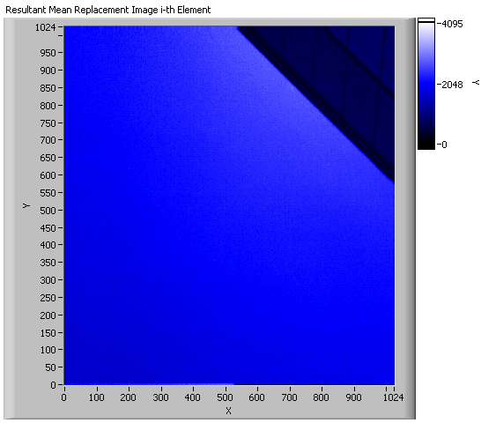
Figure 19
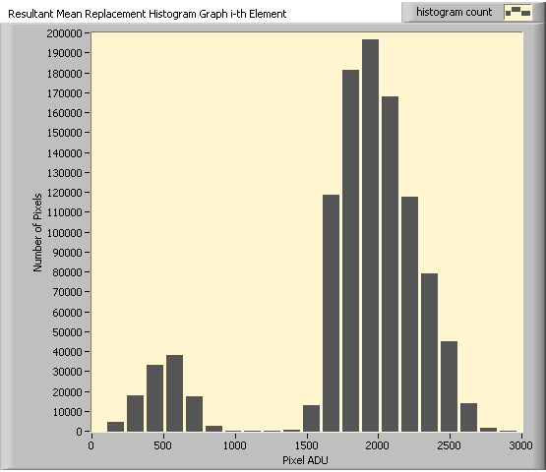
Figure 20
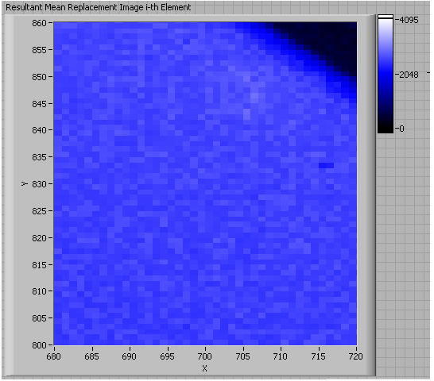
Figure 21
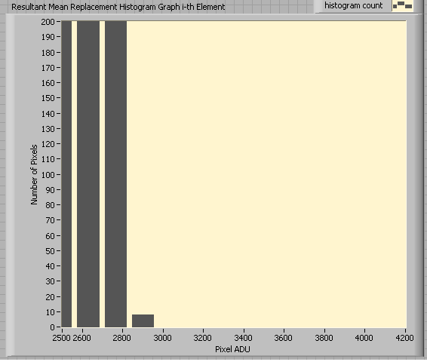
Figure 22

4.2 Time (Temporal) Median Algorithm Results
The second algorithm performed replaced a bad pixel containing an aerosol, evaluated using the same 2-sigma threshold, with the corresponding pixel taken from the previously obtained median image, which represented our second temporal variable. This algorithm showed identical success as compared to the previous one. [Figure 23] shows us the resultant image after pixel replacement according to the median image. Aerosols were not present in this image. The image histogram in [Figure 26] confirms the absence of signal around 4000 ADU. The results thus far suggest that the temporal thresholding algorithms promote superior aerosol removal technique. Regardless of the statistical parameter used, the resulting images removed the aerosols efficiently utilizing a time derived replacement scheme.

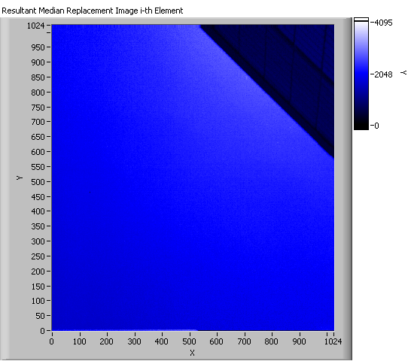
Figure 23
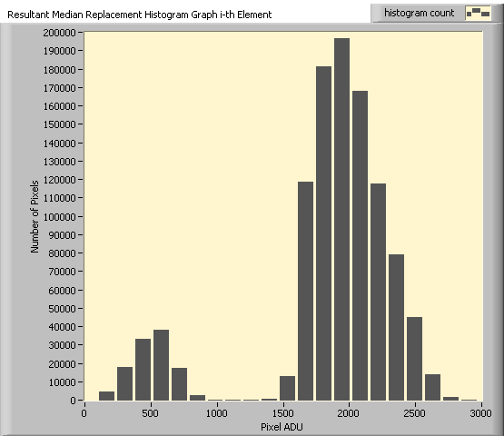
Figure 24
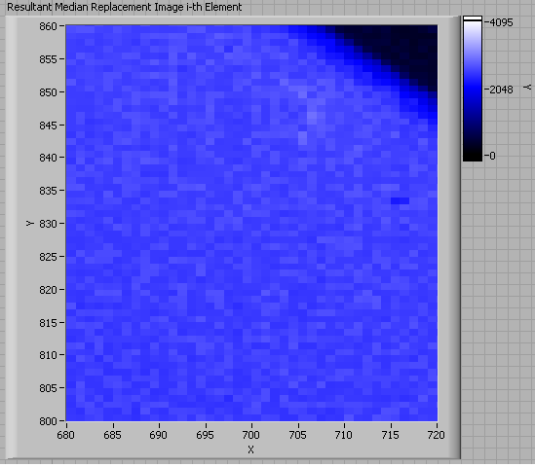
Figure 25
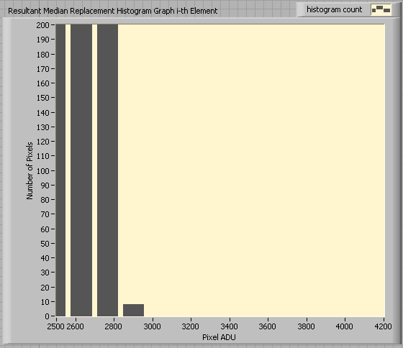
Figure 26

4.3 Proximity (Spatial) Average Algorithm Results
The third algorithm replaced a pixel marked as aerosol contaminated (using 2-sigma as the threshold) with the mean value calculated from the pixels surrounding it. For most pixels, this meant an 8-pixel average; however, the pixels along the corners or edges were replaced with the average of as many adjoining pixels were possible. This algorithm was the first of the spatial variables. In [Figure 27?] while the presence of aerosols has decreased markedly there are some abnormalities appearing near the building. Inspection of the image histogram [Figure 28?] shows that there is no signal reported beyond 3000 ADU which under our current assumptions would denote the absence of aerosols. The evaluation of the primary aerosol (PA) would prove pivotal. [Figure 29?] shows the location of the primary aerosol in our resultant image. While the aerosol itself has indeed been removed, the image remains distorted. The extended bounds image histogram in [Figure 30?] confirms the absence of aerosols with no signal around 4000 ADU; however, the histogram was not intended to detect image distortion. This result suggests that, while successful at removing the aerosols, this algorithm distorted the image and was therefore unsuitable for our needs.
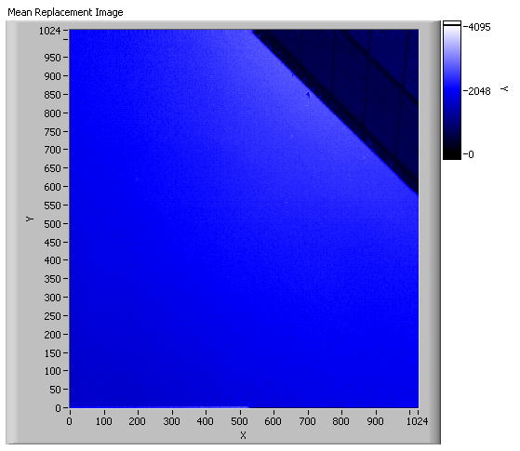
Figure 27
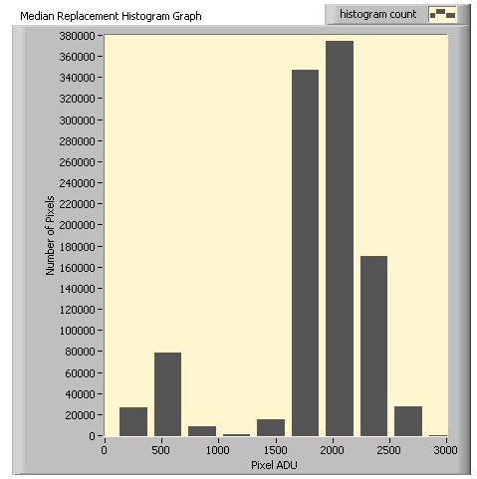
Figure 28
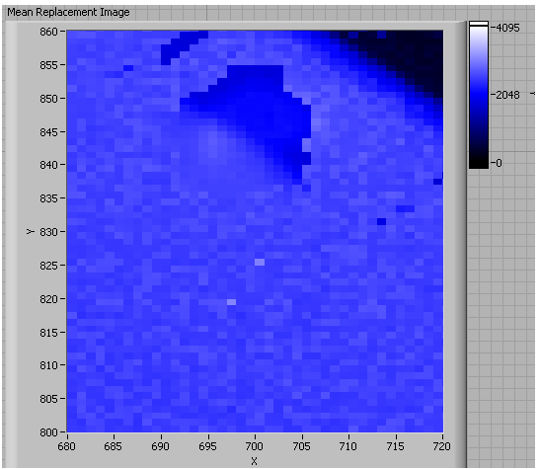
Figure 29
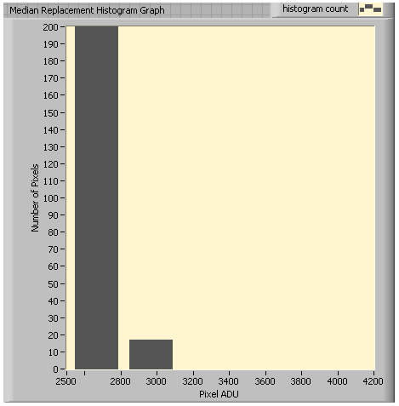
Figure 30

4.4 Proximity (Spatial) Median Algorithm Results
The final algorithm replaced those pixels containing an aerosol and thus noted as bad (according to the 2-sigma threshold) with the median value calculated from the surrounding pixels. Similar to the previous algorithm, in most instances this resulted in an 8-pixel median calculation; however, fewer pixels were utilized for pixels along the corners and edges. The results of this algorithm were slightly better than the previous spatial application. [Figure 33] shows the location of the primary aerosol (PA). The aerosol has been removed; however, there is still some remnant image distortion. The image histogram [Figure 34] confirms the removal of aerosols as there was no signal around 4000 ADU. These results suggest that, while feasible for removing aerosols, the spatial thresholding algorithms produce excess image distortion. The spatial median algorithm produced slightly less distortion than its mean counterpart; however, the temporal algorithms noted superiority.

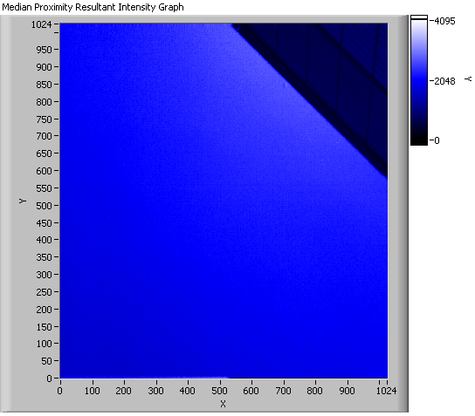
Figure 31
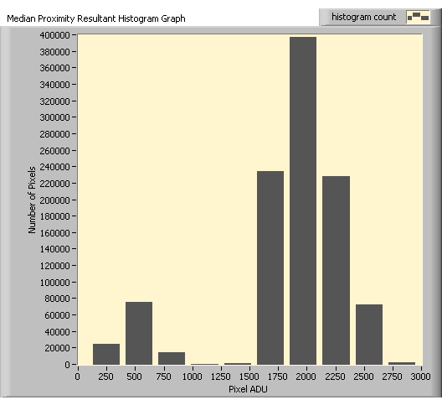
Figure 32
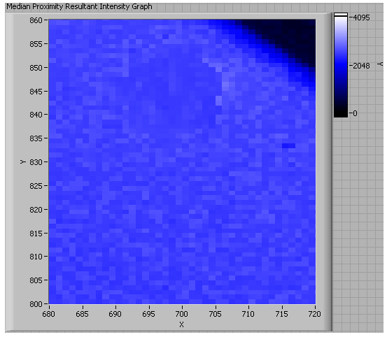
Figure 33
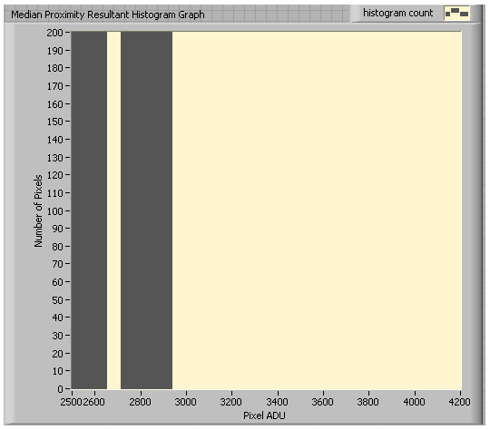
Figure 34

5.0 Discussion
The results of our algorithms suggest that real-time aerosol removal in images of the Sun’s corona is possible. All of the algorithms successfully removed the aerosols, with the temporal ones limiting image distortion to a minimum. Analysis of the image histograms before and after our thresholding applications in addition to visual observation of the images showed signal reduction at 4000 ADU correlating to the removal of aerosols. However, the deviations in efficiency between the algorithms suggest some external bias or limitations regarding spatial parameters.
The most interesting result was the marked deviation in effectiveness between the temporal and spatial algorithms. While both successfully removed the aerosols in question, the spatial algorithms resulted in significant image distortion. One possible reason to explain the distortion seen in [Figures 29 and 33] was due to the proximity of aerosols to the building’s edge. These algorithms took the average and median values from the surrounding pixels; however, some of those surrounding pixels could have contained the fingerprints associated with the building’s façade and not the surrounding sky. The odd color schemes noted in those images appear to suffer from some influence of the building. These algorithms are unacceptable, though, because the occulting disk of an actual coronagraph would act similarly to the building’s edge. If such an image distortion results from the building, it would more than likely manifest itself again with regards to the occulting disk.
The temporal algorithms, resulting in complete aerosol removal and insignificant image distortion, did not seem to be influenced by the statistical parameter utilized. Both the mean and median element replacements resulted in high efficiency algorithms. However, while this is welcomed news, the mean technique is the preferred option due to the nature of statistical parameters. An average image is more suitable because it analyzes all of the possible values in time. The median image simply takes a single, middle value. For the purposes of our project, utilizing a single value, while effective, is not demonstrative of the total realm of possibilities.
In addition to image distortion and parameter selection, these algorithms were evaluated for their performance speed. As previously stated, the intent is for these algorithms to be performed in real-time. Analysis such as this has never been done before as the current methods involve post-processing. All of the algorithms averaged about the same duration of about three minutes (~180s). This time included reading the files from the computer disk, the threshold application, and writing the processed image back to the computer disk. The creation of the mean and median images took an additional 40s each. These results were slightly disappointing since our 120 image data set was 1s worth of data, yet it required 180s to process.
Each of the images in our data set contained 1024 rows of pixels by 1024 columns of pixels which sums to 1,048,576 pixels per image. The upper bound of the 2-sigma threshold utilized ensured that only 2.5% of the pixels (~26,500 pixels) were replaced during the performance of our algorithms. The remaining 97.5% of the image pixels remained unchanged. However, 2-sigma was a fairly generous threshold and a more rigorous 3-sigma threshold could have been applied which would result in only the uppermost 0.15% of the pixels (~1600 pixels) being replaced. The 3-sigma threshold was deferred in favor of the 2-sigma one because it was possible that the 3-sigma application would allow some borderline aerosols to remain in the resultant image. The 2-sigma threshold was the safest threshold in terms of the initial algorithm creation and manipulation. The thresholding decision is dependent on the situation. Our images represented the extreme situation with a plethora of aerosols. The more likely scenario is 1-10 aerosols per minute of data. In such instances, a 3-sigma threshold would be more suitable.
During the evaluation of these algorithms, we ran into multiple memory issues which explained the size of our data set. 120 images was the maximum that the computer would process. In addition, the memory issues likely played a role in our performance times. We utilized a 32-bit operating system which significantly limited memory capacity; however, it was possible to utilize a 64-bit system in which the memory capabilities would be expanded tremendously. Future usage of a 64-bit system would suggest the ability to process more images at quicker speeds and may be the solution to our limitations.
To summarize, we have created four algorithms utilizing the mean and median as parameters evaluated in space and time to remove aerosols from images. These parameters were used in conjunction with a threshold application to replace pixels in an image to facilitate aerosol removal. Variable success was recorded between the methods and the temporal mean algorithm was determined to be the preferred method. Future evaluation of performing this algorithm using extended memory capabilities hopes to decrease the processing time. Our results suggest that real-time aerosol removal is possible which will benefit ground-based instrumentation projects in the coming years.

6.0 Conclusion
We have successfully created an algorithm capable of removing aerosols from images of the Sun’s corona in real-time. This task was performed utilizing a thresholding application that identifies bad pixels and replaces them with their corresponding elements from a previously derived mean image. This mean image was calculated on a pixel-by-pixel basis from a time series of images. Our algorithm and technique will facilitate the enhancement of ground-based coronagraphs and make them more efficient at acquiring high quality images despite previous inhibition by atmospheric aerosols.

Bibliography
Berry, Richard, and James Burnell. The Handbook of Astronomical Image Processing. Richmond, Virigina: Willmann-Bell, Inc., 2000.
Elmore, David F., Joan T. Burkepile, J. Anthony Darnell, Lecinski Alice R., and Andrew L. Stange. "Calibration of a Ground-based Solar Coronal Polarimeter." Proceedings. Tuscon: The Society of Photo-Optical Instrumentation Engineers, 2003. 66-75.
Howell, Steve B. Handbook of CCD Astronomy. Cambridge: Cambridge University Press, 2000.
Keller, Christoph U. "Instrumentation for Astrophysical Spectropolarimetry." National Optical Astronomy Observatory 889 (November 2000): 1-52.
MacQueen, R.M., et al. "The High Altitude Observatory Coronagraph/Polarimeter On The Solar Maximum Mission." Solar Physics 65 (1980): 91-107.
MacQueen, R.M., J.T. Gosling, E. Hildner, R.H. Munro, A.I. Poland, and C.L. Ross. "The High Altitude Observatory White Light Coronagraph." Proceedings. Tuscon: The Society of Photo-Optical Instrumentation Engineers, 1974. 201-212.
Malherbe, J.M., J.C. Noens, and TH. Roudier. "Numerical Image Processing Applied To The Solar Corona." Solar Physics 103 (1986): 393-398.
Tomczyk, S., et al. "Alfven Waves in the Solar Corona." Science 317 (August 2007): 1192-1196.
Tomczyk, S., et al. "An Instrument to Measure Coronal Emission Line Polarization." Solar Physics 247 (2008): 411-428.

Acknowledgements

Tables & Figures
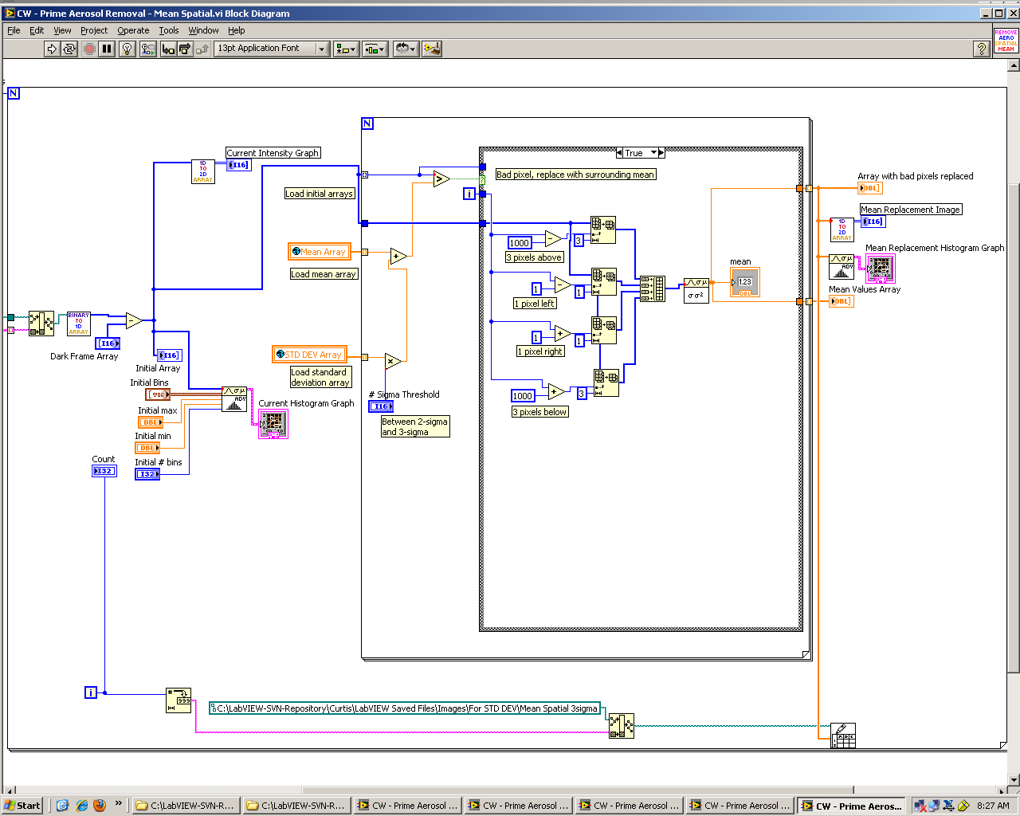
Mean Spatial

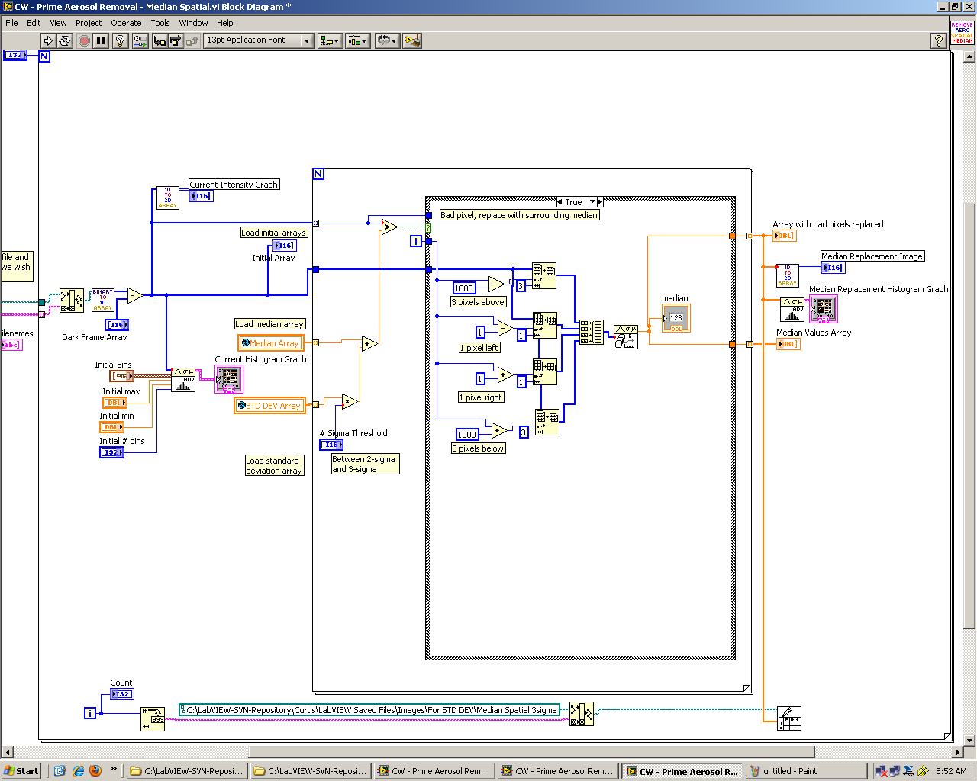
Median Spatial

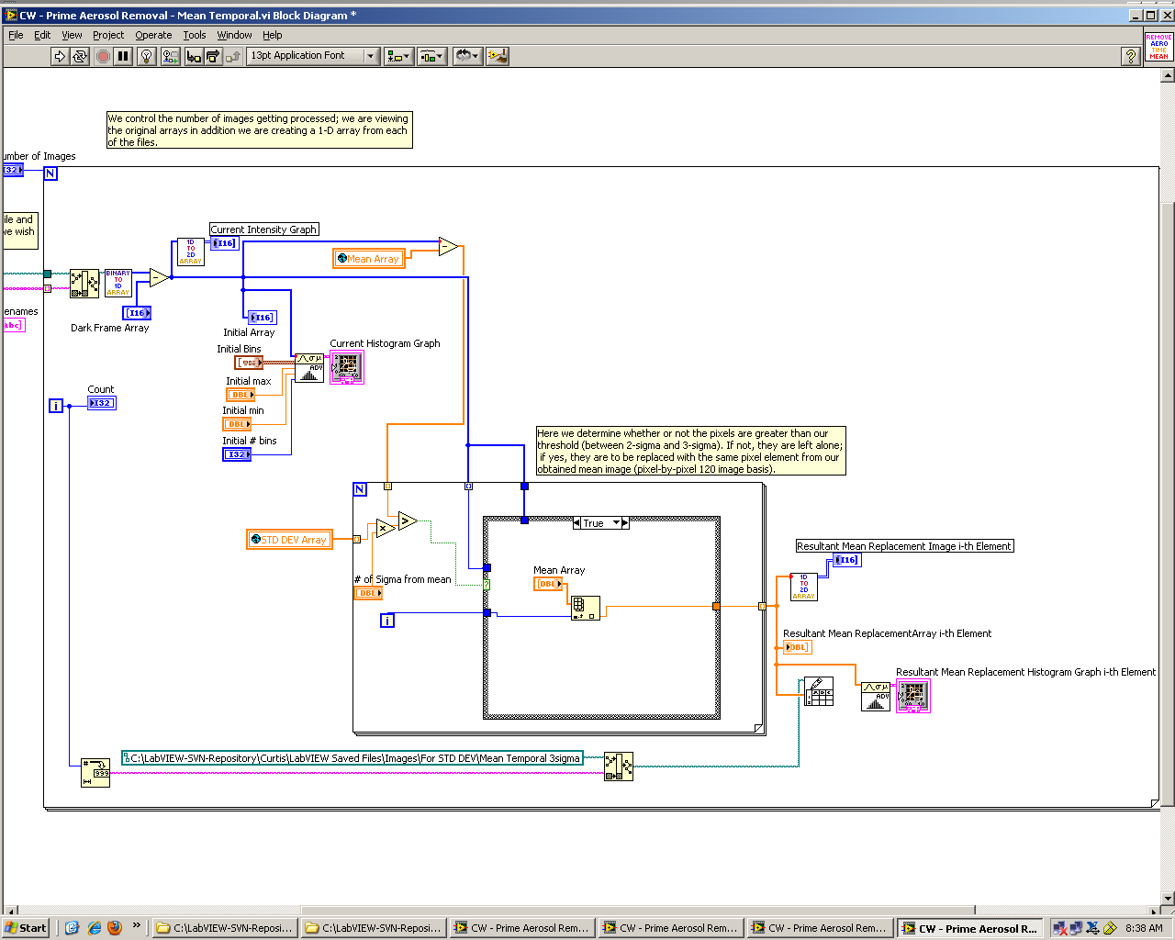
Mean Temporal

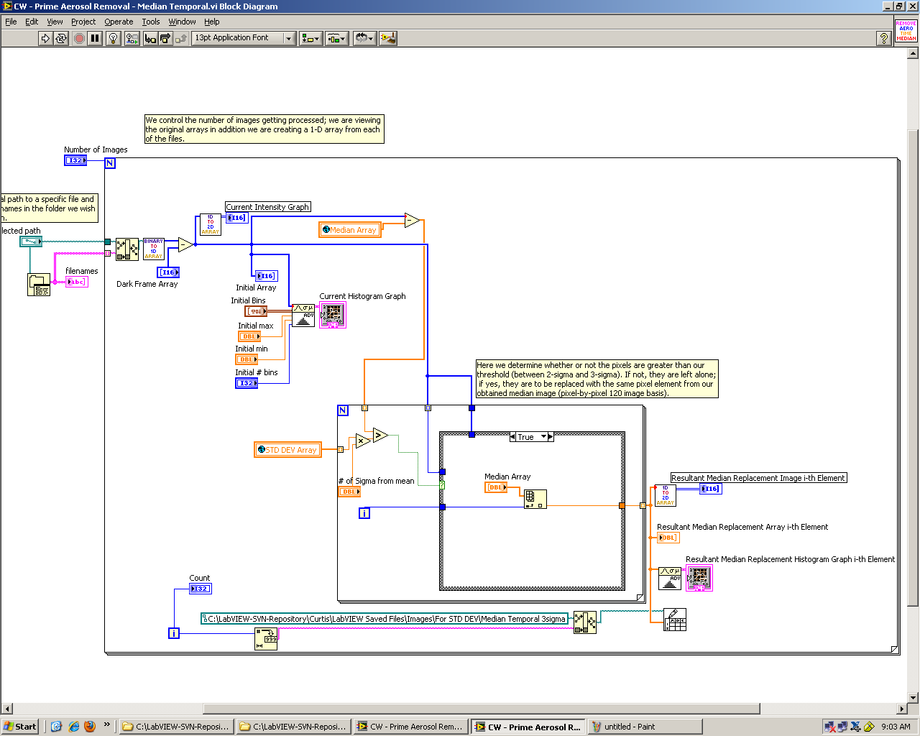
Median Temporal

