Image Processing Algorithms for Aerosol Removal in Solar Coronal Images
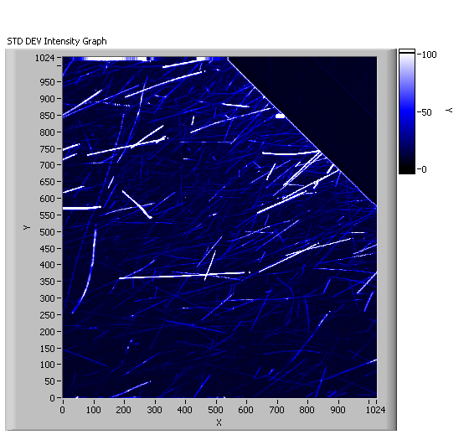
Abstract
Coronal mass ejections, which are explosions of solar material and energy into space, pose a potential threat to satellite and electrical grid infrastructures, yet little is known about the solar corona. Various questions exist, relating to the origins of these mass ejections as well as the mechanisms involved in coronal heating. The corona and coronal mass ejections are measured by satellite and ground-based coronagraphs, instruments that produce a false eclipse of the Sun in order to separate the extremely faint coronal signature from the bright solar disk. The Earth’s atmosphere and the presence of aerosols limit the usefulness of images obtained from ground-based coronagraphs compared to satellite observations. We have developed image processing algorithms to remove aerosols from a new high-speed detector in real-time. We first generated two images from a time series of images containing real aerosols; a mean and a median image. We then applied a thresholding algorithm to all of the images within the time series. If the pixel values exceed the mean and/or median image value, they were replaced with the value in that mean or median image. Both techniques were successful in removing aerosols from imagery. Due to signal to noise advantages gained by utilizing the mean image instead of the median image, we feel that is the preferred method. Processing ~1s of imagery (150 fps) required ~180s on a dual-core 2.33 GHz CPU. Further optimization will promote real-time aerosol removal in solar observation.
Keywords
Aerosols, Atmospheric Corrections, Corona, Coronagraph, Data Reduction, Image Processing
Table of Contents
1.0 Introduction 3
2.0 Data & Methods 7
2.1 Instrumentation 7
2.2 Aerosol Image Acquisition 8
2.3 Aerosol Image Dataset Overview 10
2.4 Aerosol Identification 16
2.5 Aerosol Removal Techniques 19
2.5.1 Proximity Based Algorithms 19
2.5.1.1 Mean Proximity Algorithm 19
2.5.1.2 Median Proximity Algorithm 20
2.5.2 Time Series Based Algorithms 21
2.5.2.1 Mean Time Series Algorithm 21
2.5.2.2 Median Time Series Algorithm 22
3.0 Results 24
3.1 Time Series Based Algorithm Results 24
3.1.1 Mean Time Series Algorithm Results 24
3.1.2 Median Time Series Algorithm Results 29
3.2 Proximity Based Algorithm Results 31
3.2.1 Mean Proximity Algorithm Results 31
3.2.2 Median Proximity Algorithm Results 36
4.0 Discussion 39
5.0 Conclusion 41
Bibliography 42
Acknowledgments 43
Appendix A – LabVIEW Code 44
Appendix B – Confirmation of Statistical Distribution Characteristic 48

1.0 Introduction
The Sun plays an important role in influencing Earth in terms of space weather. The outer region of the sun, known as the corona, is of particular concern since it is the solar component that most affects us. The Sun always emits energy, hence the presence of life on Earth; however, it periodically releases extreme quantities of energy. These coronal mass ejections emit billions of megatons of energy into space, and if this energy should strike Earth, it poses risk to our satellite and electrical grid infrastructures. Despite this danger, little is known about the Sun’s corona. Current observational techniques include both orbiting satellite as well as ground-based coronagraphs. A coronagraph is an instrument that produces a false eclipse allowing for analysis of the Sun’s corona. My project is to develop a set of image processing algorithms to remove aerosols for a newly available Scientific Complementary Metal Oxide Semiconductor (sCMOS) based array detector that will be interfaced with a ground-based coronagraph.
Satellite-based instrumentation requires significant investment due to position and quality requirements; however, both satellite and ground-based methods succumb to defective imagery. Correcting for defective imagery requires efficient image processing techniques, although less is usually required for satellite-based instruments. One limitation of a ground-based instrument compared to its satellite counterpart is the depth of the atmosphere. Scattering of radiation due to the atmospheric composition and the presence of aerosols renders satellite-borne instruments imperative to properly study the coronal structure and properties (MacQueen et al. 1974). Our goal is to utilize the algorithms to mitigate the influences of atmospheric aerosols on coronagraph imagery obtained from the surface.
The sCMOS detector is an integral part of a birefringent filter instrument being developed by NCAR’s High Altitude Observatory (HAO). This instrument will be deployed to the Lomnicky Peak Observatory in Slovakia at the end of March 2011 where it will be interfaced to an existing 20cm coronagraph built by the Zeiss Corporation from Germany. In addition, the detector will make high resolution (5.5 megapixel images at the diffraction limit of the coronagraph), and high cadence (30 frames per second) observations of the entire solar corona between ~1.1 and 2 solar radii at wavelengths between 540nm and 1083nm.
Once the array detector is interfaced with the existing coronagraph, this instrument, the Coronal Multichannel Polarimeter – Slovakia (CoMP-S), will allow investigators to directly address two of the most important problems of the solar corona: (i) how is the solar corona heated and (ii) how and where do coronal mass ejections occur? Both of these scientific questions require 2-D maps of coronal magnetic fields at high spatial resolution. Furthermore, these magnetic fields are dynamic and high cadence measurements are required to resolve their changing structure (Tomczyk et al. 2008).
Under most circumstances, temperature decreases with distance from the heat source; however, the corona increases in temperature with distance from the Sun. In addition to enhancing our understanding of solar coronal heating, the CoMP-S device will be able to further our understanding on ejections of coronal mass from the sun that ultimately interfere with our satellite communications (MacQueen et al. 1980) after the atmospheric aerosols have been removed.
Until recently, camera technology could provide either high resolution or high frame rates but not both in the same package and usually not with the low levels of noise required for scientific grade images of the corona. sCMOS technology, with its megapixel array size, 50 frames per second readout rates with a global shutter and 2-3 electrons of read noise, will provide a quantum leap in solar observation science if the technology produces on its promises.
Images obtained from such highly sensitive electronics often become subject to noise interference. Noise is any unwanted electrical signal that interferes with the image being read and transferred by the imager. Keller (2000) details the noise that images experience due to instrumentation errors. These errors are particularly prevalent in highly sensitive solar observations such as our CoMP-S coronagraph. Keller presents a wide array of potential culprits including dark current, flat field bias, and instrumental polarization; however, the primary focus of our investigation is the removal of aerosols. Therefore, we briefly mention a few of these other defects and note corrections performed on our data set to account for the most prevalent ones.
These defects must be processed from imagery to ensure the highest quality of analysis. Howell (2000) provides a detailed examination of the various image defects. One such error, dark current, results from the thermal (heat) agitation of the electrons in the optical device by stray electricity. Optical instruments do have mechanisms that keep them cool to minimize the impacts of dark current. As this thermal energy comes into contact with the electrons of the image, they become excited and gain kinetic energy. Dark current results in bright spots, or saturated pixels, within an image. These saturated pixels due to dark current are referred to as “hot” pixels.
Image bias is another defect due to variations among pixel gain, or quantum efficiency (Howell 2000). Individual pixels that comprise an entire image may be more or less efficient at converting photons into electrons relative to an adjacent pixel. An additional source of pixel gain error may result from the lack of uniform light exposure. Individual pixels may be exposed to more or less light than another which would also result in an image containing bias.
Berry and Burnell (2000) provide a method for performing data reduction applications to remove the aforementioned defects. Their method removes dark current via dark frame subtraction first and then performs flat field corrections for image bias. In dark frame subtraction, an image is taken with the lens cap on so that only the thermal noise component from the device (dark current) is captured. This image is then subtracted from the initial images, resulting in the omission of the noise. In flat field corrections, an image is obtained of a uniform light distribution and then averaged with the images in a data set. Flat field corrections were not performed because the impact of image bias was insignificant for the purposes of aerosol removal.
The removal of atmospheric aerosols in imagery from ground-based instrumentation is paramount to improved solar observations. Current technologies provide limited information on the Sun to protect against its dangers. Successful real-time corrections for atmospheric aerosols will broaden understanding of the Sun’s corona and influence the development of future technologies.

2.0 Data & Methods

2.1 Instrumentation
The camera utilized was the CMOS Photon Focus (Model Number MV-D1024E-160-CL-12). On its Web site, Photon Focus states that the resolution is 1024 x 1024 pixels, with a maximum frame rate of 150 frames per second (fps); a dynamic range of 12-bit (0 to 4095 gray levels) and the pixel size is 10.6 x 10.6 μm² (square microns). Figure 1 shows the optical device measuring 55 x 55 x 46 mm³ (W x H x D).
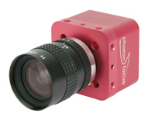
Figure 1 - The Photon Focus CMOS Camera Model Number MV-D1024E-160-CL-12 as seen on the Photon Focus Web site.

2.2 Aerosol Image Acquisition
In order to investigate and optimize techniques to remove aerosols, images were acquired containing the presence of aerosols outside of our lab, the High Altitude Observatory (HAO) in Boulder, CO on June 16, 2010. Figure 2 displays the necessary setup to acquire the data set. The CMOS camera was mounted on a table and wired to a dual-core, 2.33 GHz CPU running Windows XP for storing the images obtained. The lens was pointed up so that images of the sky and aerosols would be captured. Proper positioning of the camera with regards to the building edge was essential because the powerful light from the Sun could damage sensitive optics; however, the Sun’s light was also necessary to illuminate the aerosols enough to incorporate them in the image signal. The Sun lay just obstructed behind the building during our image acquisition. 10 seconds (s) worth of data operating the camera at its maximum frame rate of 150 fps was obtained.
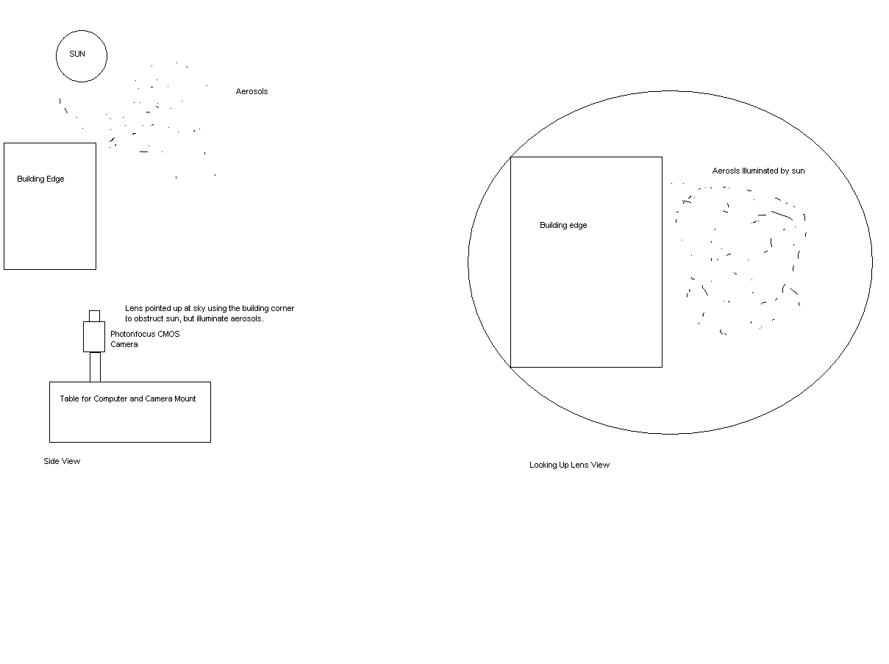
Figure 2 - Diagram demonstrating aerosol image acquisition setup. Note the diagram at left shows the side view whereas the diagram at right shows the view from the lens looking up.

2.3 Aerosol Image Dataset Overview
A data subset of 120 images was extracted from the 1000+ images in order to perform our analysis due to memory constraints. LabVIEW 2009 was used to process the images according to the created algorithms and display various image analysis graphs. Figure 3 shows one image obtained from this data set. The diagonal structure on the top right was the building edge and the Sun was just obscured behind the façade. The faint white dots abundant near the building edge were aerosols. The primary constituent on this day was cottonwood pollen. However, this represents a fairly large aerosol distribution and may not be representative of all aerosol distributions. Nevertheless, it does suffice in terms of developing and testing aerosol removal techniques.
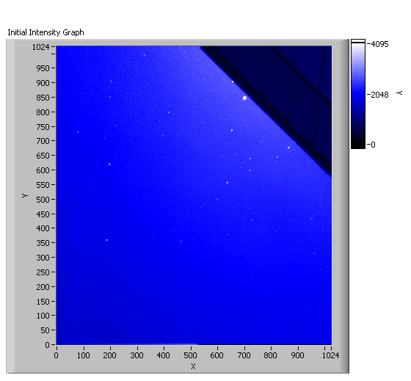
Figure 3 - Single image from data set showing aerosols (little white dots). Note coordinate axes correspond to individual pixel locations.
Figure 4 provides a more quantitative description of the image in terms of an intensity histogram. The horizontal axis corresponds to pixel brightness value, or Analog-to-Digital Units (ADU), and the vertical axis denotes the number of pixels that contained a specific brightness value. The bimodal features show the primary components of the image. The larger of the two peaks (centered at 2000 ADU) was due to the blue background of the sky, whereas the smaller maximum (centered at 500 ADU) was due to the darker structure of the building’s edge.
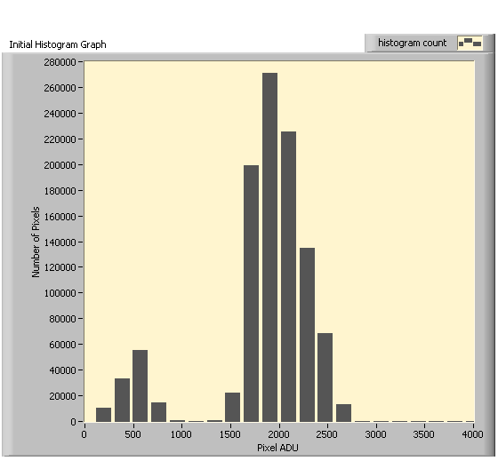
Figure 4 - Histogram of pixel intensity (brightness) values for Figure 3 Image. Note the bimodal appearance corresponds to the two main image components; the building edge and blue sky, respectively. The faint signal trace at 4000 ADU causes the histogram to be right (positively) skewed and corresponds to aerosol presence.
Figure 5 zooms in to display a specific aerosol at the coordinates: (700, 850). This aerosol will be our primary aerosol (PA) for evaluating techniques throughout the investigation.
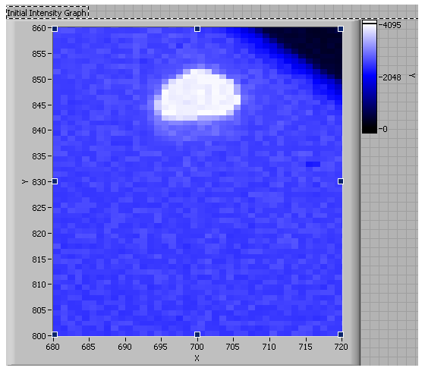
Figure 5 - Zoomed in image of Figure 3 showing an aerosol located at approximately (700,850). This will be the primary aerosol (PA) in evaluating algorithm performance.
The histogram in Figure 6 is the critical path for the removal of aerosols. The first step in aerosol removal was to identify whether or not aerosols were present. Note the spike in the number of pixels registering around 4000 ADU. These are known as saturated pixels. A saturated pixel is one that records a maximum reading in the dynamic range spectrum and corresponds to the color white. Our claim was that all of the pixels registering this maximum ADU value were aerosols. The only method to confirm this claim was via dark frame subtraction. The subtraction of a dark frame from the initial image in question removed a common background as well as hot pixels due to manufacturing defects.
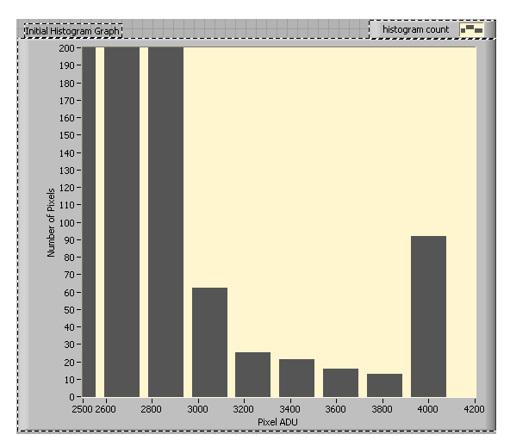
Figure 6 - Adjusted histogram from Figure 4 focused on outliers resulting in slightly right-skewed histogram. Note the peak at 4000 ADU. These are saturated pixels comprising both hot pixels and/or bright aerosols.
A dark frame image was obtained by taking an image when the camera’s lens cap was on. It was acquired for the same length of exposure time as the images in our time series. This captured the dark current, or noise, associated with the thermal energy emitted by any electronic device. Figure 7, the dark frame histogram, shows that the majority of the dark frame signal is contained between 0 ADU and 250 ADU. The signal trace beyond 1500 ADU is insignificant, and there is no signal near 4000 ADU. Our claim was that the aerosols were located at 4000 ADU. After subtracting this dark frame from all of the 120 images in our data set, that spike was still present at 4000 ADU. It is with a fair amount of certainty that we may claim those saturated pixels at 4000 ADU are representative of the aerosol contributions to the image signal.
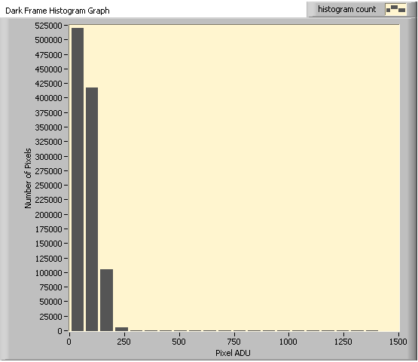
Figure 7 - Histogram of dark frame image. Note that most pixels correspond to 0 ADU (black); however, there are trace amounts of additional signal. No signal was detected beyond 1500 ADU.

2.4 Aerosol Identification
After the presence of aerosols was confirmed both qualitatively and quantitatively, the new task became identification. Figure 8 shows the aerosol trajectories over the 120 image data set. This corresponded to approximately 1s worth of data, and was obtained by taking the standard deviation of all 120 images on a pixel-by-pixel basis. The resultant image showed the change in pixel location over time. This demonstrates the real-time processing challenge that must be overcome in our experiment.
Figure 8 - Aerosol trajectories over 120 image data set (~1s).
The easiest method to identify aerosols was on a pixel-by-pixel basis. Figure 9 shows a black-and-white bad pixel image representing the PA in question once again. This image was obtained by assigning each pixel a value of 0 or 1. If the pixel’s ADU was not greater than two times the standard deviation (2-sigma) of the 120 image time series, it received a value of 0, or black. However, if the pixel in question exceeded this threshold, it received a value of 1, or white. Based on the dynamic range, this threshold would only filter out the pixels registering 4000 ADU and representing an aerosol. The remainder of the image would not be affected; however, 2-sigma was a fairly wide threshold that almost certainly identified non-aerosol bad pixels as well. This was deemed satisfactory for the purposes of identification and aerosol removal. Note that the aerosol, in white, encompasses several pixels and not just one. Also, the aerosol does not cause a solid or spherical area of pixels to be saturated, but rather an irregular swath of pixels. The aerosol identification process resulted in yet another barrier to overcome; the non-uniform nature of the aerosols when viewed on a pixel by pixel basis.
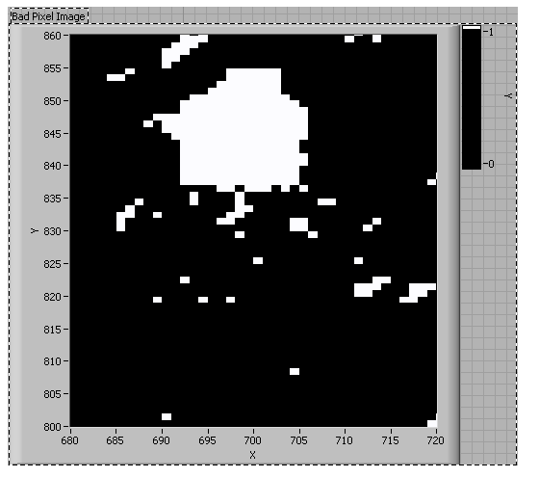
Figure 9 - Aerosol located at (700,850) as viewed on a pixel-by-pixel basis. The data have been reduced from grayscale to black and white for clarity. Note the challenging logistics issue of the aerosol not being a single pixel but a variable blob over several pixels.

2.5 Aerosol Removal Techniques
We utilized LabVIEW to both acquire imagery and create the aerosol removal algorithms. We have developed four techniques to remove aerosols from imagery with efficiency and speed noted as the parameters of success. These techniques can be classified as either proximity based algorithms or time series based algorithms. The former uses individual images and the latter utilizes information about the entire time series to perform aerosol removal. These algorithms have been developed taking special care to address the issues of aerosol motion as well as the non-uniform nature of the saturated pixels containing aerosols.

2.5.1 Proximity Based Algorithms

2.5.1.1 Mean Proximity Algorithm
Our initial technique was to remove these bad pixels by replacing them with the average of the surrounding pixels, a “proximity” average algorithm. The overall premise is shown in Figure 10. 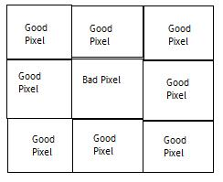
Figure 10 - This figure shows the orientation of pixels association with the proximity based algorithms. The bad pixel will be replaced by the mean/median value of the surrounding good pixels in the algorithms.
Once a bad pixel had been identified, the goal was to replace that pixel with the average ADU of the pixels around it. Bad pixels were identified as those whose values were greater than two standard deviations above the mean value of the entire image. This relies on the impetus that a coronal image does not possess a wide variation across the field of view. The pixels greater than this threshold were then replaced by the average brightness value of the surrounding pixels. In most instances, this involved an 8-pixel average. For the issue of extended aerosols covering multiple adjacent pixels in close proximity, a larger window was used to determine the average. For a look at the code see Appendix A Figure 1.

2.5.1.2 Median Proximity Algorithm
This algorithm is identical to the previous except that the replacement value was derived from the median of the surrounding pixels, as opposed to the mean. All other procedures were identical to the above method. For a look at the code see Appendix A Figure 2.

2.5.2 Time Series Based Algorithms

2.5.2.1 Mean Time Series Algorithm
This algorithm utilized the mean image shown in Figure 11. This image was obtained by calculating the mean brightness values of all 120 images in our data set on a pixel-by-pixel basis. This algorithm then analyzed our complete time series on an image-by-image basis comparing an individual image to this mean image. If a pixel was greater than two standard deviations above the mean value, it was replaced with the pixel element from the mean image. For a look at the code see Appendix A Figure 3.

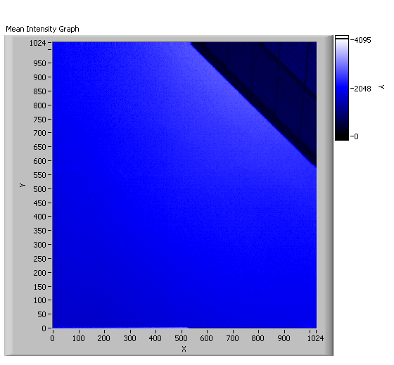
Figure 11 - Mean image calculated from 120 image data set on a pixel-by-pixel basis. This will serve as one of the images to replace pixels by if they exceed the threshold. Note the apparent absence of aerosols.

2.5.2.2 Median Time Series Algorithm
The median image was obtained similarly to its mean counterpart. The median brightness values of all 120 images in the data set were calculated on a pixel-by-pixel basis. Figure 12 shows the median image. This final algorithm was identical to the previous; however, if a pixel were greater than two standard deviations above the mean value, it was replaced with the pixel element from the median image. For a look at the code see Appendix A Figure 4.
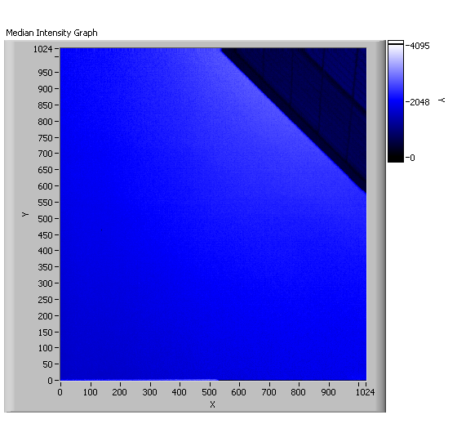
Figure 12 - Median image calculated on a pixel-by-pixel basis from 120 images in the data set. Note similarities to the mean image as well as absence of aerosols.

3.0 Results
The time series based aerosol removal algorithms yielded similar degrees of success regardless of the statistical parameter (mean or median) used. However, the results varied markedly between the usages of proximity versus time series based algorithms. Success in removing aerosols was noted by visual observation from the time series of 120 images. The time series based algorithms were the most efficient at aerosol removal.

3.1 Time Series Based Algorithm Results

3.1.1 Mean Time Series Algorithm Results
The results of this algorithm are shown in Figures 13-16. In Figure 13, no aerosols were visible when compared to the image presented in Figure 3. More quantitatively, inspection of the image histogram (Figure 14) showed no signal above 3000 ADU. Figure 15 is a blow-up the PA region we have been using as a metric for our analysis. As expected, no trace of the aerosol was present. The histogram in Figure 16 quantitatively demonstrates its removal. These results suggest that this algorithm was highly efficient at performing aerosol removal.

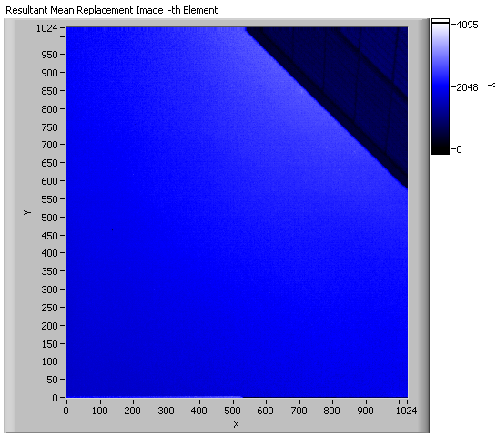
Figure 13 - This image displays the result of replacing bad pixel elements containing aerosols from our time series with the same pixel element extracted from our previously created mean image. Note the absence of aerosols.
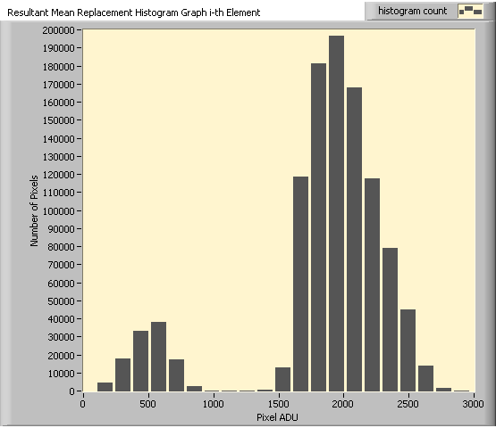
Figure 14 - The image histogram for Figure 19. Note the similar bimodal features corresponding to the primary image components. The lack of signal beyond 3000 ADU is our measure of success.
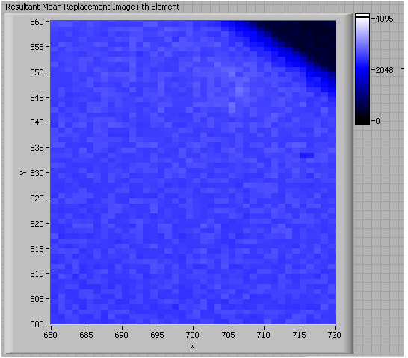
Figure 15 - The resulting image from Figure 19 at the location of the PA. Note that there is no indication of its presence.
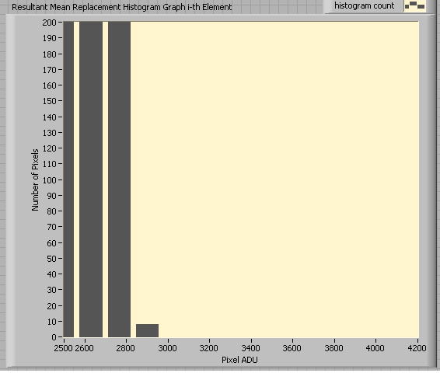
Figure 16 - A manipulated image histogram shows no image signal at 4000 ADU, the demarcation that this algorithm has indeed removed the aerosols successfully.

3.1.2 Median Time Series Algorithm Results
This algorithm worked also successfully removed aerosols. Figure 17 shows us the image after pixel replacement according to the methods described earlier. Aerosols were not visually present in this image. The image histogram (Figure 18) confirms the absence of signal around 4000 ADU. The algorithms removed the aerosols efficiently regardless of the statistical parameter used (mean or median).

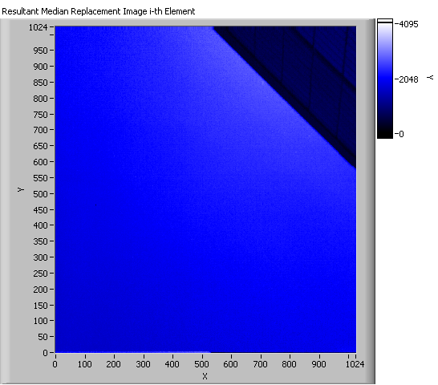
Figure 17 - This image is the result of replacing bad pixel elements from our time series with the same pixel elements extracted from the previously created median image. Note the absence of aerosols.
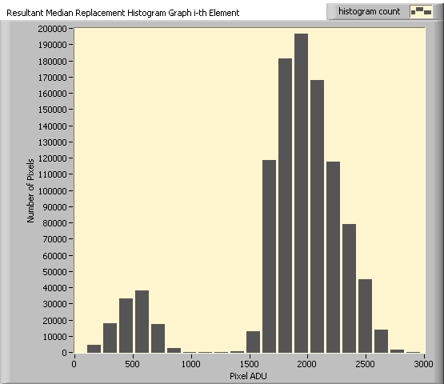
Figure 18 - Image histogram shows same bimodal feature. Note the diminished signal out towards 3000 ADU.

3.2 Proximity Based Algorithm Results

3.2.1 Mean Proximity Algorithm Results
Figure 19 shows the results of this algorithm. While the presence of aerosols has decreased, there were some abnormalities appearing near the building. The image histogram (Figure 20) shows that there is no signal reported above 3000 ADU which under our current assumptions would denote the absence of aerosols. The evaluation of the PA location; however, demonstrated the shortcomings of the algorithm. Figure 21 shows the location of the PA in our image. While the aerosol itself has indeed been removed, the image remains distorted. The histogram (Figure 22) confirms the absence of aerosols with no signal around 4000 ADU; however, the histogram was not intended to detect image distortion. This result suggests that, while successful at removing the aerosols, this algorithm distorted the image and was therefore unsuitable for our needs.
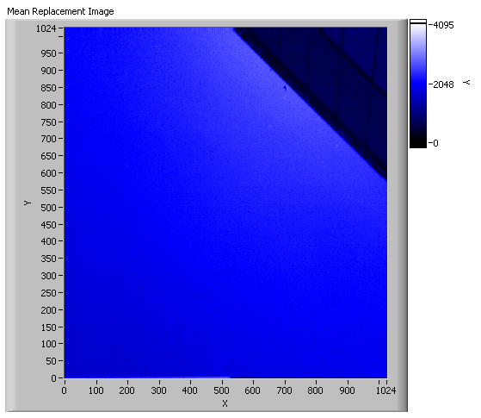
Figure 19 - This image is the result of identifying bad pixels and replacing them with the average of the immediately adjacent pixels. While aerosols do not appear present, note the distortion near the building's edge.
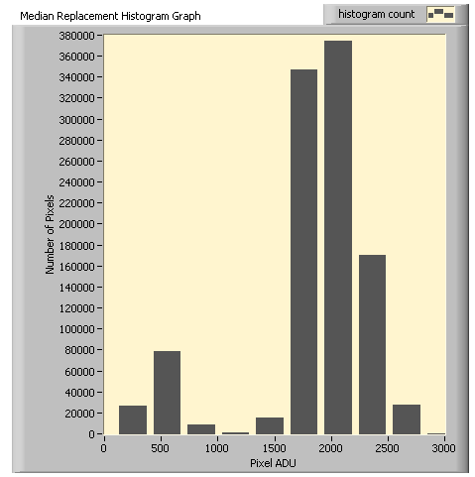
Figure 20 - Image histogram shows similar bimodal features and limited signal beyond 3000 ADU.
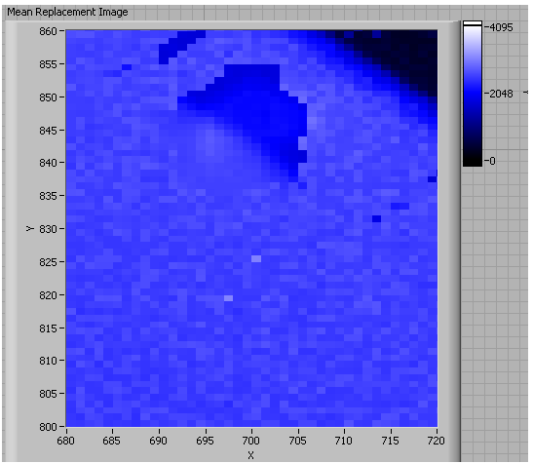
Figure 21 - The location of the PA. Note that while the aerosol is absent, there is a significant amount of distortion left in its wake.
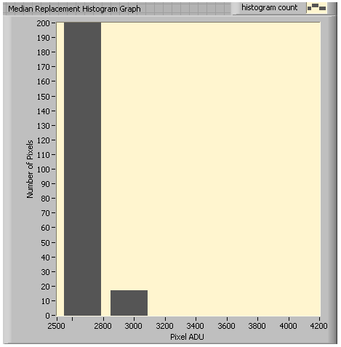
Figure 22 - Image histogram confirms absence of aerosols as there is no signal beyond 4000 ADU; however, it does not account for image distortion.

3.2.2 Median Proximity Algorithm Results
The results of this algorithm are shown in Figure 23. The PA has been removed; however, there is still some remnant image distortion. Based on visual comparison, this distortion was less than that of the previous algorithm. The image histogram (Figure 24) confirms the removal of aerosols as there was no signal around 4000 ADU. These results suggest that, while feasible for removing aerosols, the proximity based algorithms cause image distortion. The median proximity algorithm produced slightly less distortion than its mean counterpart; however, the time series based algorithms were more efficient.

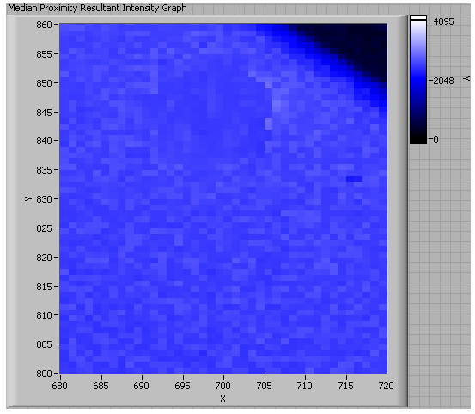
Figure 23 - The location of the PA. Note the slight distortion in the wake of aerosol removal.
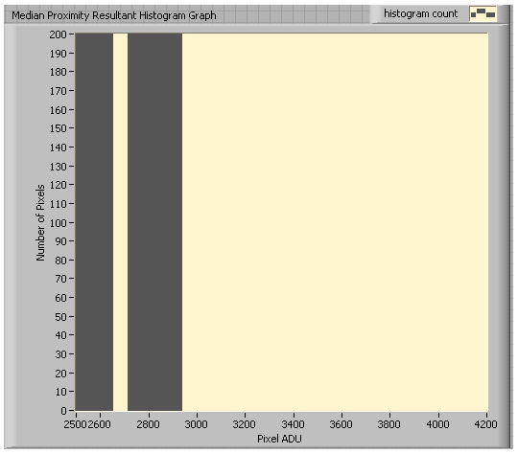
Figure 24 - The absence of aerosols is confirmed with the signal absence around 4000 ADU; however, this does not account for the image distortion.

4.0 Discussion
The results of our algorithms suggest that aerosol removal in images of the Sun’s corona is possible. All of the algorithms successfully removed the aerosols, with the time series based algorithms limiting image distortion to a minimum. Analysis of the image histograms before and after our algorithms showed signal reduction at 4000 ADU. Visual observation of the images also confirmed the removal of aerosols. However, the image distortions observed in blown-up images suggest the time series based techniques are preferred.
The proximity based algorithms suffered from two primary defects. First, it is important to note few (if any) aerosols were represented by a single pixel. Most were irregular swaths of saturated pixels as shown in Figure 9. If they were single pixels, these algorithms may have yielded better results. The first defect was the uncertainty in which pixels to average around a non-uniform blob of aerosol saturated pixels. The second defect was due to the proximity algorithms being essentially low-pass (spatial) filters. They smoothed the images, in particular the sharp edges of a structure and/or aerosol. Smoothing will naturally introduce distortions wherever there are transitions. The impacts of the defects associated with these algorithms could manifest themselves in an actual coronagraph due to the sharp edge of an occulting disk with the corona. This project may benefit from the use of Fourier transforms in future image processing when performing spatial filtering algorithms.
The image distortion caused by the proximity based algorithms could only be evaluated through visual observation. The image histograms were insufficient to detect the defects associated with the algorithms themselves. The histograms display the dynamic range of the signal contained by an image. While a useful metric for determining the presence of aerosols, they were unable to detect the distortions resulting from the aforementioned issues. It is imperative to future improvements that all defects be cataloged both qualitatively as well as quantitatively. Future work for this project will seek a means of assessing the image distortions beyond visual recognition.
In addition to image distortion, these algorithms were evaluated for their performance speed. As previously stated, the intent is for these algorithms to be performed in real-time. Analysis such as this has never been done before as the current methods involve post-processing. All of the algorithms required about three minutes (~180s) to process about 1s of data (120 frames). This time included reading the files from the computer disk, the removal algorithm, and writing the processed image back to the computer disk. The creation of the mean and median images took an additional 40s each. Future work also hopes to optimize these algorithms for true real-time usage.
During the evaluation of these algorithms, we ran into multiple memory issues which explained the size of our data set. 120 images was the maximum that the computer would process. In addition, the memory issues likely played a role in our performance times. We utilized a 32-bit operating system which significantly limited memory capacity; however, it was possible to utilize a 64-bit system in which the memory capabilities would be expanded tremendously. Future usage of a 64-bit system would suggest the ability to process more images at quicker speeds and may be the solution to our limitations.

5.0 Conclusion
To summarize, we have created four algorithms capable of removing aerosols from a time series of images. This task was performed utilizing a thresholding application that identifies bad pixels and replaces them with either a corresponding element from a previously derived mean/median image, or the mean/median value of surrounding pixels. The results among the different algorithms were varied; however, the time series based algorithms appeared to remove the aerosols with the least amount of distortion to the image. Future evaluation of performing these algorithms using extended memory capabilities hopes to decrease the processing time. In addition, an investigation into a preferred time series based algorithm will be conducted. Our algorithms, which suggest that real-time aerosol removal is possible, will facilitate the enhancement of ground-based coronagraphs and make them more efficient at acquiring high quality images despite previous inhibition by atmospheric aerosols. The ability to overcome inhibition due to atmospheric aerosols in ground-based instrumentation is paramount to the promotion of improved solar observations. The success of real-time corrections for atmospheric aerosols will broaden understanding of the Sun’s corona and influence the development of new technologies.

Bibliography
Berry, Richard, and James Burnell. The Handbook of Astronomical Image Processing. Richmond, Virigina: Willmann-Bell, Inc., 2000.
Elmore, David F., Joan T. Burkepile, J. Anthony Darnell, Lecinski Alice R., and Andrew L. Stange. "Calibration of a Ground-based Solar Coronal Polarimeter." Proceedings. Tuscon: The Society of Photo-Optical Instrumentation Engineers, 2003. 66-75.
Howell, Steve B. Handbook of CCD Astronomy. Cambridge: Cambridge University Press, 2000.
Keller, Christoph U. "Instrumentation for Astrophysical Spectropolarimetry." National Optical Astronomy Observatory 889 (November 2000): 1-52.
MacQueen, R.M., et al. "The High Altitude Observatory Coronagraph/Polarimeter On The Solar Maximum Mission." Solar Physics 65 (1980): 91-107.
MacQueen, R.M., J.T. Gosling, E. Hildner, R.H. Munro, A.I. Poland, and C.L. Ross. "The High Altitude Observatory White Light Coronagraph." Proceedings. Tuscon: The Society of Photo-Optical Instrumentation Engineers, 1974. 201-212.
Malherbe, J.M., J.C. Noens, and TH. Roudier. "Numerical Image Processing Applied To The Solar Corona." Solar Physics 103 (1986): 393-398.
Tomczyk, S., et al. "Alfven Waves in the Solar Corona." Science 317 (August 2007): 1192-1196.
Tomczyk, S., et al. "An Instrument to Measure Coronal Emission Line Polarization." Solar Physics 247 (2008): 411-428.

Acknowledgments

This work was performed under the auspices of the Significant Opportunities in Atmospheric Research and Science Program. SOARS is managed by the University Corporation for Atmospheric Research and is funded by the National Science Foundation, the National Oceanic and Atmospheric Administration, the Cooperative Institute for Research in Environmental Science, and by the Center for Multiscale Modeling of Atmospheric Processes.

In addition, I would like to thank my mentoring staff who have supported me throughout my endeavors with technical assistance, revision support, and stress relief.
Science Mentor: Scott Sewell
Writing Mentor: Amy Stevermer
Community Mentor: Lance Jones
Peer Mentor: Theresa Aguilar

Lastly, I would like to thank the staff at the NCAR High Altitude Observatory, specifically the Instrumental Group, for opening their hospitality and assistance to me, I could not have succeeded without their input.

Appendix A – LabVIEW Code

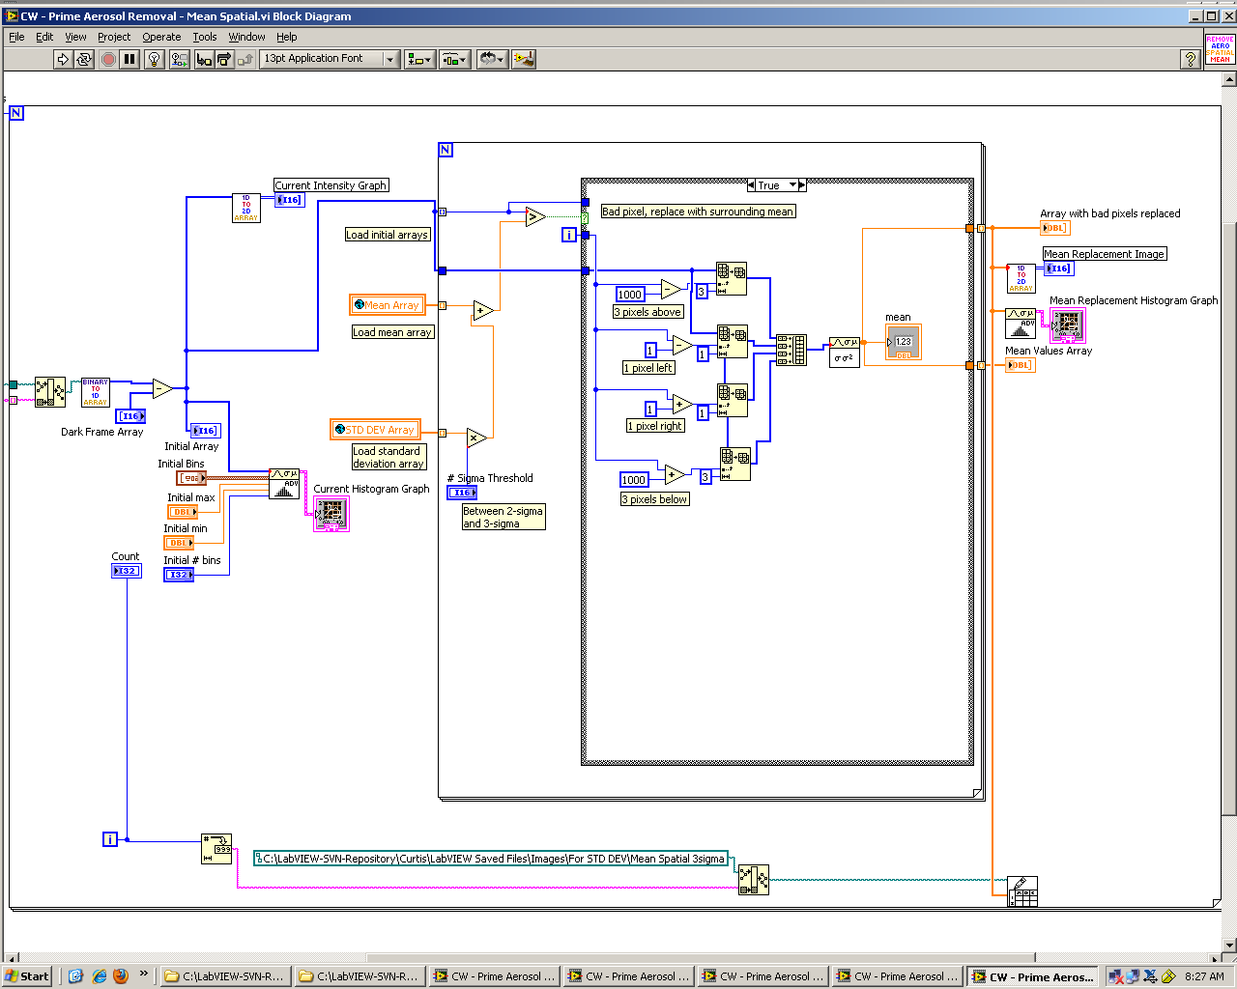
Figure 1 - LabVIEW code that loads in a series of images, subtracts dark frames, identifies bad pixels containing aerosols, and replaces them with the mean value calculated from the immediately surrounding pixels.
Mean Proximity Algorithm

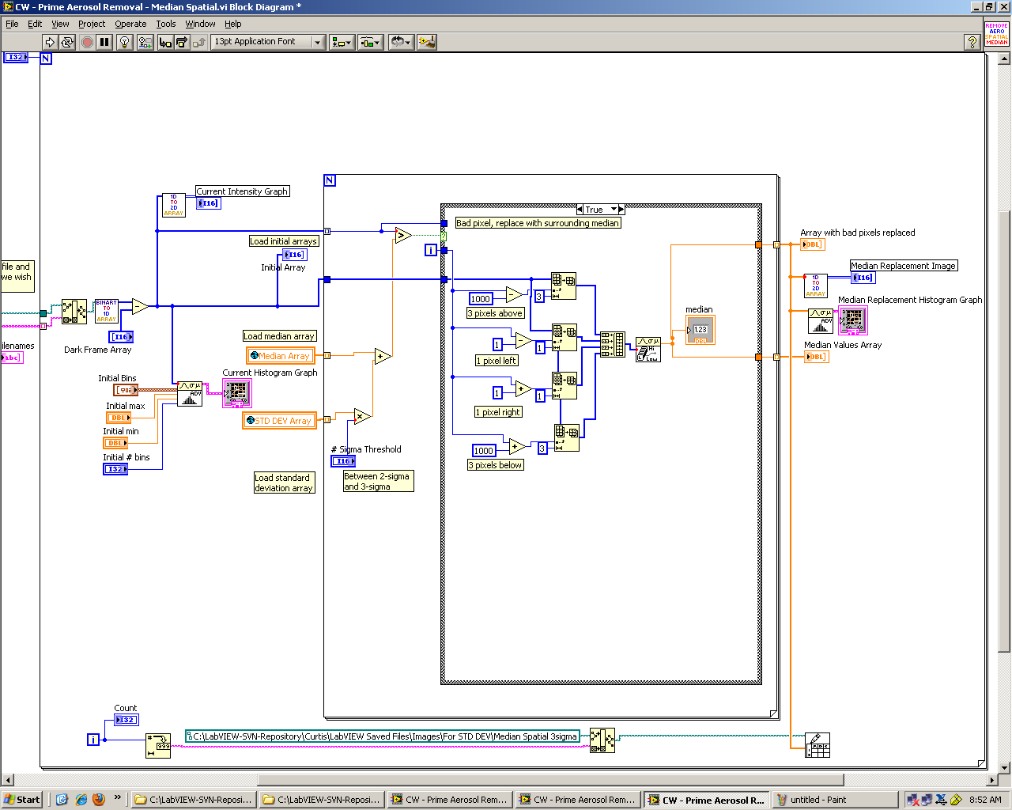
Figure 2 - LabVIEW code that loads in a series of images, subtracts dark frames, identifies bad pixels containing aerosols, and replaces them with the median value calculated from the immediately surrounding pixels.
Median Proximity Algorithm

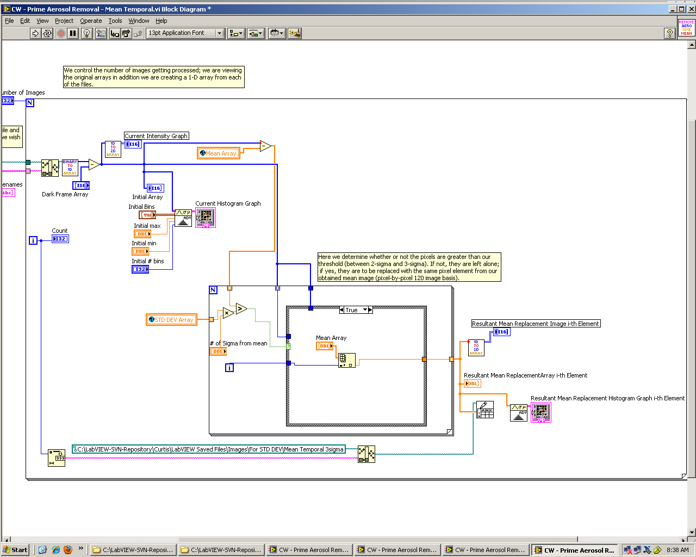
Figure 3 - LabVIEW code that loads in a series of images, subtracts dark frames, identifies bad pixels containing aerosols, and replaces them with the same pixel element extracted from the previously calculated mean image.
Mean Time Series Algorithm

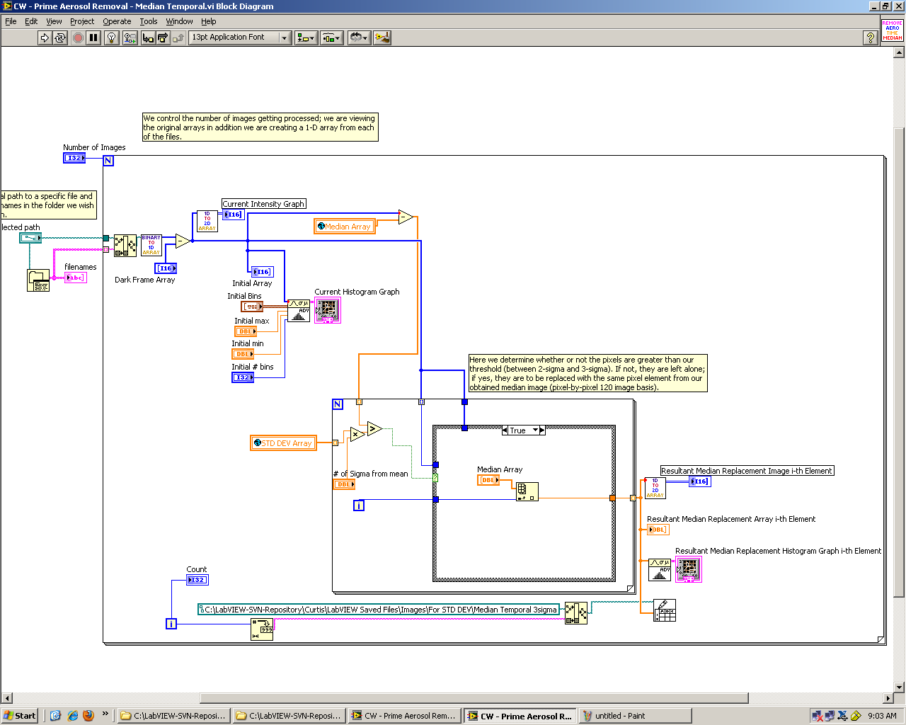
Figure 4 - LabVIEW code that loads in a series of images, subtracts dark frames, identifies bad pixels containing aerosols, and replaces them with the same pixel element extracted from the previously calculated median image.
Median Time Series Algorithm

Appendix B – Confirmation of Statistical Distribution Characteristic
Gaussian statistics states that the 2-sigma confidence level corresponds to 95% of the data while the 3-sigma confidence level corresponds to 99.7% of the data. Our data set provides a unique opportunity to test this. Each of the images in our data set contained 1024 rows of pixels by 1024 columns of pixels which sums to 1,048,576 pixels per image. This very large number will allow us to test the 2 and 3-sigma bounds with some level of confidence. When we applied the upper limit of the 2-sigma threshold, ~26,500 pixels were replaced. This is ~2.5% if the pixels as predicted by the Gaussian distribution. The remaining 97.5% of the image pixels remained unchanged. The uppermost 3-sigma results also confirmed Gaussian statistics where ~1600 pixels were replaced (~0.15%). We do not know the true distribution of aerosols in these images, and therefore it is impossible to determine which threshold was more effective than the other.

