LabVIEW
- Dark Frame Subtraction

- Algorithm Steps
- Load a TIF Image File from computer
  - One should be the initial image while the other should be the dark frame
- Display individual pixels of images
- Perform Statistical Analysis on image pixels
- Subtract dark image from initial image (heart) on pixel-by-pixel basis
- Perform Statistical Analysis on the resulting image pixels
- Reload image from pixels
- Images
- Q Drive\CoMP-S\Tests\pco.edge Camera Tests June 2010\pco.edge Camera tests 01-june-2010
- Use 10 ms bullseye 01-june-2010
- 10 ms lens cover on –room lights off.tif

³

10 ms bullseye (Bullseye & Histogram)

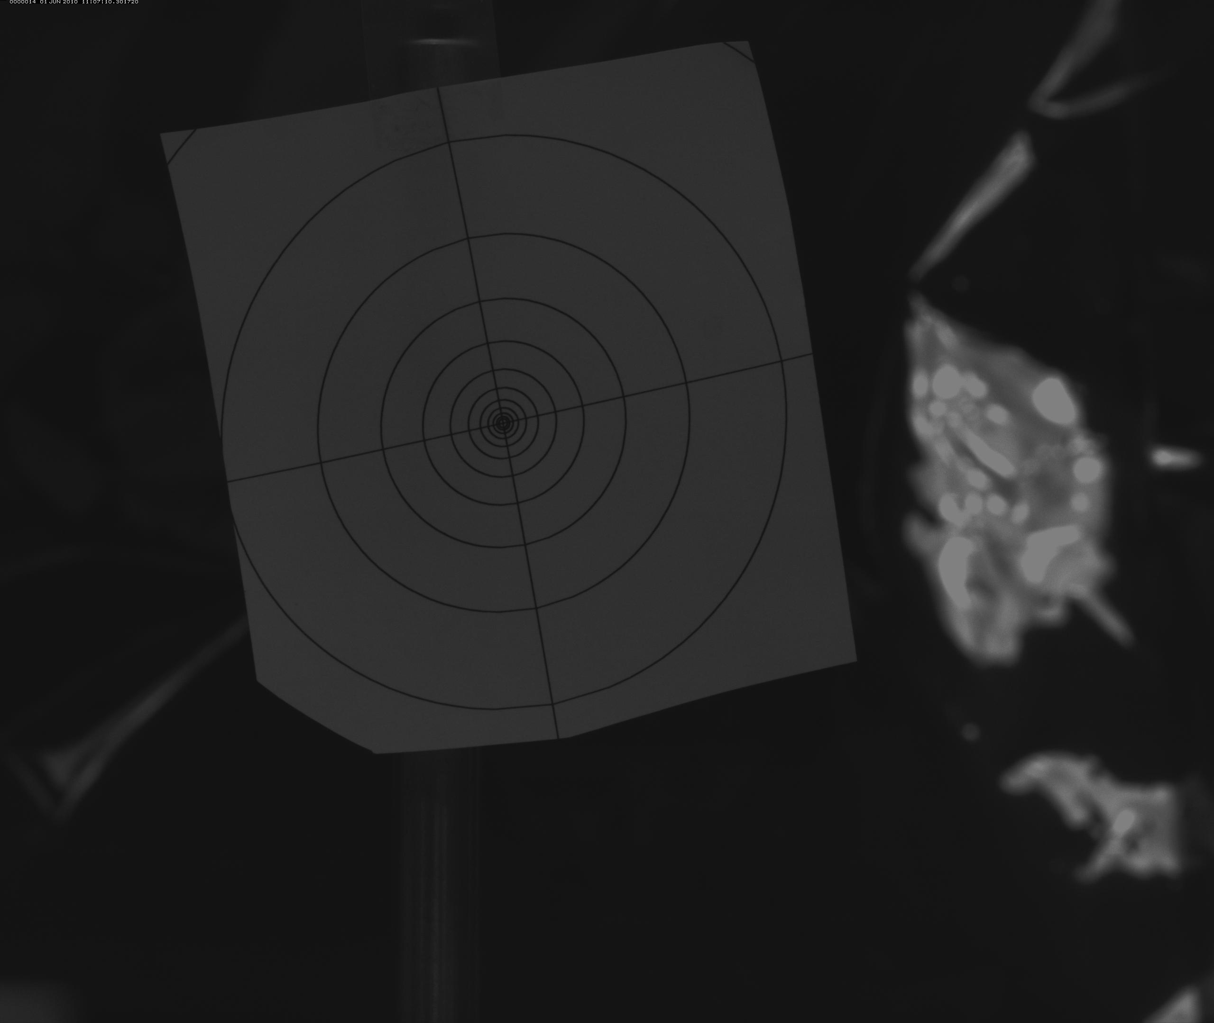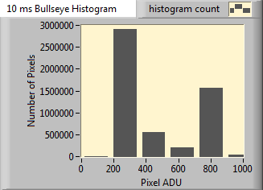
Figure 1 - PCO.Edge sample "target" image and accompanying histogram displaying Pixel Analog-to-Digital Units (ADU) and the Number of Pixels. Exposure time was 10 ms (10⁻³s).

10 ms lens cover on – room lights off (Dark & Histogram)

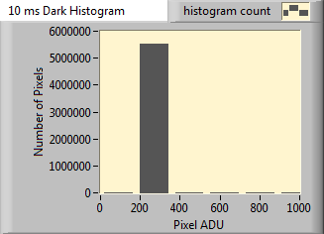
Figure 2 - Dark frame obtained from PCO.Edge sCMOS detector and accompanying histogram displaying Pixel Analog-to Digital Units (ADU) and the Number of Pixels. The exposure time was 10 ms to match that of the target image.

(Bullseye – Dark & Histogram)

- Flat Field

- Algorithm Steps
- Load a TIF Image File from computer
  - One should be the initial image while the other should be the flat taken under uniform illumination
- Display individual pixels of images
- Perform statistical analysis of image pixels
- Divide initial image by its flat image to obtain flat field image
- Perform statistical analysis of image pixels
- Reload image from pixels

- Aerosol?
- Polarization?

Two different cameras were utilized to obtain images for [comparison of] data reduction (image processing, transformation of raw data into a more useful form) techniques, including (move the above list to here). The first camera was the sCMOS PCO.Edge that will be used with the actual coronagraph. Its resolution is 2560 x 2160 pixels, the maximum frame rate is 100 frames per second (fps), the readout noise is less than 3 electrons at 100 fps (less than 2 electrons at 30 fps), the dynamic range is 14-bit and the pixel size is 6.5 x 6.5 μm² (square microns). [Obtained from manufacturer’s website] This device is currently on the leading edge of available technology. The second camera utilized was the more modest CMOS Photon Focus (Model Number MV-D1024E-160-CL-12). Its resolution is 1024 x 1024 pixels, a maximum frame rate of 150 fps, the dynamic range is 12-bit and the pixel size is 10.6 x 10.6 μm². [Obtained from manufacturer’s website].
The cameras were used to obtain their own unique image data sets (compilation of different types of images) for later manipulation. Each data set consisted of a number of target frames (images of the desired object), dark frames (images with the shutter closed to prevent all light from entering), and flat frames (images of uniform illumination). The target frames of the sCMOS PCO.Edge detector captured a fake print-out of a solar eclipse thus allowing the surrounding corona to be seen. The presence of aerosols was simulated in these target frames by sprinkling oatmeal and salt in front of the image while the detector was acquiring the images inside of the High Altitude Observatory Instrumental Group Optics Lab (HAOIG). The exposure of the 423 images obtained over 60 seconds (s) was set at 33 milliseconds (ms) which is equivalent to 30 Hertz (Hz). The target frames of the CMOS Photon Focus camera were actual aerosols of cottonweed as illuminated by the sun obtained outside during a clear afternoon in Boulder, CO. In the sample data set, 1000 images were obtained at an exposure of 33 ms as well. [See Figure 1].
The bias frames (dark frames and flat frames) were acquired specifically for each image data set. The only bias frame obtained for the sCMOS detector was the dark frames due to time restraints. The lens cap was placed on the camera, and the room was made pitch black for the dark frames. The door was shut, the lights turned off, and the computer monitor shut off to eliminate all sources of light pollution. The dark frames obtained must be the same exposure as the target images they will be subtracted from (Berry and Burnell 2000). In our case, this would require an exposure time of 33 ms. [See Figure 2].
The bias frames obtained from the Photon Focus device consisted of both dark frames and flat frames. Since there were 1000 target images, 10 dark frames would suffice to subtract the bias presented by dark current. Based on this multiplicative factor of 10, the number of flat frames to be obtained was also set at 10. In order to obtain a flat frame, the lens of the detector must receive a uniform light output (Berry and Burnell 2000). Every pixel in the detector must receive the same amount of light as any other. The uniform dispersion of light was achieved via an Opal Diffuser. This piece of glass is coated with opal to cause a large amount of scattering loss. The result is a uniform distribution of photons reaching a detector, such as the CMOS camera. The diffuser is placed at the end of the lens and the images obtained are the flat frames to be used for later calibration.
To perform the image calibrations and correct for bias, LabVIEW 2009 was utilized to create algorithms capable of performing data reduction procedures. Performing any type of math or analysis on an image requires first converting the image into an array of its pixels. Based on the image resolution for the detector, a 2-Dimensional grid of pixel values, known as an array, is required. The easiest method to perform this conversion was(is?) to save the acquired images first as binary files. Then using LabVIEW, these Binary files can first be converted into 1-D arrays and subsequently into the required 2-D arrays. A LabVIEW programming structure known as a For Loop allowed all the files specified by the user in a particular directory to undergo the same processing to allow for time efficiency, a necessity when converting over 1000 images.
Once the arrays were obtained, the first step in the data reduction process of dark frame subtraction commenced. First, an average dark frame array was created from all the dark frame arrays. This was necessary to obtain a Master Dark Frame Array (MDFA), an image array that will be subtracted from the initial target image arrays. After the positioning of another For Loop, the MDFA was subtracted from all of the initial target image arrays. The resultant arrays were then saved for later usage in the second procedure and converted back into images for observational analysis. LabVIEW was highly efficient at facilitating all conversion needs.
The second procedure of flat field division involved a similar approach. The acquired flat frame arrays were averaged together to create a Master Flat Frame Array (MFFA). The resultant image arrays from the first procedure were then divided by the MFFA. In an identical fashion, a For Loop ensures that all of the images are processed via the same methods. These new resultant arrays are then saved for later usage and converted back into images for observational analysis.
The last stage in the data reduction procedure specific to the coronagraph was the removal of aerosol pollution in the images. Dark frame subtractions omit thermal noise from the detectors. Flat field divisions ensured a uniform light distribution. However, neither method was sufficient enough to combat the natural constituents of our atmosphere. A new, three-pronged method was applied to the post-processed image arrays.
This new method converted our pre-processed arrays into three new arrays that were later analyzed. Each of the new arrays was derived using LabVIEW from the same initial, post-processed array. The first new array, known as the Minimum Array (MINA) took the minimum value of all the previous arrays and subjected those arrays to this threshold. Only the Pixel ADU values that were in agreement with this minimum array value would be displayed thus lowering the array’s dynamic range. The MINA was then converted into an image for later comparison. The second array, known as the Median Array (MEDA) operated in a similar fashion. The median of all the post-processed arrays was taken and then used as a threshold for the resultant, MEDA. The MEDA was also converted into an image for later visual analysis. The final new array created was the Average Array (AVGA). Average was substituted for mean to prevent acronym confusion. The AVGA was obtained after the post-processed arrays were averaged together and another threshold was utilized based on the mean array value. The AVGA was also converted into an image for later analysis.
All of the obtained arrays throughout the data reduction procedures were subjected to additional analysis. LabVIEW was utilized to produce histograms displaying the relationship between the Number of Pixels in an array in regards to the Pixel ADU. In addition, time series were constructed in which Pixel ADU was plotted against the Frame Number in order to observe any irregularities that appeared. Lastly, all arrays created were evaluated for their mean and standard deviation. This analysis produced quite an impressive display that will revolutionize the image processing community.

