Office of Education & Outreach Communicating Science Series
Workshops for K-12 & Public Audiences

Workshop Goals:
- Share EO’s educational resources for teachers and the public with other UCAR, NCAR, & UCP staff
- Encourage collaborations in enhancing and disseminating science content for these audiences
- Provide support for staff wishing to communicate science in K-12 classrooms and public events
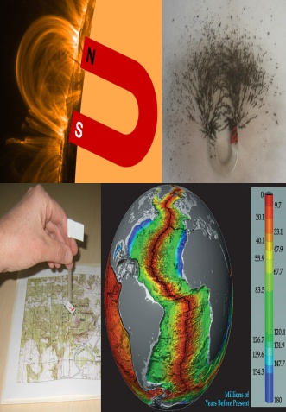
Hands-on Magnetism Activities, Space Weather, and Geomagnetism
Thursday, February 3rd, CG1 – Conference Room 2126, 1 - 2:30 pm

This workshop blends several hands-on activities about magnetism with background information about the Sun, space weather, Earth’s magnetosphere and upper atmosphere, auroral activity, and geomagnetism. We’ve presented versions of this workshop regularly (roughly a half-dozen times per year at various venues) for the past eight years, progressively refining and improving it in response to the interests and requests of teachers. Presented by Randy Russell
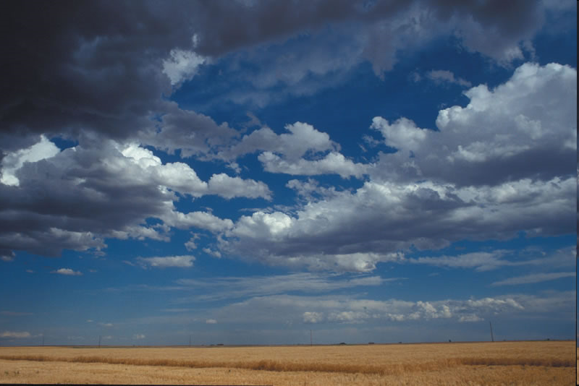
Cloudy Day: Activities Bridging Cloud Science, Literacy, and Art
Thursday, March 17th, FL2 – Cafeteria Atrium, 2:30 pm
Explore hands-on and online approaches to teaching elementary to middle school students how clouds form, common cloud types, and what clouds have to do with the weather. The next cloudy day will become a teachable moment using our cloud viewer and online cloud type gallery, clouds in art interactive, cloud formation activities, literacy activities, and related content. Presented by Becca Hatheway

Radar and Weather Together
Thursday, April 14th, FL2 – Cafeteria Atrium, 2:30 pm

Find out how radar technology and the physics of wave energy can be engaging to learners through hands on activities about NCAR’s weather and severe storm research. These activities have been used effectively in both public science events and in the K-12 classroom, especially with a focus on the deployment of the Doppler on Wheels in field campaigns. Presented by Tim Barnes
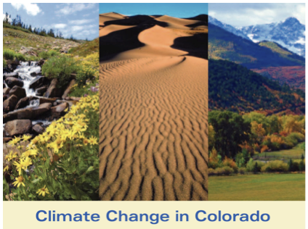
The Impacts of Climate Change in Colorado: Today and Tomorrow
Tuesday, May 3rd, Mesa Lab Classroom, 2:30 pm

Pine beetles, water resources, urban heat, snowpack, and other factors are expected to be affected as the global climate warms. This workshop combines hands-on activities with science content related to what we know about Earth’s climate, how climate change is causing environmental changes in Colorado, and how scientists are monitoring and predicting these impacts. Presented by Teri Eastburn, Becca Hatheway, and Susan Foster

For more information, contact Natalie Culkin, email nculkin@ucar.edu, telephone 303-497-2585

