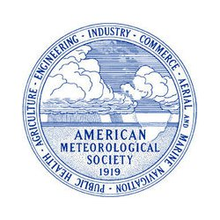 | AMS 2015 Teacher Workshop  Saturday, January 3, 2015, 8am - 4:30pm  at the Renaissance Phoenix Downtown Hotel  50 East Adams Street, Phoenix, Arizona 85004
SPONSOR INVITATION
The AMS cordially invites you to be a SPONSOR for the AMS 2015 Teacher Workshop. The Teacher Workshop exists to present innovative and effective educational resources, scientific tools, and research in the atmospheric and related sciences to 4th-12th grade educators. This workshop will provide additional exposure for your company or organization. We are pleased to offer the following benefits, as our way of saying thank you for your generous support.

BENEFITS FOR ALL SPONSORS
- Sponsor logo on the AMS Teacher Workshop Web page
- Sponsor recognition on the workshop presentation slide template used during the Workshop
- Verbal acknowledgement during the workshop
- Sponsor sign prominently placed in front of the Workshop location (Poster provided by sponsor)
- Lunch, introduction, thanks, and time to introduce sponsor by addressing participants
- Sponsor sign in the lunch room (Poster provided by sponsor)
- Verbal acknowledgement during the end of the Workshop
- Sponsor signage prominently placed in the reception room (Poster provided by sponsor)
- Sponsor’s information package provided to participants (Package provided by sponsor)

Sponsorship will contribute to all or one particular workshop need:
- Teacher Registration Fee ($25 each - 50 Teachers are expected)
- Breakfast and Snacks
- Lunch
- Reception
- Hotel Equipment (projector, audio, Internet, wireless, etc)

We look forward for your support and involvement!

